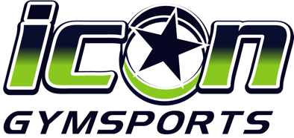

THE ICON BRAND

COLOUR PALETTE

The Icon Gymsports colour palette is lime green, navy blue and white.

Navy Blue | Lime Green | White
Hex = #041E42  RGB = 4 / 30 / 66  CMYK = 100 / 90 / 13 / 68  Pantone = 289 C | Hex = #97D700  RGB = 151 / 215 / 0  CMYK = 46 / 0 / 90 / 0  Pantone = 375 C | Hex = #FFFFFF  RGB = 255 / 255 / 255  CMYK = 0 / 0 / 0 / 0

FONT

The Icon Gymsports font is Avenir Next and secondary fonts for individual programs have also been selected.

PRIMARY FONT
Aa | Aa | Aa
Avenir Next  Regular | Avenir Next  Demi Bold | Avenir Next  Bold

SECONDARY FONTS

Gymnastics | Cheerleading
Aa | Aa
Wild Youth | Freshman

PHOTOS AND VIDEOS

The use of real photography and videos are essential to communicating the excitement, skill level and culture of the Icon Cheer brand. Real photos and videos of the athletes training, performing and posing should be used to bring vibrance, action and authenticity to Icon’s marketing collateral and visual communications.

Photos and videos used (as much as is possible) should aim to adhere to the following criteria:

- Bright colours with vibrancy
- Bright lighting
- Contemporary and modern feel
- The emotional characteristics of people should be (any combination of) positive, determined, focused, proud, confident and happy

OTHER GRAPHIC ELEMENTS

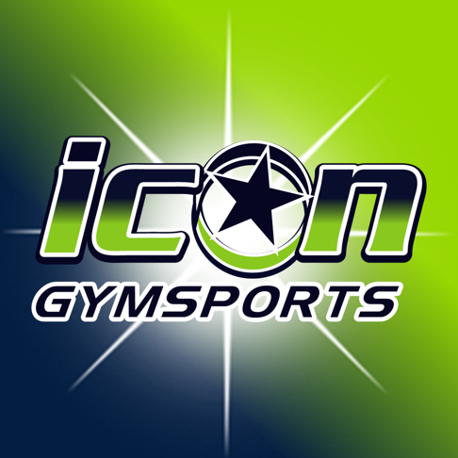
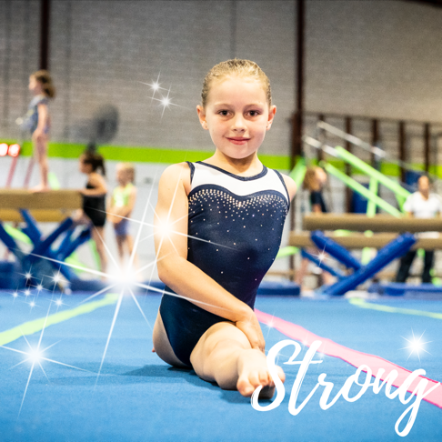
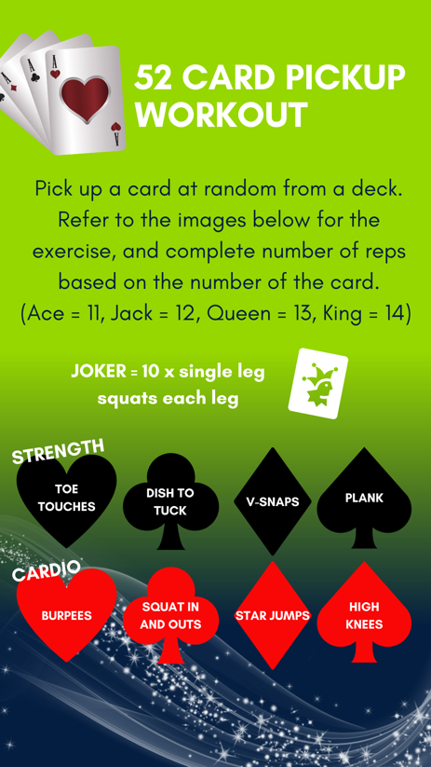

The Icon brand is further characterised and recognised by its use of a lime green and navy blue gradient effect, as well as intricate, sharp and eye catching star graphics in its graphic design. Examples below.

