How the Quantitative ETF Strategies Work

The idea behind the quantitative ETF rotation strategies, is to essentially be in the strongest (leading) sector or fund using strength and momentum data. I'm using relative strength over multiple periods to figure out where the strongest ETFs/Sectors are - then weighting volatility over multiple periods in order to filter out erratic moves. As with any investing strategy, the strength is in the long term, where you're putting probabilities and compounding your growth over time. Compounding your money is the trick to growing wealth in investing. You don't have money on the sidelines waiting for the right stock at the right time. Charlie Munger famously said that the “The first rule of compounding is to never interrupt it unnecessarily”. With these strategies, you’re actually compounding at a monthly rate. You'll see during any testing period I use, that I will use ATLEAST a 3-year period. No strategy beats the market every single year. I am going to mention CAGR throughout the strategy writeups - and this stands for Compounded Annual Growth Rate. Which is the key % indicator in growing your wealth over long periods of time.
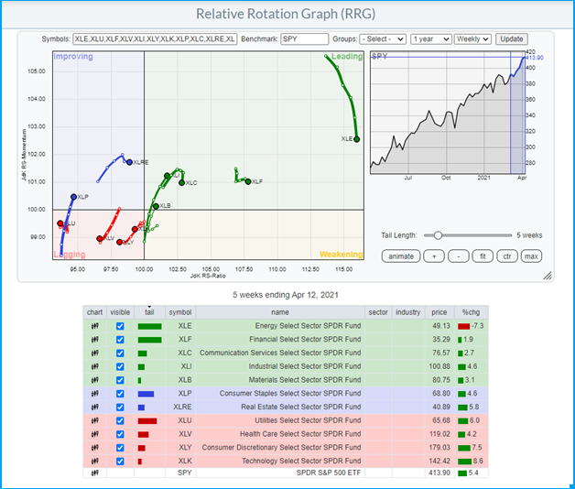

Growth ETF Rotation Strategy

In simple terms, the idea of the Quant ETF Rotation strategy, is to always be rotating into assets where the most money is flowing. It’s based on strength and momentum. You're in 4 ETFs at all times and its rebalanced monthly.

Performance – Last 18 Years

(Exhibit 1)
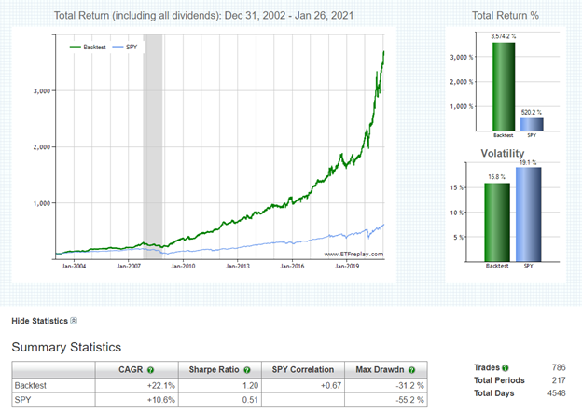

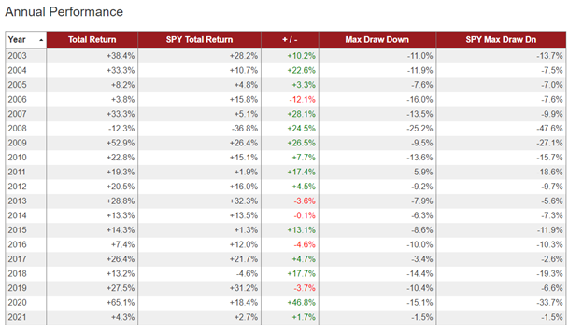
When I am backtesting a strategy, I want to know how well it will do in trending markets (I want it to outperform). How it will do in down trending bear markets - both long and short term. How volatile is it when we have a market crash? Finally, how well it does in the long term through all the above scenarios. If it outperforms with less volatility and drawdowns - then it’s a winner.

I don't go back further than 2003 in my backtesting, because 1) ETFs are fairly new to the scene and many didn't exist before then. 2) In my opinion, we live in a different world than we did 20+ years ago. More people are in the market than ever before, technology has changed drastically, research is easier to come by, and people are going to jump into the markets whenever a correction or crash happens because they don't want to miss out.

Exhibit 1 above shows a backtesting of the strategy from 2003 to today as of writing the article - Jan 2021. The blue line shows the S&P 500 ETF (SPY) and the green line shows the rotation strategy. It shows that starting in Jan 2003, if you had followed the strategy, you would have a total return of 3,574.20% - compounded at an annual growth rate of 22.1% per year (CAGR). During that same time, if you had put your money in an S&P 500 fund - it would have returned a total of 520.2% - compounded at an annual growth rate of 10.6% (CAGR). You would have 35x your money having a return almost 7x the S&P 500, with less volatility, and a significantly less max drawdown of 31.2% vs 55.2% in 2008. A $10k investment would have turned into $357,420. That's without ever adding any capital to the portfolio.

Stress (Volatility) Tests

The 2008 Financial Crisis

Let’s look at one of the most volatile periods of the last 20 years - 2008. In the below scenario, you started investing in 2007.
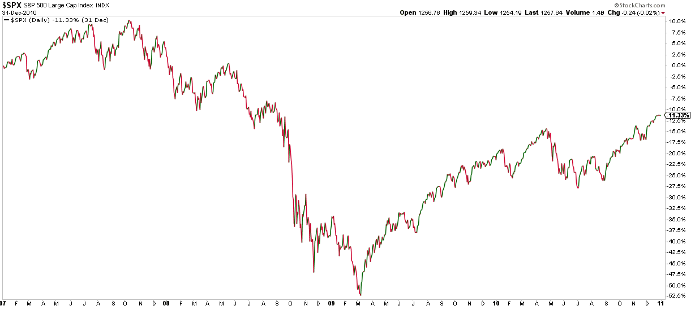

2008 was a tough year as some of you may remember. All markets took a hit and there were really no safe havens for investors. Even Gold dropped 30% from its high that year. This strategy dropped 31.2% as well, but then shifted into the top performing assets. Your 3-year total return would have been 78.6% (Green Line) vs -16.0% for the S&P (Blue line).

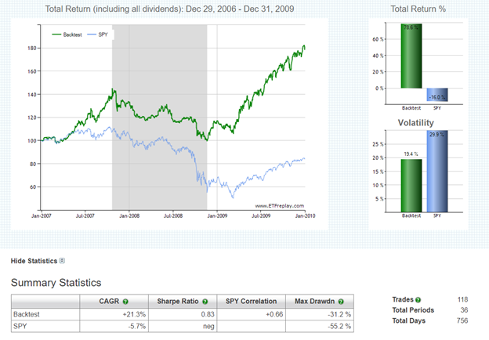

The 2020 Covid Crisis

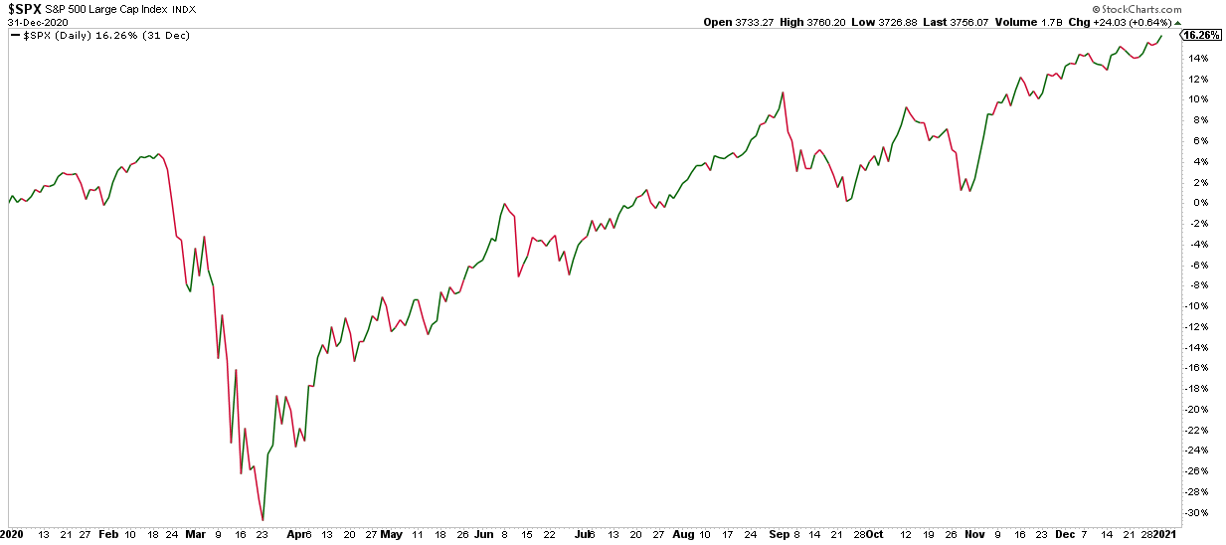

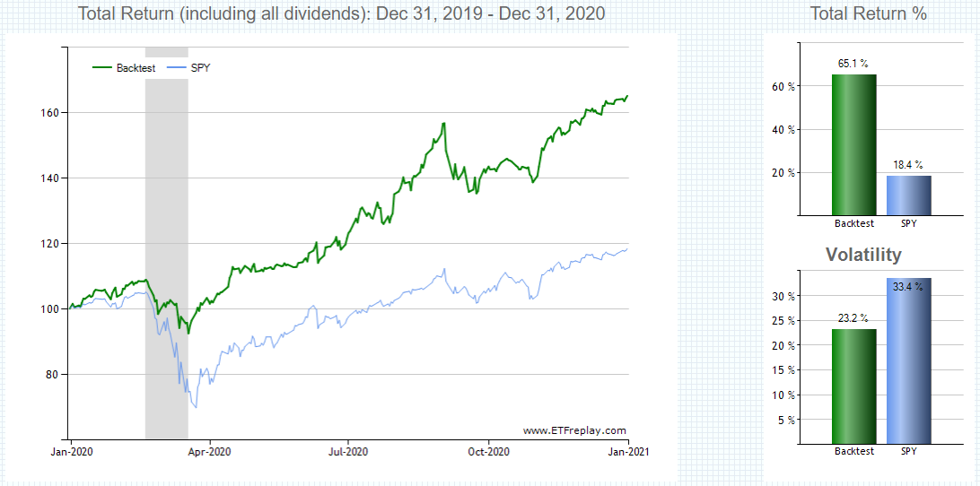

Performance – 3 Year Period – Jan 2018 - Dec 2020
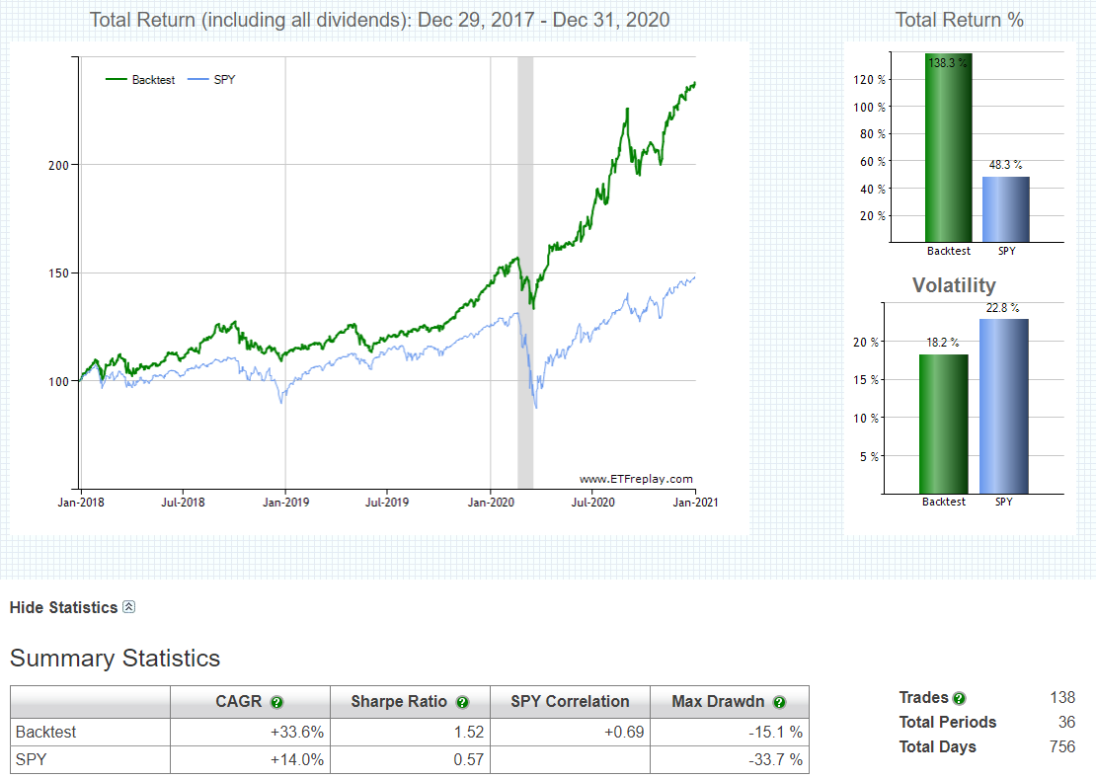
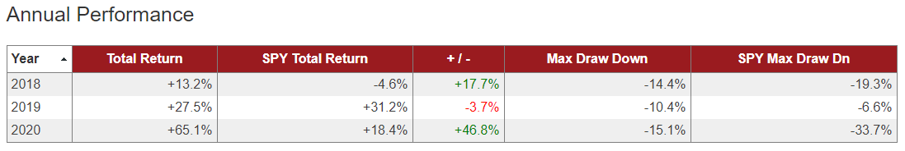

Historical Performance
Performance – Last 10 Years – 2010-2020
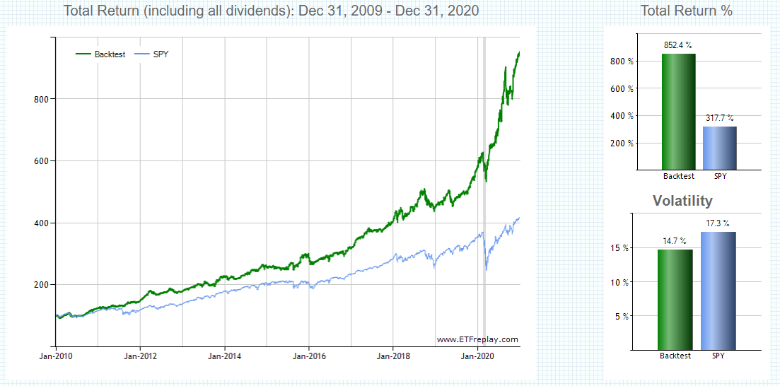
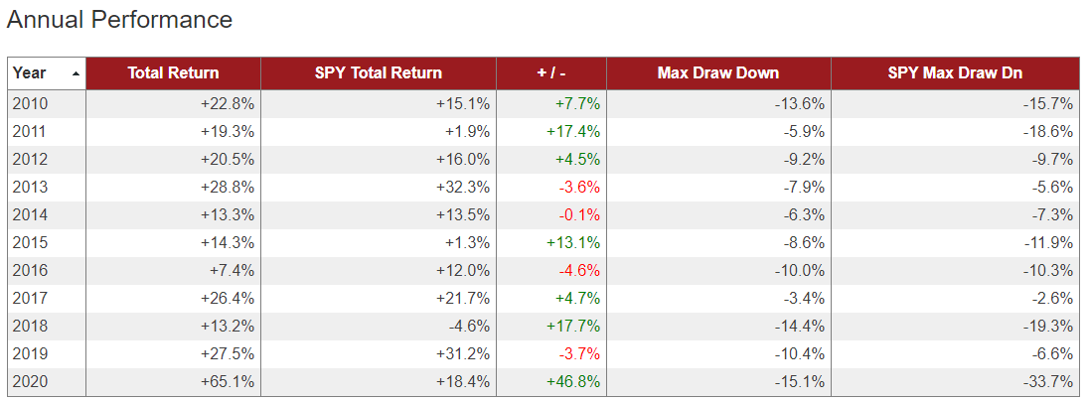

Performance - Last 5 Years – 2015-2020
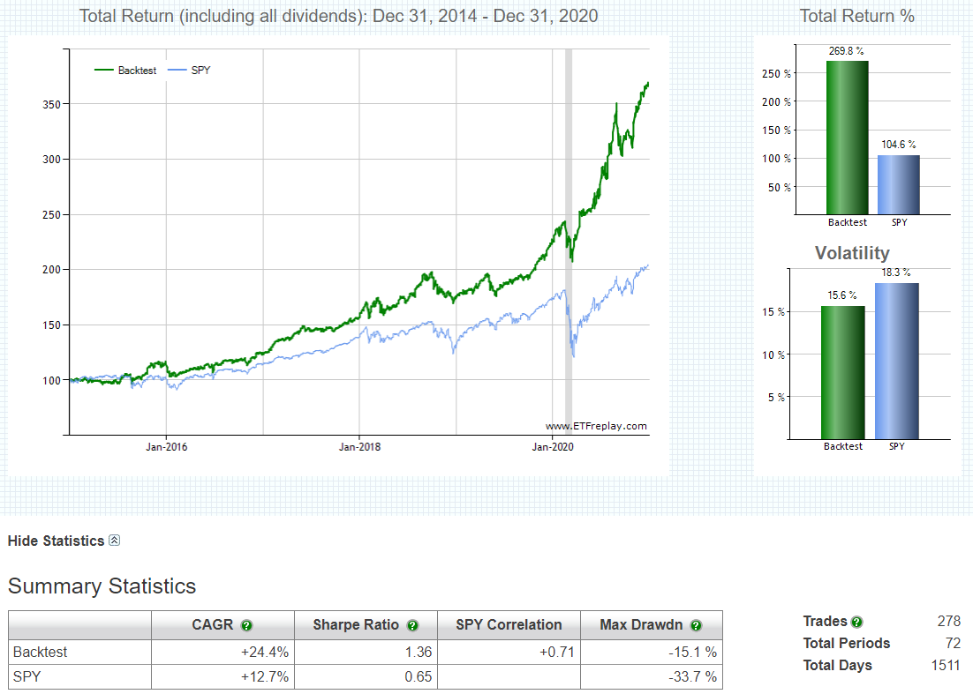
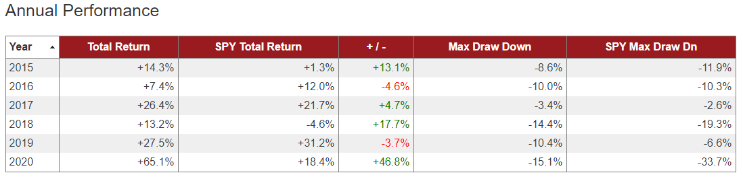

Conservative ETF Rotation Strategy

The 60/40 rotational strategy is a 60/40 asset (60% Equity/40% Bond) allocation meant to beat the S&P over the long term, but keep up with the S&P (100% equities allocation) in the shorter time frames, with less volitility. The strategy will only hold 2 ETFs per month. You'll see from the charts below, that the reason the strategy outperforms in the long run, is because during market corrections this strategy doesn't need to recover from a large drawdown (if the market drops 50%, it takes a 100% move to recover). It will protect itself by switching to cash in volatile times. This will underperform during market periods where the market is in a constant uptrend - due to the bond allocation.

This is a conservative strategy that invests in 60% stocks during "risk on" time periods, in the strongest performing stock index and switches to cash when volatility comes into the markets. The other 40% will always be allocated to bonds. Bond type will depend on relative strength and short-term volatility.

This strategy is for those that want to take a more conservative approach and want to protect themselves from volatility and large drawdowns. You'll see from the charts below that through the 2008 and 2020 market corrections, the max drawdown was only 11.8% vs 55.2% in the S&P.

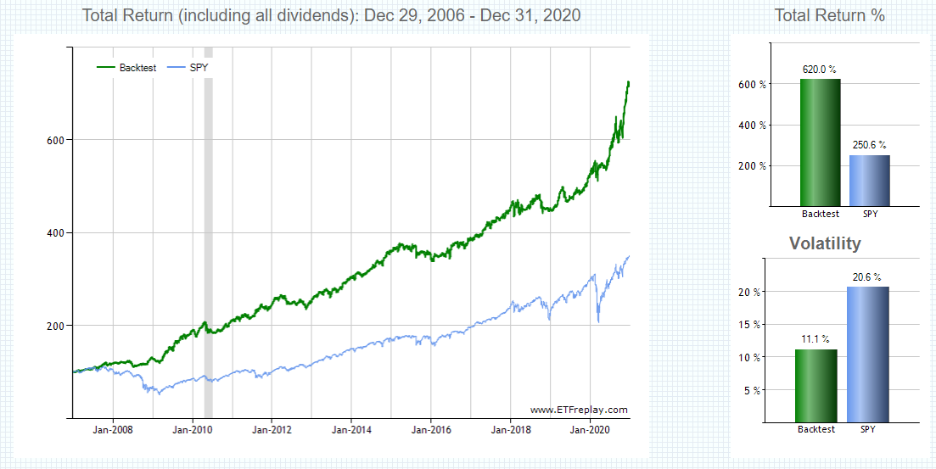
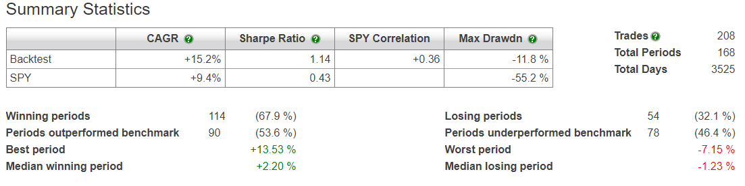
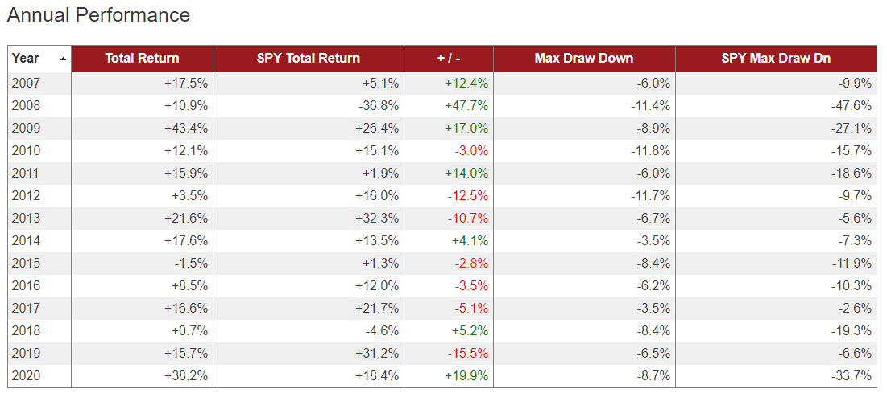

Stress (Volatility) Tests

The 2008 Financial Crisis

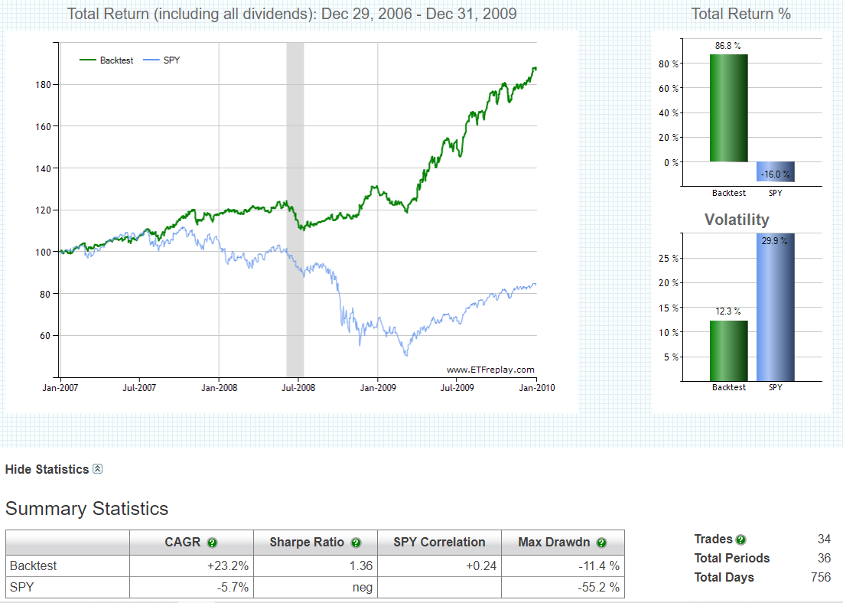
The 2020 Covid Crisis

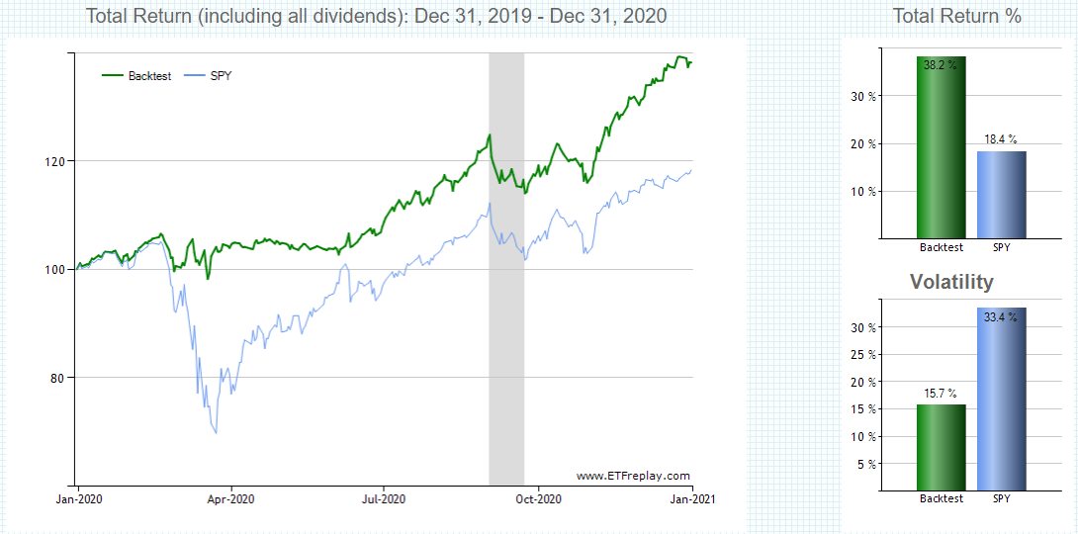
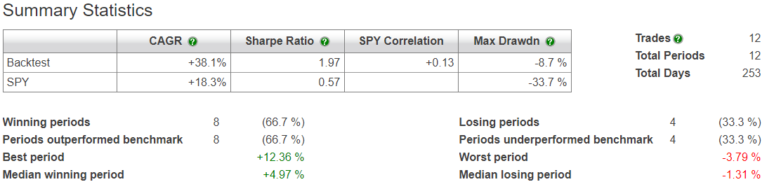

Historical Performance
Last 15 Years
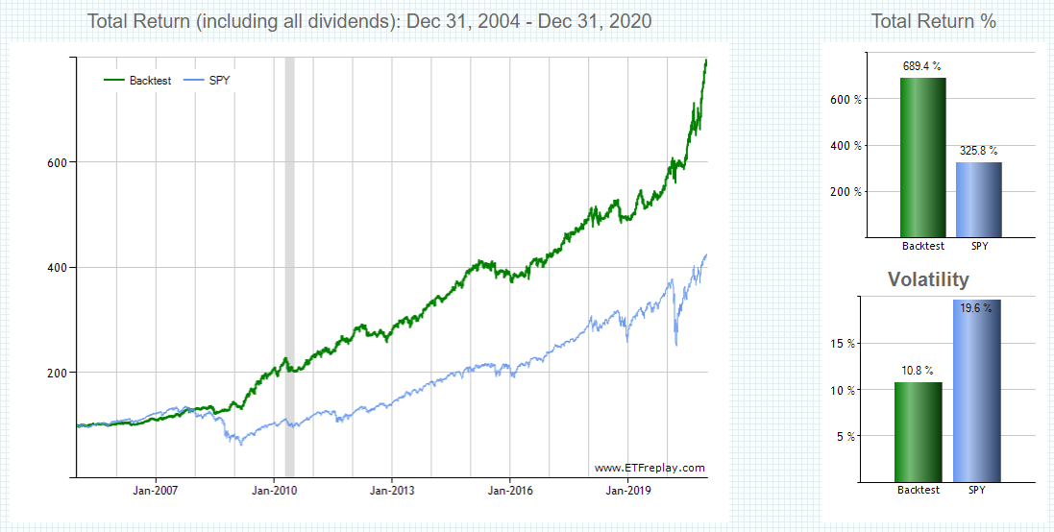
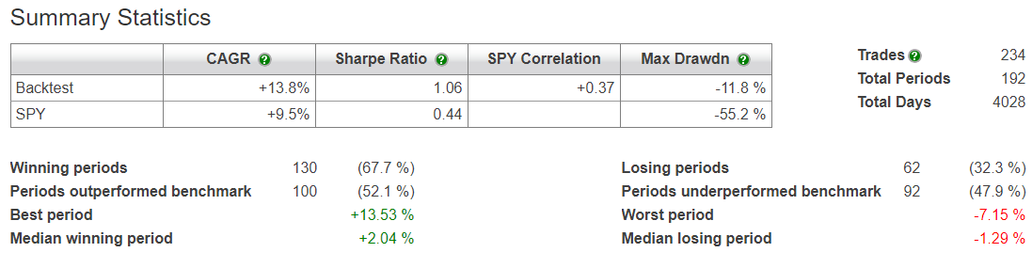
Last 10 Years
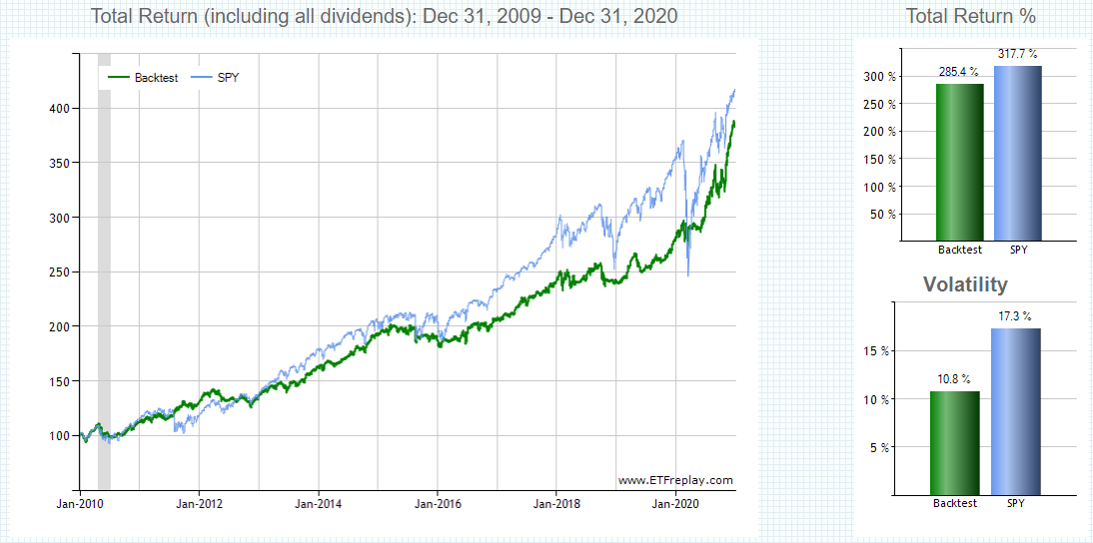
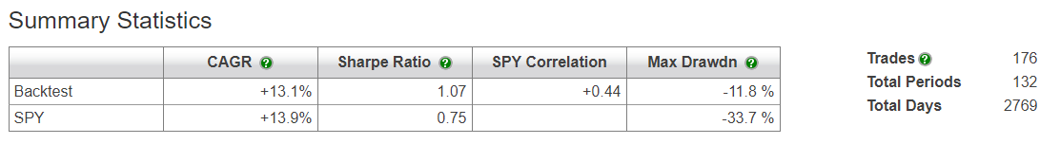
Last 5 Years
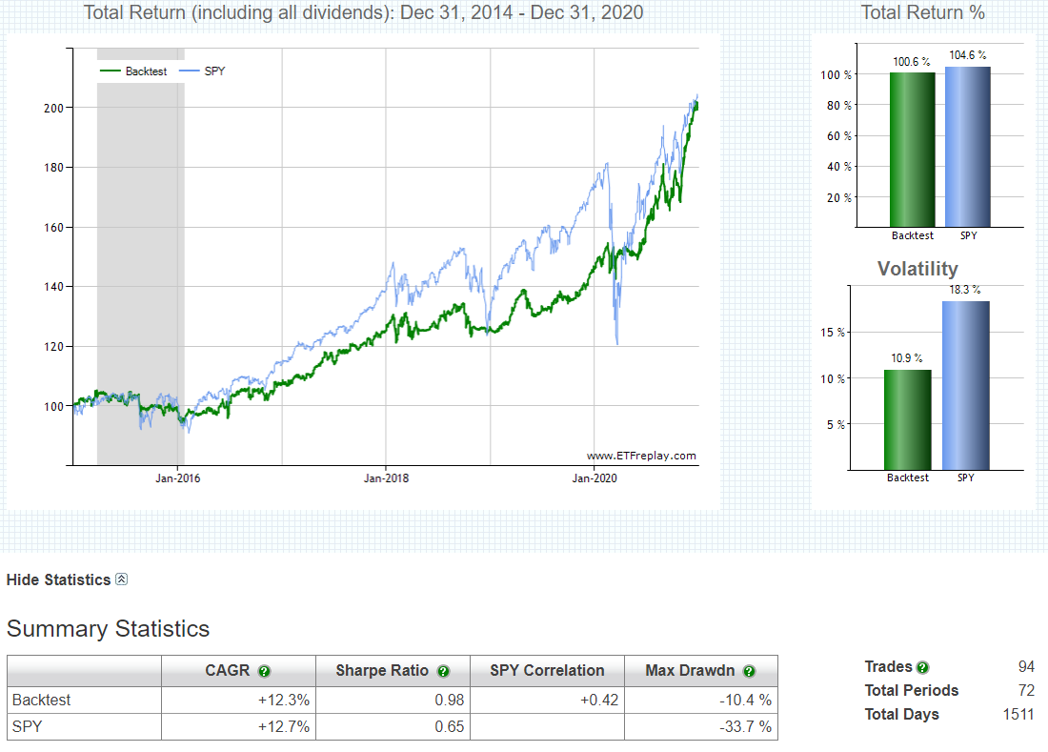

This is a strategy for someone who is more conservative, does not like to see large drawdowns in their account and doesn’t mind giving up some potential upside in order to have some downside protection.

Whale Rotation Strategy

The whale rotation strategy is fully allocated to Stocks at all times. The universe of stocks include all large cap stocks. The portfolio holds 4 stocks at a time and is rotated and/or rebalanced monthly. Since the allocation is concentrated to 4 stocks and there is no hedge - this portfolio strategy has the most volatility. If you can stomach volatility, then the returns can be amazing. You are going to be in high quality blue chip companies and those are the ones that will rebound the fastest.

Last 10 Years
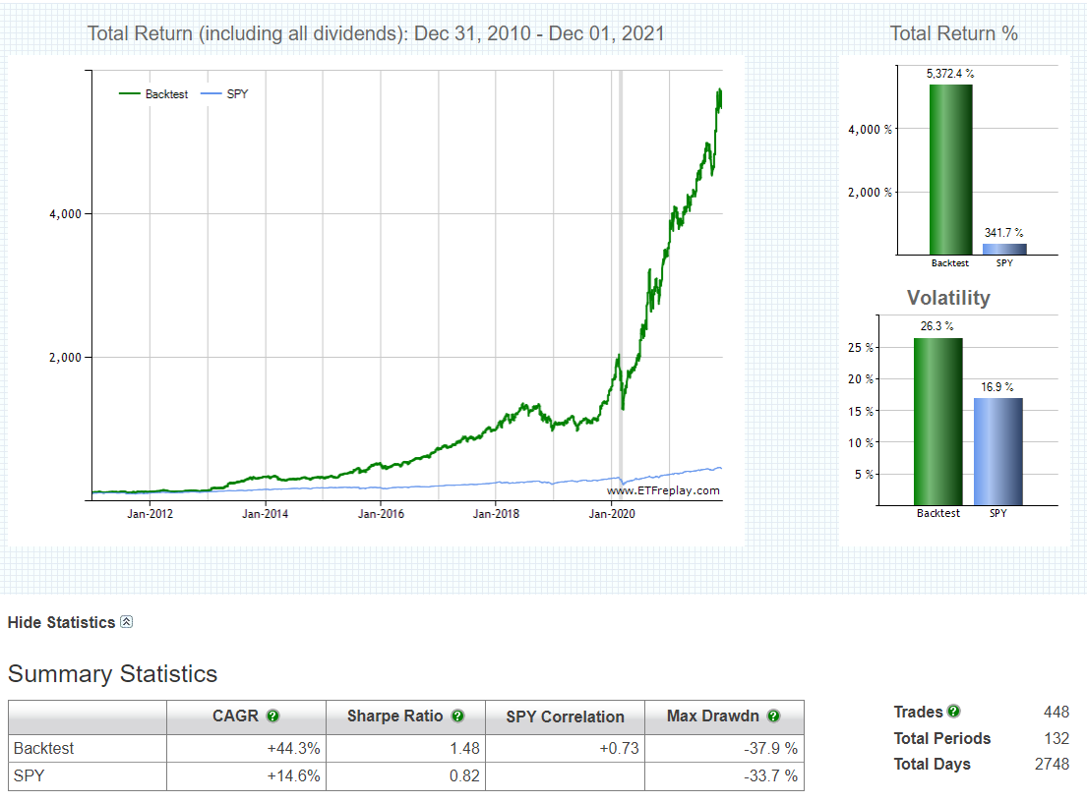
Last 5Years
