

this is the one that I like the best; however, not these colors and I would prefer the logo flipped-- with the head at the left side. I also like the font in the North Carolina logo, the Sleep Solutions part, not the North Carolina part

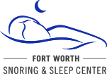

I also like this version except I would like it longer, like the United Sleep Apnea logo above with the moon maybe further to the right. The person can be gender neutral like this as our patients can be either male or female

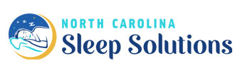
I also like the font in the North Carolina logo, the Sleep Solutions part, not the North Carolina part

