Below is a customized image of a butterfly with the body of a tobacco joint and antennas as smoke that forms a peace sign. Although one would assume the joint would be the attention grabber, most individuals don’t recognize the joint until they’ve thoroughly viewed it or when it’s brought to their attention. I’d like for the art piece to remain that way (inconspicuous, well blended and balanced).
My goal is to secure a t-shirt design that is focused on the creativity of the piece. I’d like for the design to be clean, tasteful, yet aesthetically pleasing. Regarding the image, the following would be expected:
- Re-create the dragonfly and butterfly “as it is” and add a background.

- The primary objective is to bring the image to life by adding color and background to a cool/creative image.
Smoke/Peace Symbol
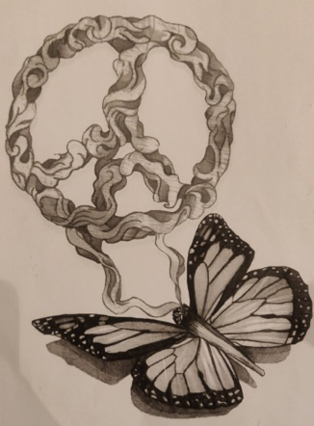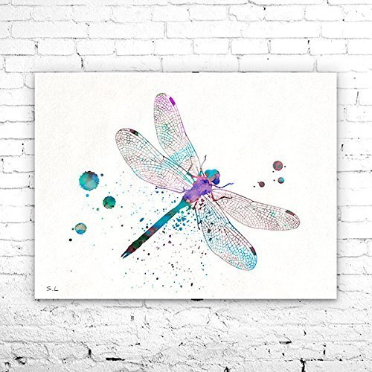
Joint
Wings
Below, I’ve provided a few notes to assist with any questions you may have.
Peace & Blessings,
Blue

Image: Please complete 2 versions (each insect can utilize the same background). 1) Butterfly w/ joint, wings, and smoke that forms a peace symbol. 2) Dragonfly w/ joint, wings, and smoke that forms a peace symbol.
Background: I’d like a “simple” background (i.e. splashes, dots, sunflowers, etc.) added to give the design life. Although I’ve provided examples of a background, you should not feel limited to them, as your creativity is valued. Therefore, you are even welcome to take a completely different direction. Regarding the background.
Text: Blew (Brand’s name)
Position of text: Anywhere at the bottom of the artwork. Not so bold/large that it takes away from the centerpiece. But, not so small that the brand is overlooked.
Font Type: I have it in mind for the font type to be slim/narrow text, for the purpose of maintaining a clean and simplistic look (ex. Blew, Blew, Blew). Please note, I’d also leave this to your knowledge and creativity.
Colors: 4 colors (3 preferrably) or less. Provided below are the first 5 sweaters of the collection. The color pallete of each design should at minimum match the first four sweater (Gary, Red, Green, and Cream). Example: One insect design could be placed on a green, cream, gray, or red sweater. Same design, different sweater.

Sweater examples for color pallete
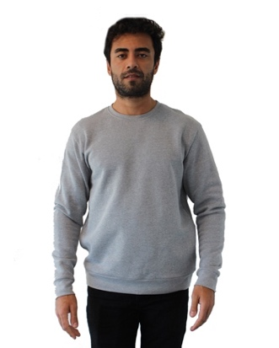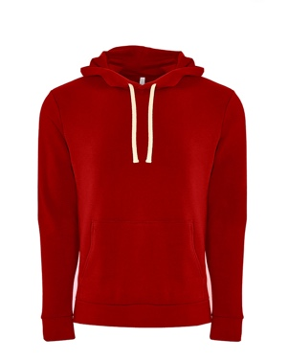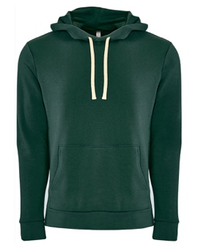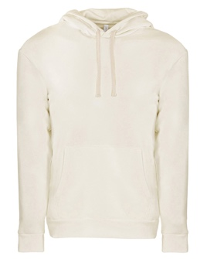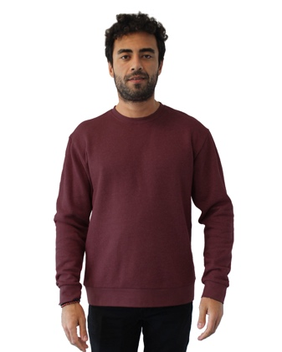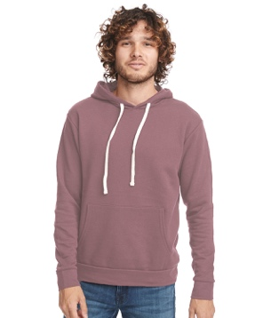

Vector Image Original (Hand drawn)
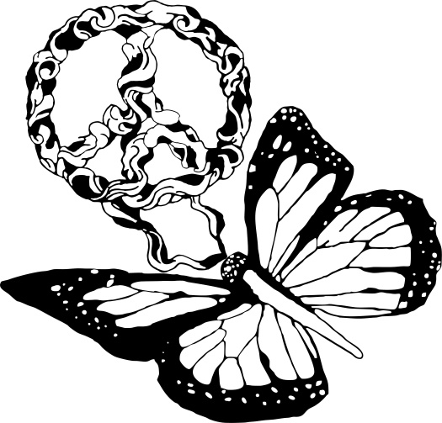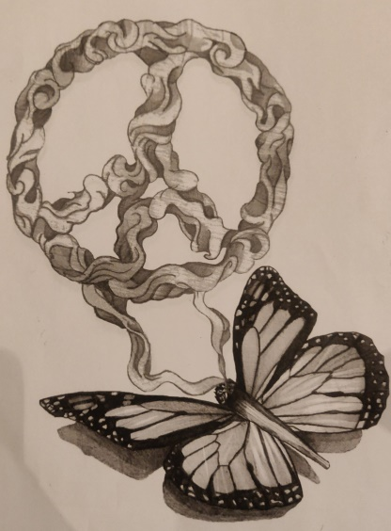
Smoke
Wings
Joint

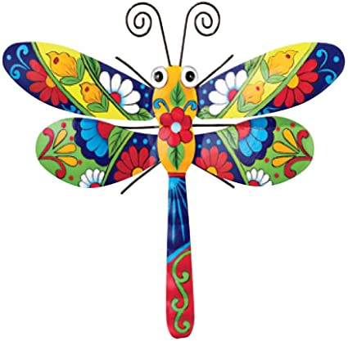
Joint
Smoke

Background Ideas (Disregard the insect. Examples are for the purpose of sparking ideas for background but are not limited to… All ideas/designs are welcome
