EDA Values
The 4b’s of EDA
Be Adventurous
We make things an adventure; we’re not afraid of the unknown or unchartered and we often take the leap of faith. Things that often seem scary are usually the start of amazing opportunities. We all make mistakes and that’s ok but it’s even more important is that we learn from them.
Be the brand
Immerse ourselves in our customers passions and we provide a service that helps our customers live their best life. We’re amazing in every interaction we have: with customers, colleagues and partners.
We live the brand daily and deliver exceptional outcomes in everything we do.
Be a winner
We’re religious in celebrating the wins. The little wins; the big wins; the change your life wins.
We overcome challenges, build trust and support relationships. We’re not afraid to ask for help and we’re there for our people, winning together
Be Passionate
We bring our whole selves to work allowing the best version of ourselves to shine in every interaction, everyday. We prioritise our community (our family) to build relationships, lean on each other and create an inclusive environment.
We also play together. Having a laugh with each other is the special sauce that allows us to go above and beyond every single day.

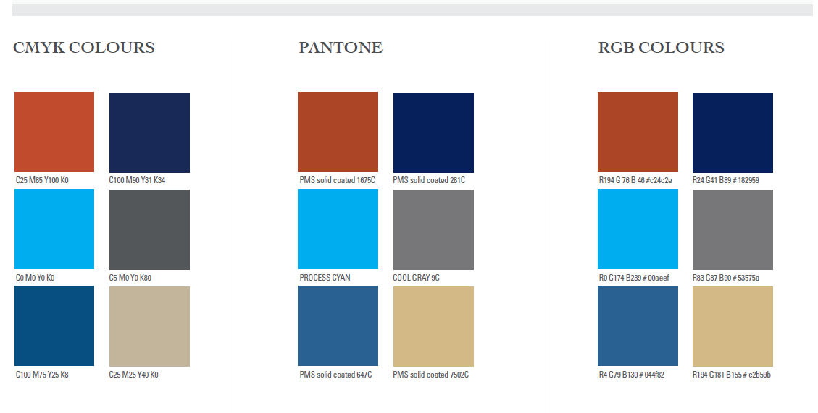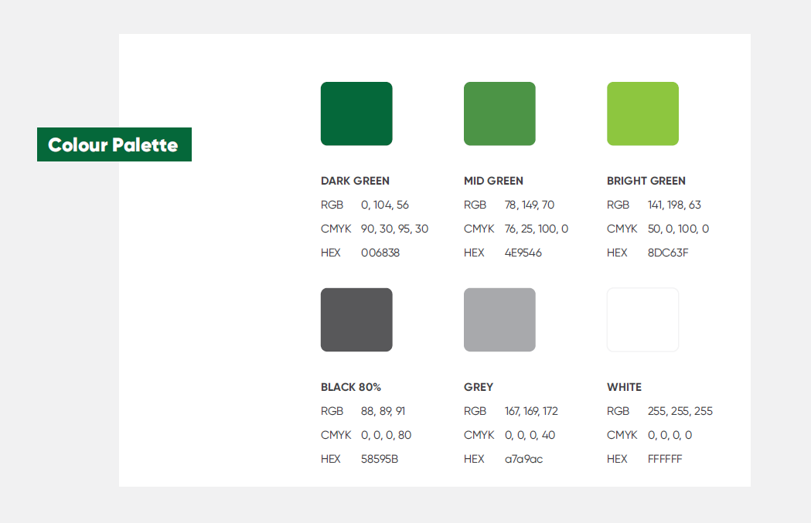


The Zappos Family Core Values (zapposinsights.com)

