


Today’s medical technicians are constantly pressured to maximize productivity and minimize unexpected downtimes. This requires easy access to technical product knowledge and fast expert support. However:
- Who do you contact in case of an unexpected device malfunction?
- What are the capabilities of the technician I call?
- Is there a lengthy lead-time before service is performed?

Certified diagnostic and repair services for your biomedical equipment

2921 Union Road, P.O. Box 1228, Paso Robles, California 93446 • (805) 238-7401 • Fax (805) 238-6541

From otoscopes to fluoroscopes, the expert technicians at Eagle Medical GSM diagnose, service, repair, and maintain the critical devices that your staff and patients rely on every single day. For the fastest response from the highest-skilled technicians, free pre-service evaluation, and your first 2 hours of service time FREE contact us at the number below.


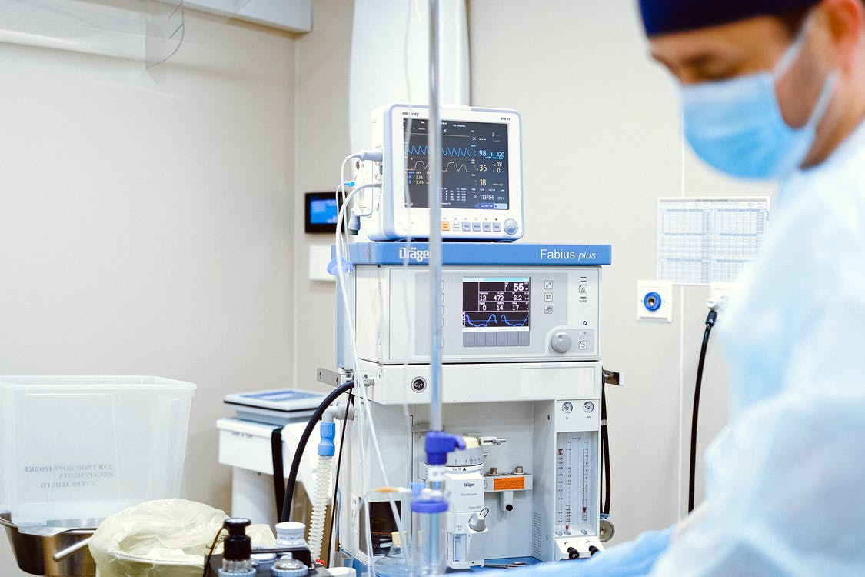

Eagle Medical GSM Rate sheet
Off-site
Scheduled

Planned service and/or recurring maintenance of equipment that can be shipped to our repair center

$160/hour

The most cost effective way to cover the annual maintenance and calibration requirements on your medical devices – avoid paying for travel time by boxing and shipping your devices to us.

On-site
Unscheduled
Emergency priority service -technicians typically on-premises within 24 hours

$225/hour*

Electronic device failure is one of the few certainties in life. We don’t know when mission critical devices will malfunction, but if we’re prepared and have a plan in place to address unscheduled device repair, positive outcomes result. Call us now for your free pre-service inspection so we are both prepared for your next emergency service.

Off-site
Unscheduled

Emergency priority service of equipment that can be shipped to our repair center

$175/hour

Anticipate the unexpected – put your plan in place now to address medical device failures. Whether you’re facing a shortage of hospital resources or a complicated repair that can’t be corrected in-house, we’ll prioritize your equipment for the shortest lead-time.

On-site
Scheduled
Planned service and/or recurring maintenance – technicians required on premises

$195/hour*

Following the proper maintenance schedule can help reduce catastrophic failures, increase the lifespan of your biomedical devices, and typically results in significant cost savings. Scheduling on-site maintenance and calibration in advance directly

Contract

The best hourly rates and response times are achieved with this model. Lock in coverage for all of the equipment you choose to include.

Call for quote

For hospitals that prefer maintenance cost certainty, Eagle Medical GSM offers a variety of customized service contracts. Entering into an annual service contract will save you money, includes higher priority response times, and results in budget certainty in a business unit with potentially dramatic fluctuations in service costs.

* Hourly rate includes travel within 200 miles of Eagle Medical HQ in Paso Robles
* Cost of replacement parts not included

