Simcoe
802 Selah Vista Way Selah, WA98942

$399,500

REF# 580619

1176 Square Feet.
2 Bedrooms-1.75 Baths
2 Car Garage
40x117
2021 Year Built
This flyer features a QR barcode! Scan with your mobile phone using a bar code scanner to access all lis1ing details.

•
•

Er <:>or
Simcoe Cottage BUYERS' AGENTS WELCOME! 3% COMMISION ML S#21-939 This energy efficient, sustainably built cottage design is the smallest model offered in Selah Vista Homes. Selah Vista Homes was developed with the belief that everyone deserves. to live in a healthy home and has received the ZERH award and Indoor Air Plus Award and are Solar ready. House indoor air quality is maintained with a whole house HEPA filter and non-toxic finishes.
Simple design with quality Built Green S Star standards

? us
overlooking the community green space with native

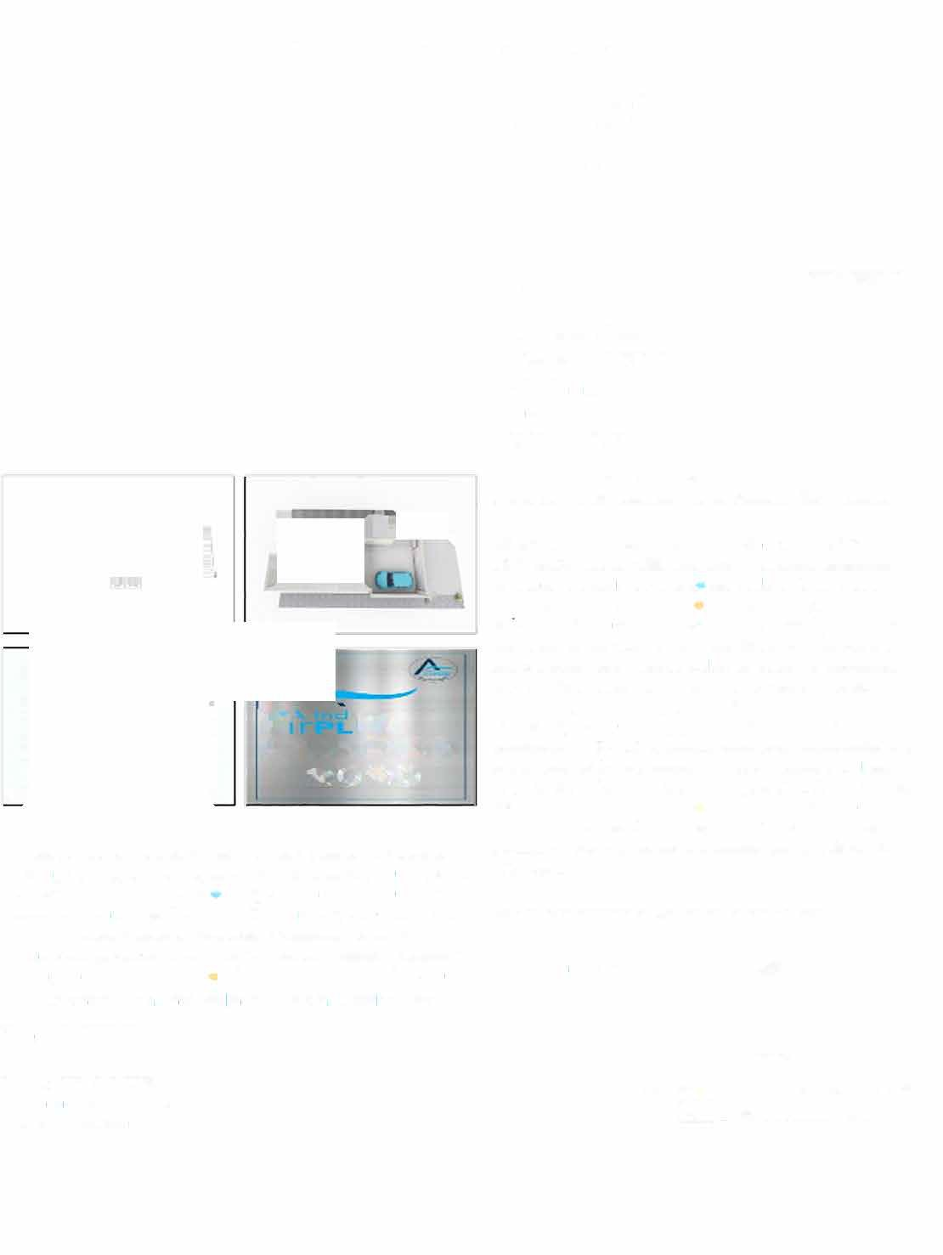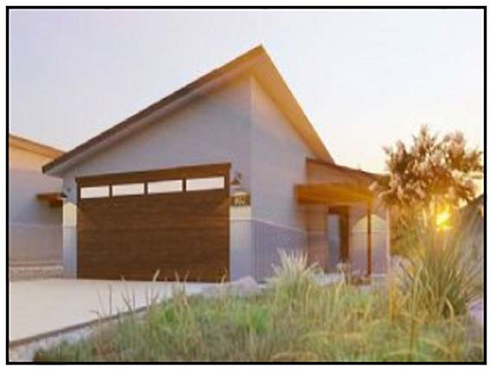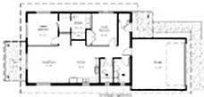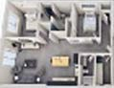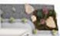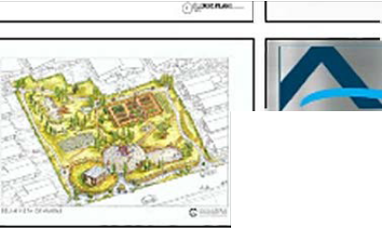LEADER
2020

Stove - Dogs Allowed - Pets Allowed - Central Air - Central Heating - Energy Efficient Systems - Close Distance from Schools
- Close Distance to Town/Sh opping - Within S Miles from Fitness Center- Within S Miles from Town/City/Shopping - Lot: Level - Lot: Private - Garage (Attached) - Attached Parking - Walking/Jogging/Bike/Hiking Trail - Agent Commission Available - Living Room - Laundry Room - Master suite - Main Floor
Bathroom - Main Floor Bedroom - Modern - Garden View
Steve Weise
Phone: {509) 949-5560
Alt. Phone: {509) 571-1351
MLS4owners.com
landscaping. HOA CCRs include landscape maintenance and snow removal for this model. High quality home in a great neighborhood Move-in ready by August 31, 2021COTTAGE For SALE BY BUILDER-Pre-approved buyers contact Steve (509)-571- 1351 opt 3

Builder is often on site. Call today to book a tour

... Read more at MLS4owners.com/580619

MLS4owners.com
All Information Deemed Accurate but not Warranted
C=) !QUAL HOUSINGOPPOl'tTUNrTY

