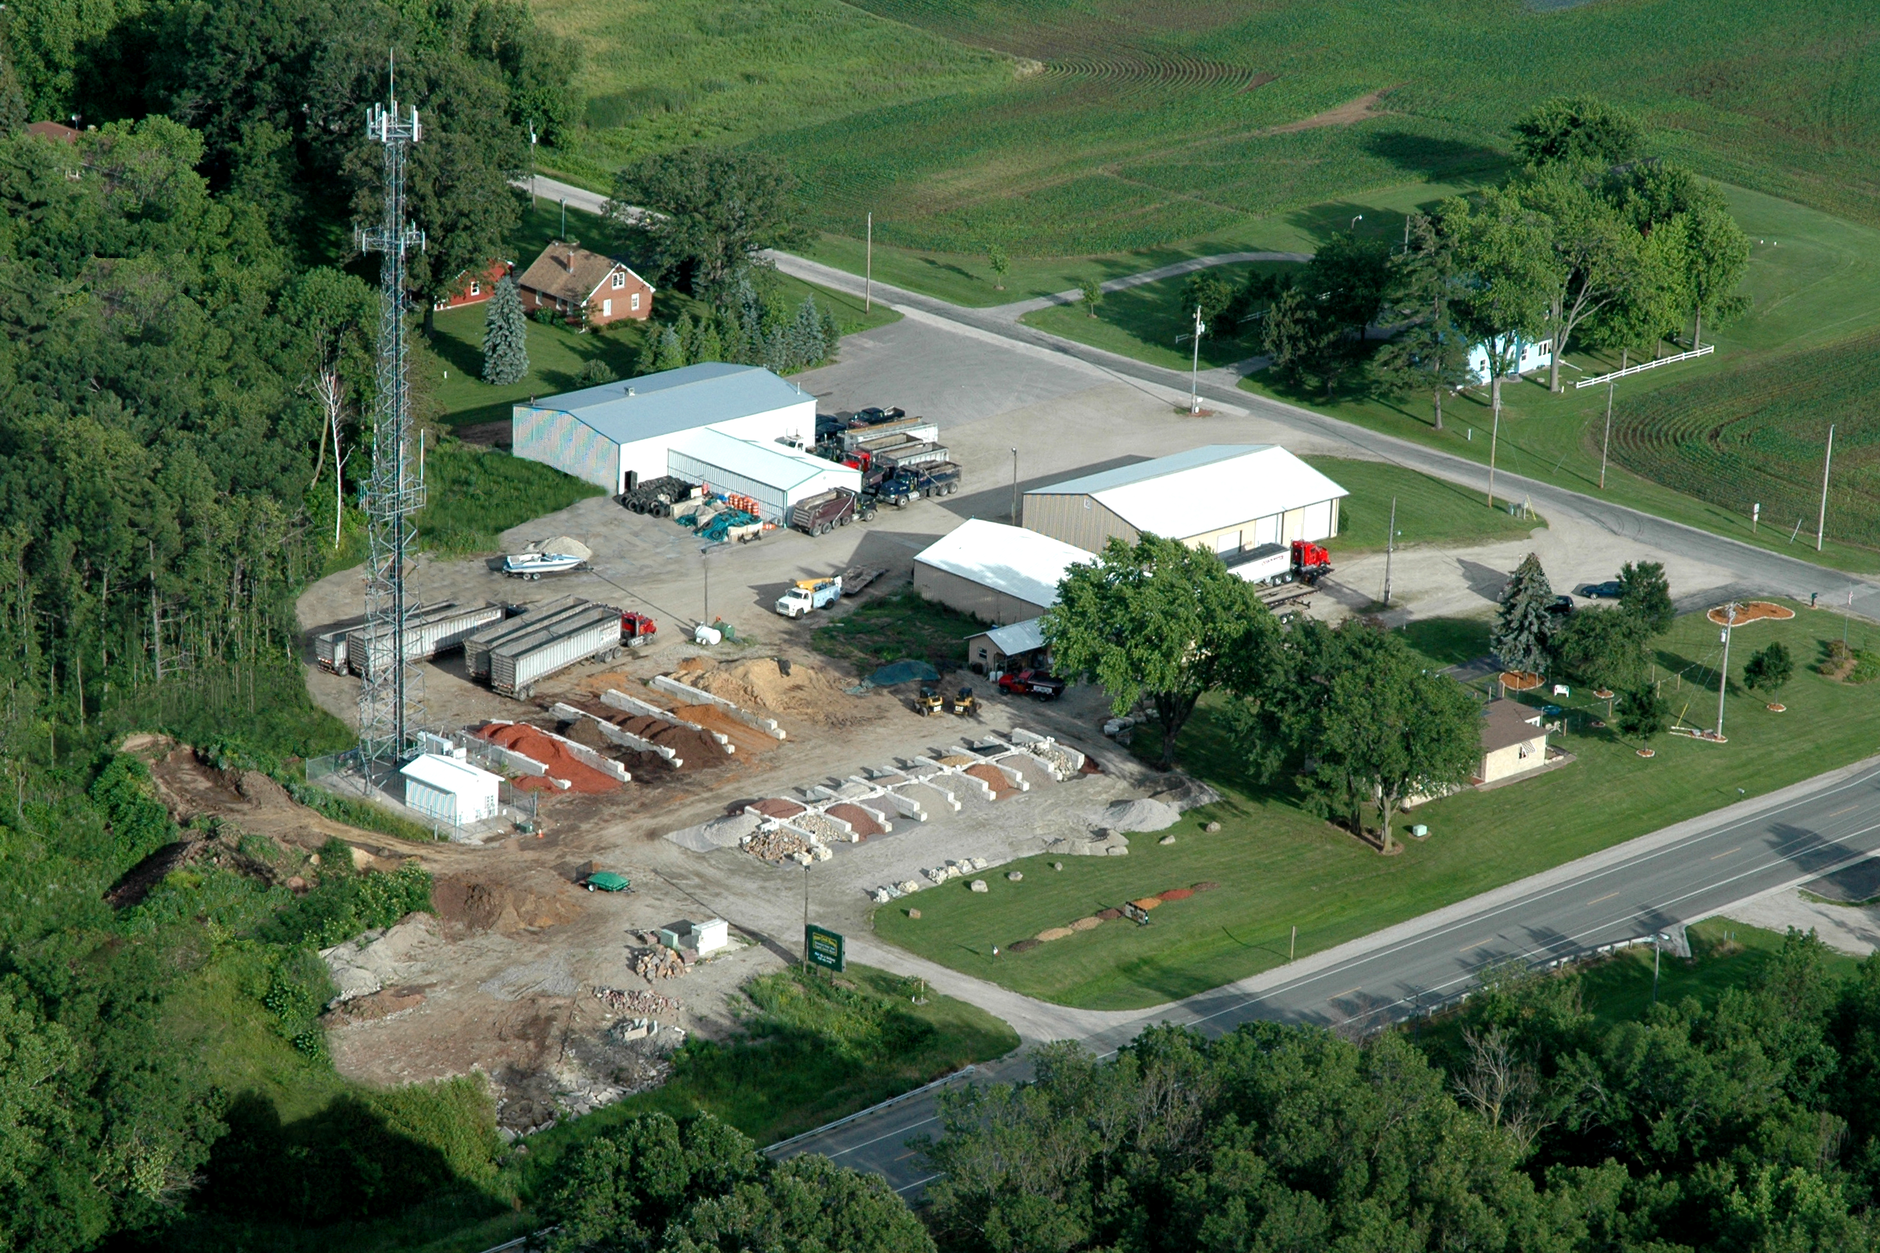  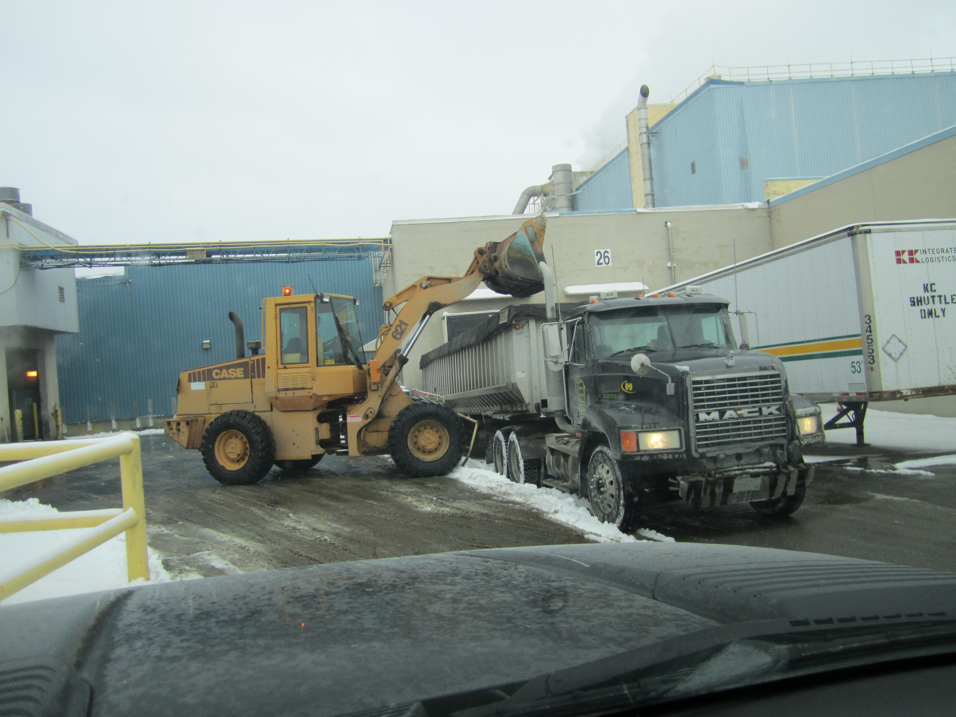  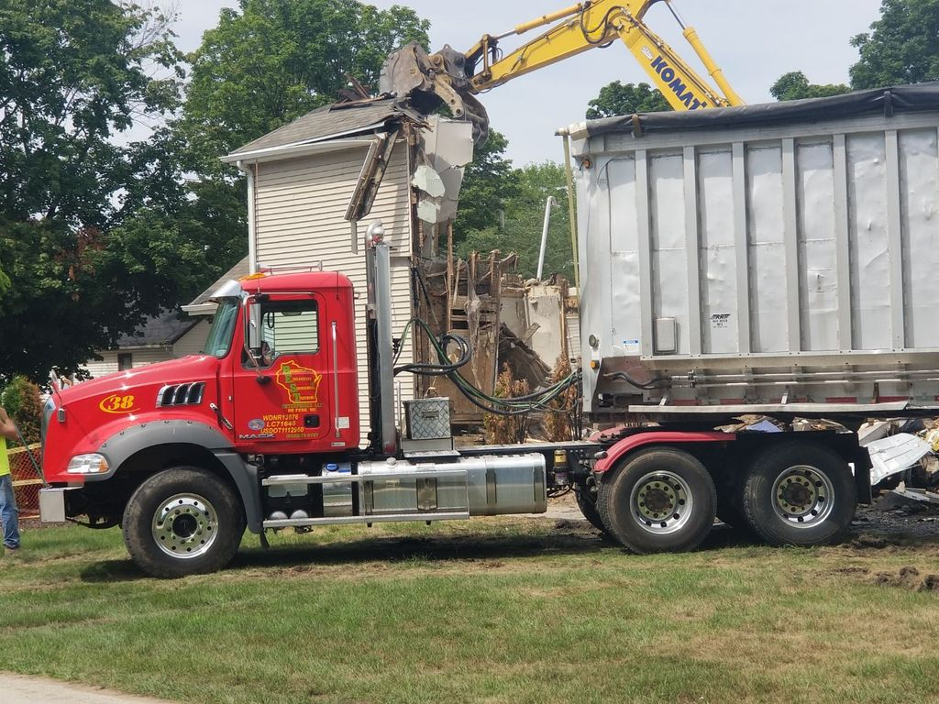  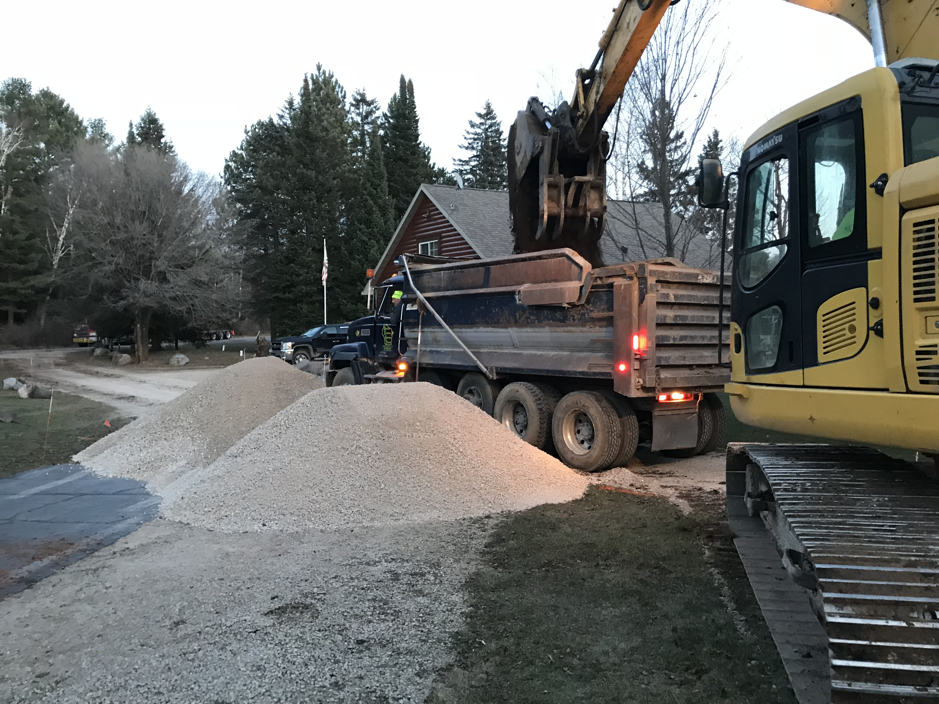
  Who We Are
  About Us
  Our company was founded in June of 1994 by Frank Calaway, in 2001 the company changed its name to BEST Enterprises, to better reflect the services we offer.
  Our services include Excavating, Trucking, Snow Plowing & Removal, Demolition, Septic Systems and Delivery of a vast array of materials.
  Contact Us
  Phone: 920-983-9787
  Email: Jesse@bestenterprisesllc.com
  Web: bestenterprisesllc.com
  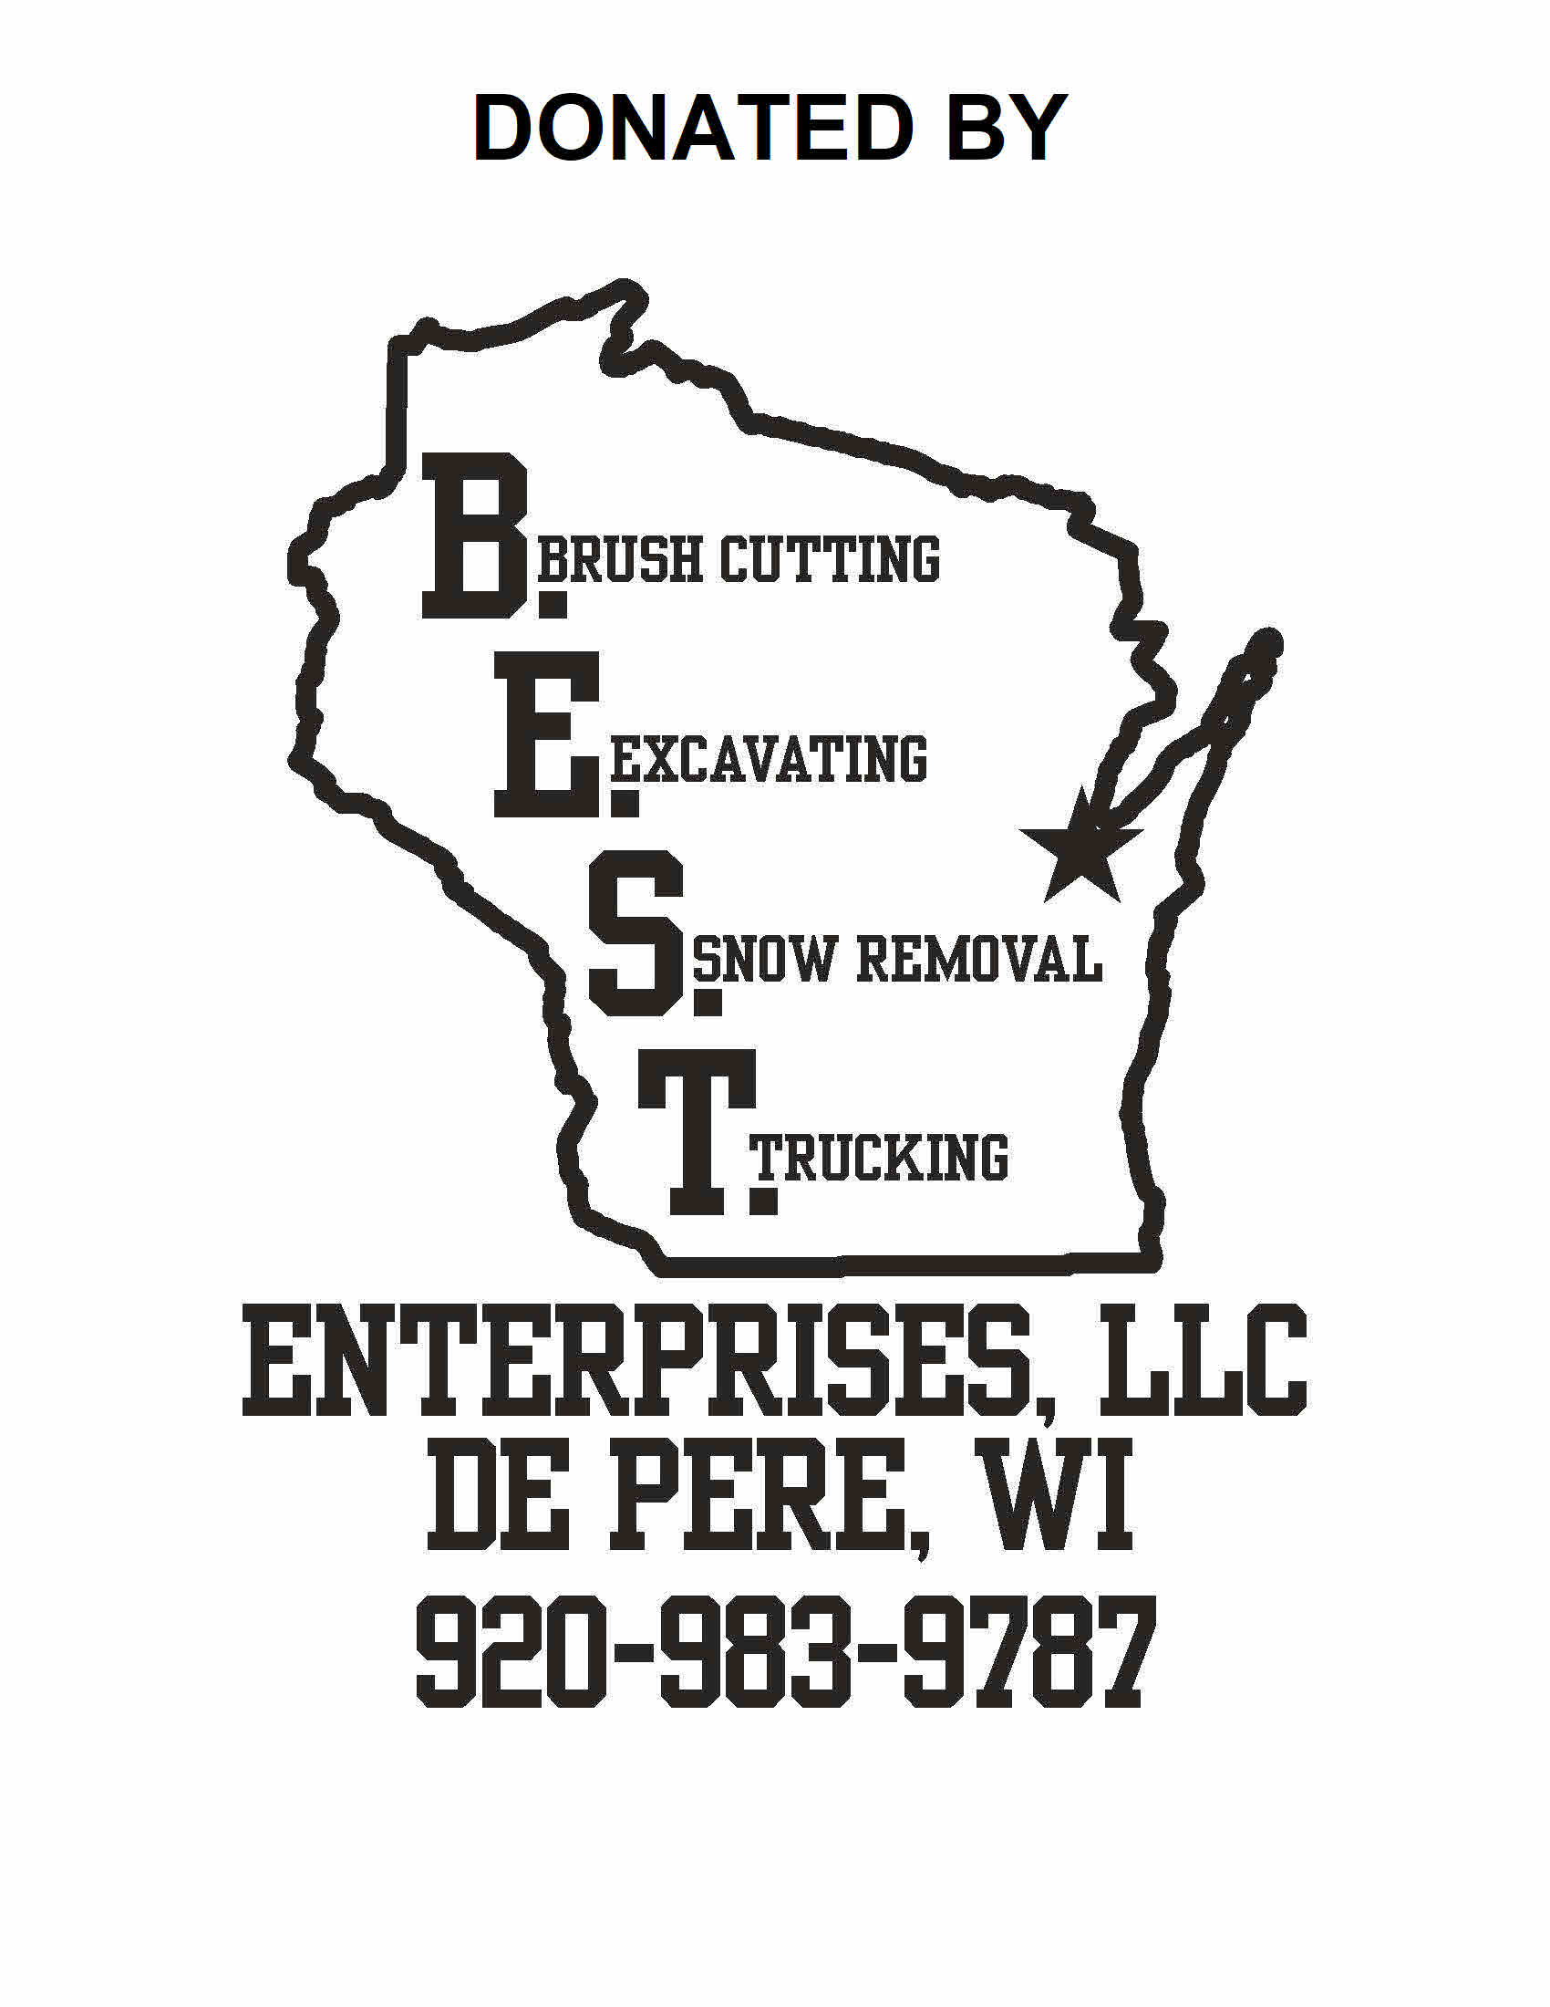 |  | BEST Enterprises, LLC  3230 Eiler Rd  De Pere, WI 54115
  BEST Enterprises, LLC

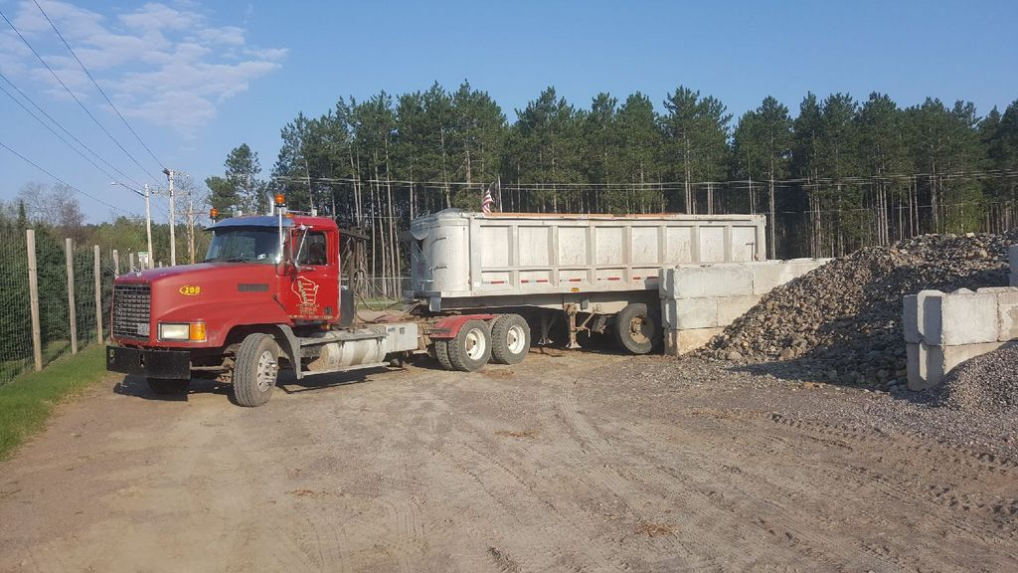  Trucking  With our wide variety of trucks and trailers, and our experienced drivers, we guarantee we have the equipment and know-how to expertly handle all of your hauling needs. Our Fleet includes Dump Trucks ranging from 5 yard to 30-yard boxes, Semi Dump Trailers, Refuse Belt Trailers capable of transporting up to 120 cubic yards, and Flatbed Trailers. We also offer Low Boy Hauling as well as Overweight and Over-width services. BEST Enterprises, LLC operates throughout Wisconsin - primarily in North Eastern Wisconsin from Marinette to Milwaukee.  Radius of Business: We primarily operate in North Eastern Wisconsin – from Brown County and adjoining counties. |  |  | Excavating  Our diverse fleet of excavating equipment and expert operators make BEST Enterprises, LLC your one-stop contactor with the tools and the know-how get any job done.  Excavation Services Offered  * Basements  * Parking Lots  * Site Preparation  * Driveways  * Mounds  * Septic Systems  * Ponds  * C-Soil Hauling  * Disaster Clean Ups  * Demolition  *Sanitary & Water Laterals  *Brush Clearing and Stump Grinding or Removal  * Material Delivery  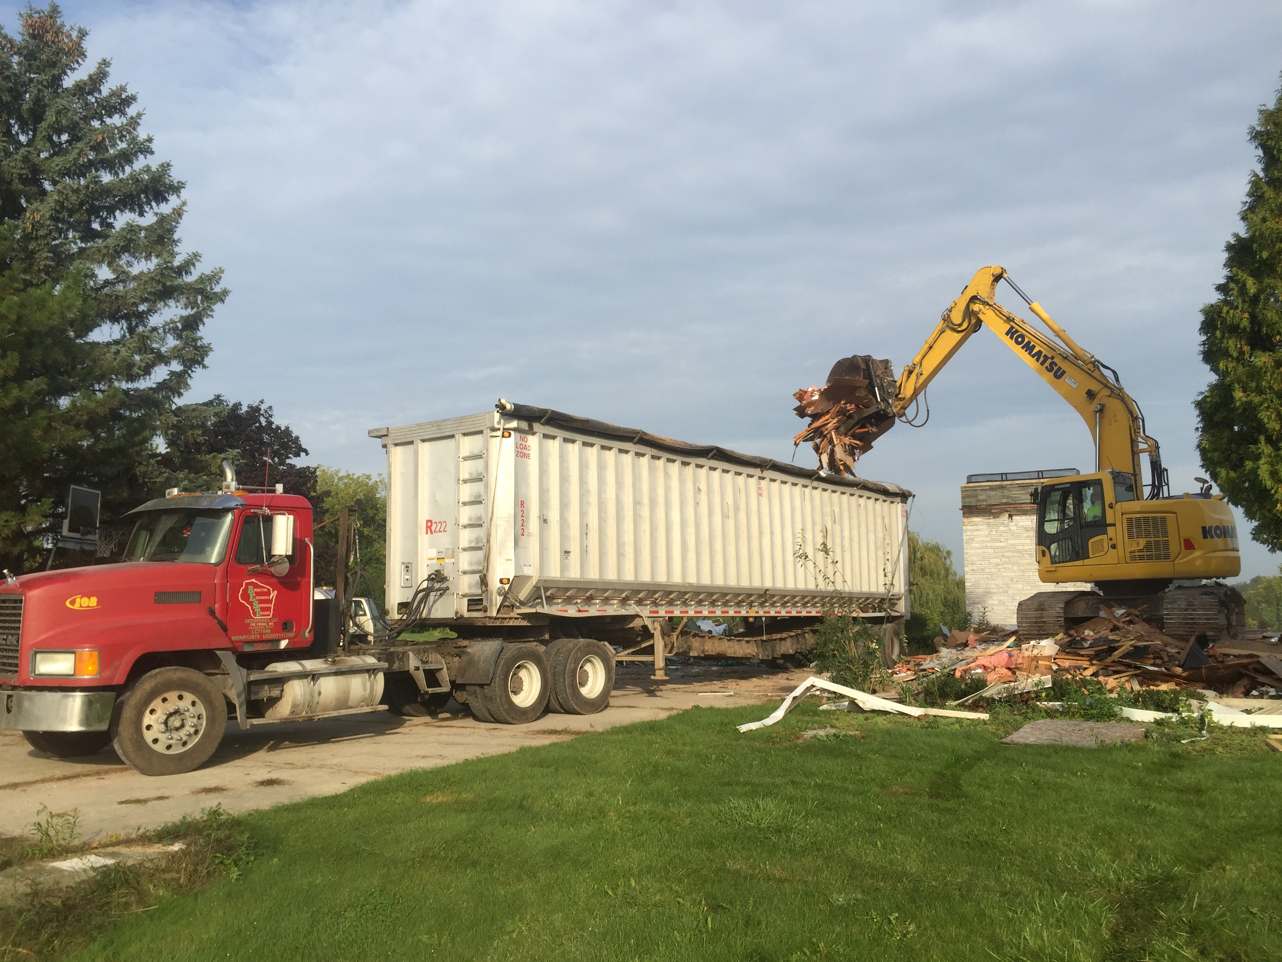 |  |  | 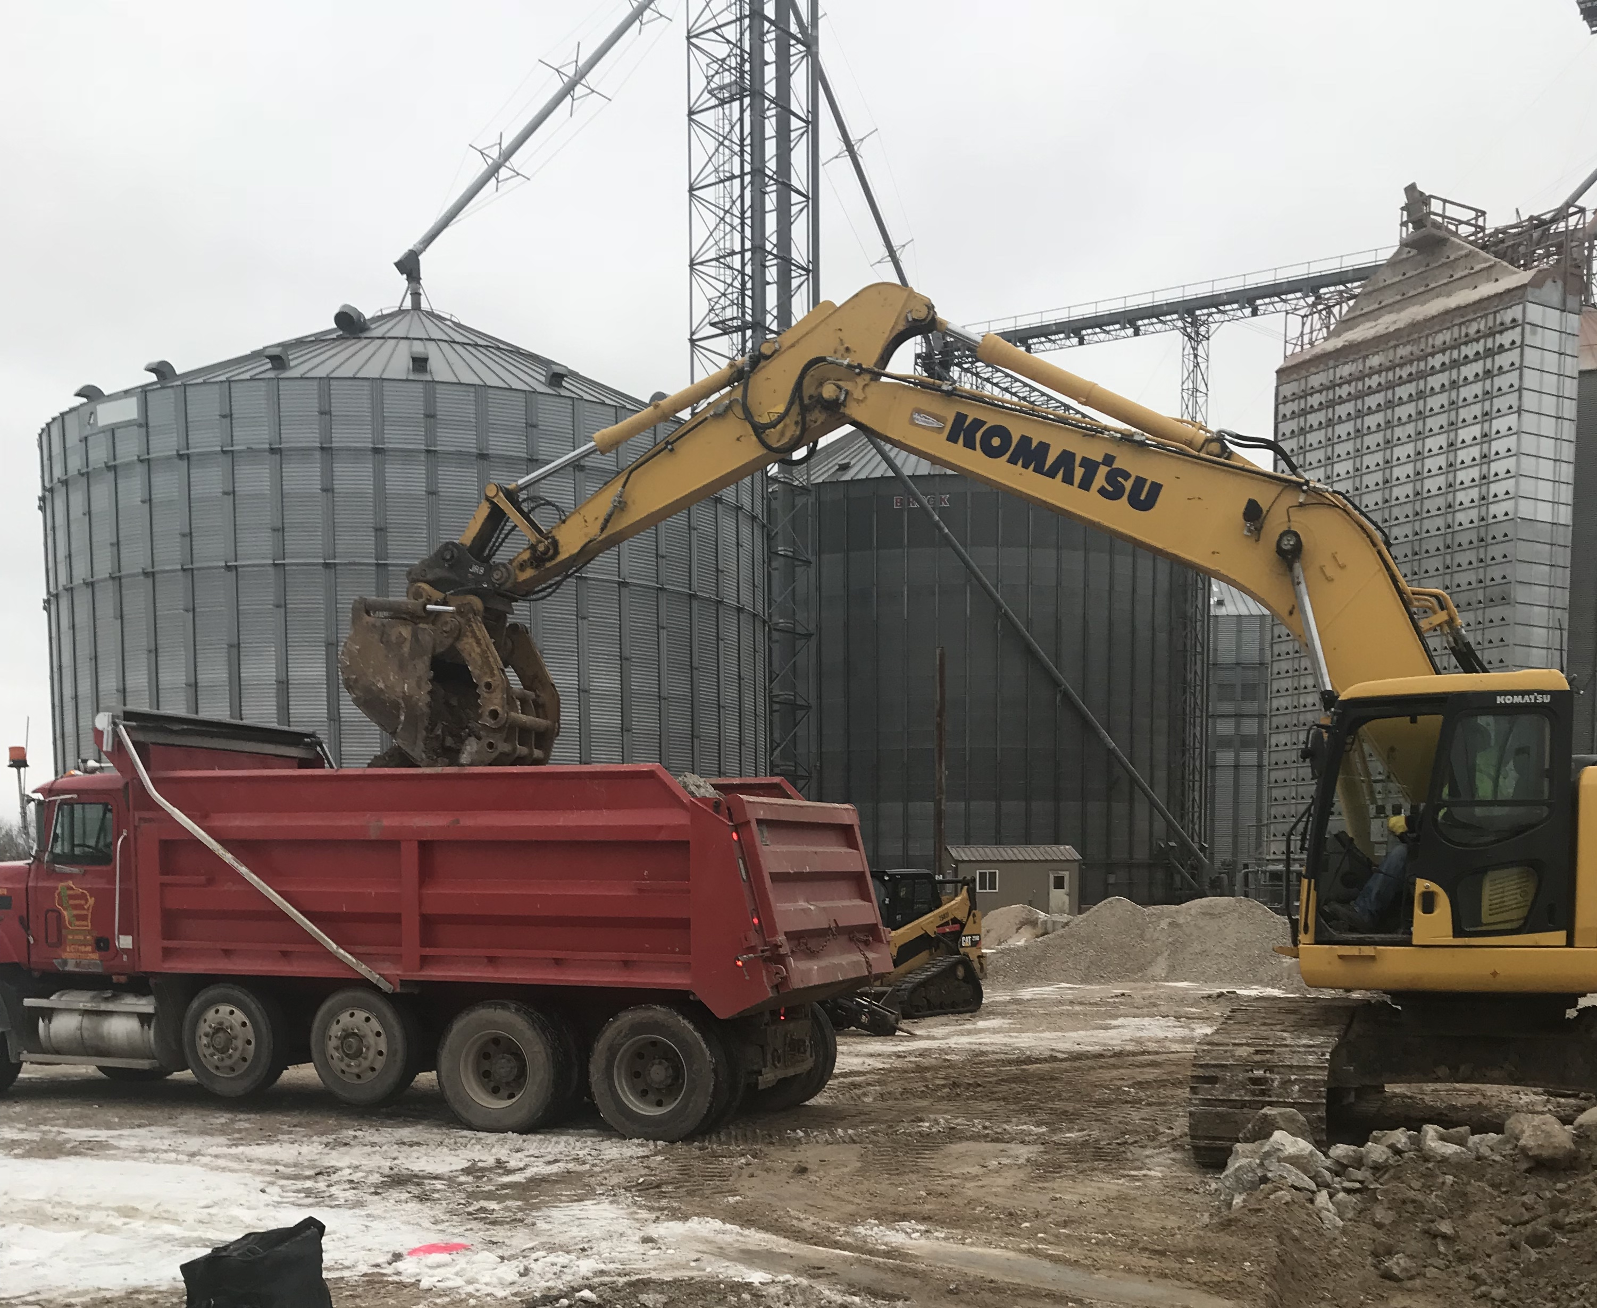  Other Services Offered  - Low Boy Services  - Brush Cutting  - Commercial Snow Plowing  - Product delivery  - Metal Dump Trailers  - Drive on Walking Floor Trailer used for disposal needs  - Disposal locations of concrete and other fill materials  - Variety of decorative stone, mulch and other landscape materials  - Erosion mat, silt fence and silt sock available  - Disposal outlets for C&D, Refuse and other products for disposal

