Introduction to the
George & Paula
Apartments

The George and Paula apartment buildings are a unique walk-up style building apartment building with a courtyard in between.
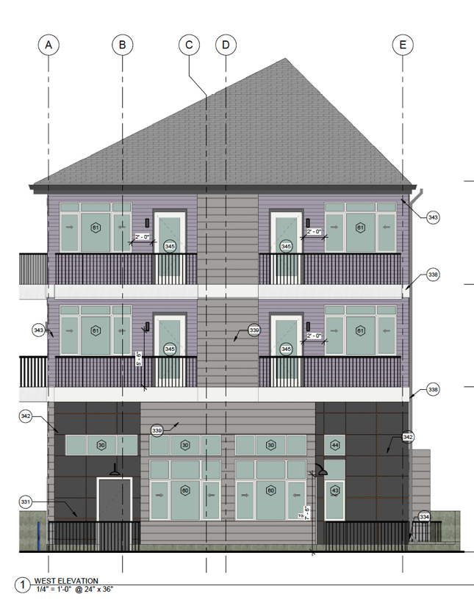
Paula
George
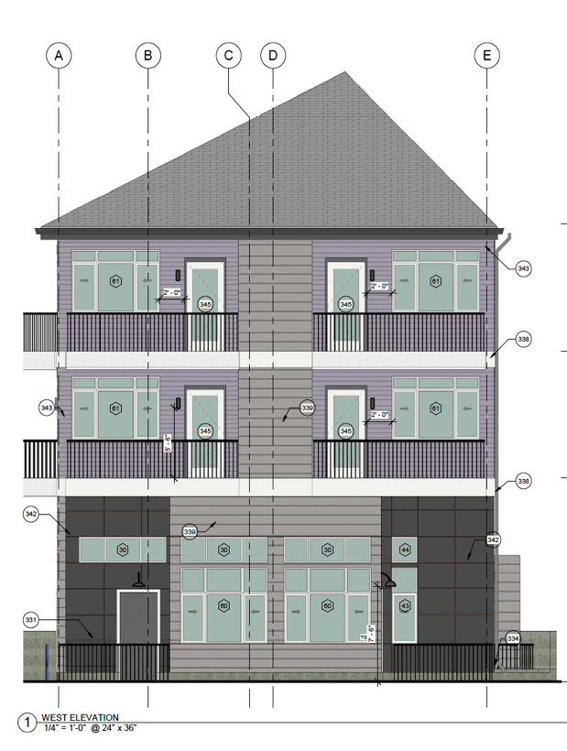

Each building consists of 7 studios and 11 1-bedrooms.

The 1st floor has exceptionally high 15ft ceilings with very large windows, providing residents with a unique living experience.

The building’s amenities are geared towards highly efficient and active residents. Some features include:
- Smart locks – unlock your unit from your smart phone!
- Smart lights – dimmable and controllable from your smart home.
- Fans in all units – both geared for hot and cold weather
- Quartz countertops in kitchens and bathrooms
- Custom cabinetry with soft-close cabinets
- Large triple door master closets so you can see 2/3rds of your closet at once!
- Each unit has a bike rack and ample closet space
- Bathrooms include shelving for additional storage

Charming
Since most walk-up apartments are located in older buildings, you can expect a level of vintage charm in the architecture of the building. Many of them have unique features that you won’t find in newer apartments, such as original crown molding and oversized bay windows.

Tightly-knit Community
As many walk-up apartments are in smaller buildings with anywhere from 4 to 40 apartment units, you can expect fewer tenants. If you’re lucky enough to find friendly tenants, you can quickly make connections with the other people living in your building. Alternatively, you can keep your business to yourself more easily if you value your privacy.

Exercise
With a walk-up apartment, getting daily exercise will become part of your regular routine. Even if you don’t have time to hit the gym, you will be getting a lot of cardio simply by walking up and down the stairs to your apartment.

