Oh So Clean Logo Design Brief

Business Information: Oh So Clean Peroxide is a website that sells food grade hydrogen peroxide in two different strengths, 12% and 35%. We plan to eventually expand to other products in the future such as a pre-diluted 3% version, but for now those two strengths of food grade hydrogen peroxide are the focus.

Product: Food grade hydrogen peroxide is an all natural cleaning solution that is free of certain stabilizers that are found in commercially available hydrogen peroxide, but should not be ingested. When diluted food grade hydrogen peroxide had many uses from being used in dental care products and processes, to in-home food preparation and storage, to food-related cleaning such as cutting board and countertop disinfection to refrigerator and dishwasher cleaning. There are even medical uses for diluted versions of food grade hydrogen peroxide that are unsupported by research but suggested by some supporters of alternative medical treatments.

Target Audience: It's hard to precisely define our target audience at this point since we have no data to go off of due to the tight lid Amazon keeps on customer data. I would start with our target market being anyone who is looking for alternative ways to clean and sterilize their home or to use as part of their dental hygiene process/products, or those looking to buy it in order to dilute and use for medical purposes. As we gather customer data through the website and CRM we can work to redefine the target audience for social media posting and advertising as well as in coming up with ad creative, and eventually YouTube video ads.

Competitors: The two largest competitors would be Amazon and Walmart for which I have included their product pages instead of their home pages due of course to the nature of their site versus a site like we are planning to build or most of the competitor sites listed below.

Bulk Peroxide - Here is the link to their shop with all the different products they sell. This is a link to their Facebook page. I didn’t find an Instagram page for them.

Lab Alley

Viva Doria - Here is a link to their Facebook page and here is a link to their Instagram tags which is all I could find when I searched for them.

Blubonic Industries

Brand Values: We aim to be a trusted supplier of natural and health conscience disinfectant for homes and small businesses alike.

Colors: Based on our brand values and what I want to psychologically communicate to the customers I chose the colors blue and green based off of the psychology of color in branding. However, I am open to suggestions especially the colors turquoise or purple.

Logo Style: I would like for the logo to look somewhat playful though like the first example below (Fit Organic), but I’m not sure if we should stick to something more simple/universal and “professional” looking like the second one, or the third one which feels like a blend of the first two. When I looked at types of logos I found that the combination mark and lettermark styles seem to be my preference.

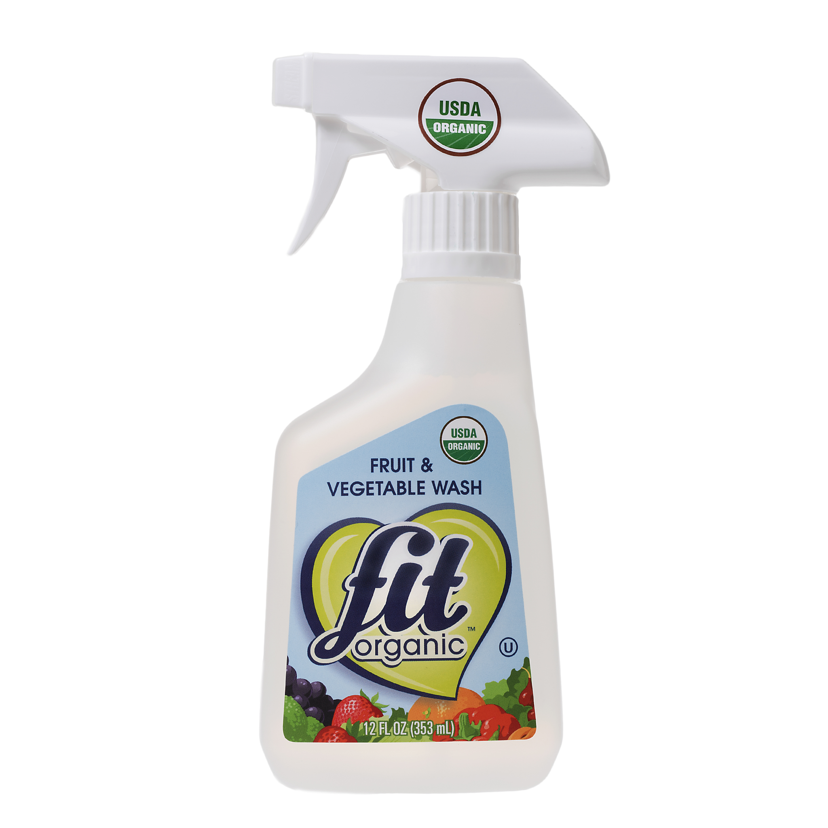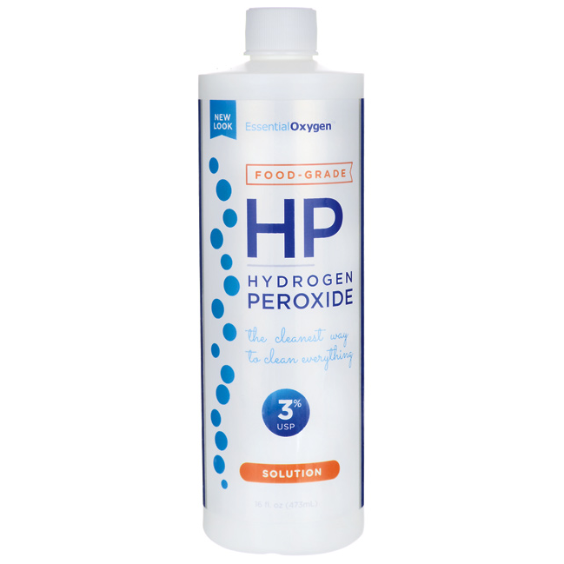

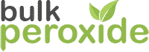

Timing: I would like to hopefully have the design in 3 weeks as I am trying to have the site up by the second week November at the latest but I know that this is a process so if it takes longer I understand.

Budget: I don’t have a specific budget but I would like to stay under or at $500.00 at most, although I am somewhat flexible. I’m not sure if you charge by the project or the hour, either way is fine with me.

