Information for the agency
Current situation:
The occasional or regular rental of rooms for events, meetings, practice rooms, etc. is not handled professionally today, in contrast to the rental of flats or similar. The interested party has to enquire about availability via e-mail dialogue or by telephone. This leads to dissatisfaction on the part of the interested party, often even to a cancellation of the booking. For the landlord, this results in great expense and fewer bookings.

Our offer:
LOOK&BOOK is a cloud service platform for handling instant bookings for short-term rentals of any kind of rooms directly from the landlord's website. An online calendar, an entire process incl. payment options are offered.

How Look&Book works
- Interested parties search for possible spaces via Google, advertising platforms, social media
- Interested parties visit your website and discover a suitable room offer.
- With one click, a calendar with all free times is displayed to him.
- If he wants to book for the first time, he has to register.
- He is guided step by step through the booking process. In the process, he also selects his specific room characteristics (e.g. beamer, catering).
- He books the room at the defined price.
- Payment is made immediately by credit card or by subsequent invoice.
- He will immediately receive a booking confirmation by e-mail.
- Tenant and landlord talk together offline about further details.
See our demo; click on special room and Look&Book starts: https://stephanbreitenmoser.wixsite.com/situation

Our customers are: Room rental
  - Event locations (private/business)
  - Meeting room providers (restaurants, companies with free meeting rooms)
  - Training room (music practice room)
  - Basically all with rooms that are rented out by the hour or by the day.
The clients usually have little budget and cannot change their home page.

Our requirements for the website
- WordPress
- Language version German (but the agency should do it in English - we will translate it then)
- https:// Lookandbook.live
- Type Clean Web-page
- Responsive
- SEO optimised
- Logo Font: Montserrat - For the text, feel free to do it as you like.

Number of pages
- Home Page (one-page)
- Contact form
- One page each for "General Terms and Conditions", "Data Protection".

Websites which we like
- https://sell.fruugo.com/en / https://sell.fruugo.com/en/why/
- https://mailchimp.com/de/

Images and logos




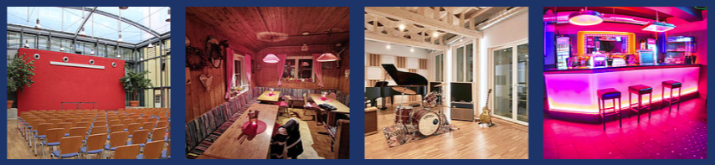
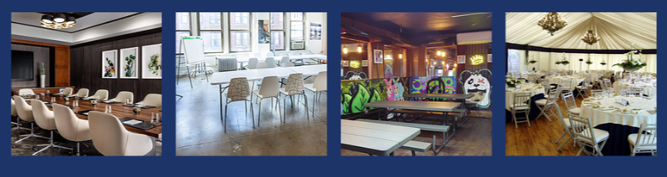

Website
We have created the texts in English for you as an agency. We will then translate these into German ourselves.
IMPORTANT: the texts in German are always longer than in English. Therefore, always provide more space!

Website "Home Page

Main Pitch /Explanation
More bookings for your rooms
Attract new tenants via your website - regardless of where you have placed your advertisements.

Promo message
Get more bookings now with Look&Book transcation platform. Ask for more information.

Conversion Button ( Contact form / 2nd page)
"Start now for free"

Login Button
Login

Possible Sub Pitch 1
Look&Book Live makes it happen

Possible Sub Pitch 2
Stress-free booking for interested parties.
Easy handling for your employees.

Possible Sub Pitch 3
Booking like on well-known booking platforms (e.g. AirBnB)

Possible Sub Pitch 4
With us you are in the best hands.

Possible Sub Pitch 5
Get Started For Free

Possible Sub Pitch 6
Made for Switzerland

Picture worlds (important to show for whom / which type of renters)
Show various Room-Types (not licensed Pictures yet)

Images Traffic Supliers (social media, advertising platforms)
Please show the relevant logos

What you have been waiting for?
Why | Justification
Connecting social media, your advertising partners, Google. | Direct prospects, regardless of where they come from, to your website and turn them into tenants.
Live calendar with all rooms | The tenant immediately recognises the availability of the room.
Book 24h/days a week | Booking option as is standard today.
Central booking system for your rooms | No more Excel, no more Outlook; access for all at all times and easy booking adjustments.
More bookings thanks to instant bookings | To make life easier for prospective tenants and at the same time motivate them to book immediately.
Room-specific prices | Comprehensive price calculation concept per room available.
No more unnecessary booking requests | Thanks to the live calendar, you will only be contacted if you have a specific booking.
No rental - no costs | Only fees for bookings from third parties (external customers). In addition, no minimum contract period.
No payment defaults | Connection of credit cards, Twint - Every booking is paid for.
More bookings = more consumption turnover | Look & Book is a turbo. With it, we also significantly increase the associated further sales.

What else you want to know about Look&Book
Do you have another question? Just give us a call

Frequently asked questions | Answer
Who is Look&Book suitable for? | Event halls; companies that rent out meeting rooms or work desks; public administrations; non-profit organisations; Co-Space landlords; anyone who wants to rent out a room by the hour.
Do I need software? | No. The booking software runs in the service platform (cloud). We ensure high system availability.
What does it cost? | Fee per booking, starting from CHF 10 excl. + any charges from payment providers. Ask for your specific offer.
Are there initial costs? | No. We also configure the system and the respective rooms for you.
What brings more bookings? | The number of rooms that can be found on the internet is constantly increasing! Experience shows that interested parties are won over when all the information (availability) is available. The interested party is always afraid that his room will be "snatched away" and wants to book immediately.
Which payment methods are supported? | We support card payment, Twint etc. and on account.
How does Look&Book work exactly? | 1. interested parties search for possible spaces via Google, advertising platforms, social media  2. interested parties visit your website and discover a suitable room offer.  3. with one click, a calendar with all free times is displayed to him.  4. if he wants to book for the first time he has to register.  He is guided step by step through the booking process. In the process, he also selects his specific room characteristics (e.g. beamer, catering).  6. he books the room at the defined price.  7. payment shall be made immediately by credit card or by subsequent invoice.  7. he/she will receive a booking confirmation by e-mail immediately.  8. tenant and landlord talk together offline about further details.
What about data security and data protection? | See our data protection information. Our cloud infrastructure is compliant with the DSGV. Our systems have an SLA of 99.9%. We monitor the operational readiness of Look&Book live.
Adaptations necessary on the website? | Minimal - all it needs is a web link to the Look&Book calendar.
How much do bookings from your own organisation cost? | Internal bookings are always free of charge.
Is a minimum number of rooms necessary? | No.
How can you reach us? | Via email: Kontakt@lookandbook.live and via WhatsApp

Quote of client
Look&Book brings us significantly more rentals.
This has had a very positive impact on additional consumption turnover.
Peter Meier, ABC Company

Our mission at Look&Book
Our team was frustrated when we were looking for a tool for room bookings for our non-profit association and did not find anything suitable. We were convinced that we were "losing" a lot of potential volunteers with our mail process and volunteers who were hard to reach by phone. At the same time, our association had no budget for website customisation. We therefore developed Look&Book - focused on the short-term rental of rooms.

Our steps at Look&Book
We started promoting Look&Book at the beginning of November 2021. Many valuable features are already included in our service platform and more are being added all the time.
First customers are connected. To gain your trust, we offer you a special offer.

Footer
© 2021 M2S Expert GmbH Imprint (link) terms of use | Privacy Policy

2nd web page "Contact form

Main Pitch /Explanation
Are you ready?
Use Look&Book to take bookings online 24h/day.
- Show booking calendar per room
- Enable instant bookings
- State-of-the-Art Booking

Sub-Pitch / Offer
Take advantage of our offer now! Test 1 room for 2 months free of charge.

Sub-pitch
You are in good company.

Form
Contact name
Phone
E-mail address
Website URL
Comment

( ) I don't want to receive promotional emails from Look&Book.
( ) reCAPTCHA

Alternative - Contact us with Whatsapp

Your contact / Imprint

M2S Expert GmbH
Bahnhofstrasse 7
CH 6102 Malters
Tel.: 079 400 00 00
E-Mail: kontakt@lookandbook.liveUID: CHE-184.050.518

