Design Brief - Mrs O’Connell’s

What do are we looking for?

We are after a logo/label for Mrs O’Connell’s. We’ve chosen to name our honey business after the O’Connell River in North Queensland where most of our apiaries are located on.

We would like the logo to have a sketch of a river or an (old) lady in it that creates a bit of a vintage look. Up to you, because we can’t seem to make our mind up. The honey will mainly be for sale locally, but we’re aiming for a professional look. Our buyers should feel they purchased a good-looking homemade/farm fresh product.

The label will be on three different sized plastic containers that might require different shaped labels. All containers are see-through and come with yellow lids. The 500g bottle will fit a little circle on the front and back. The 1kg jar and 3kg bucket, however, could fit an all-in-one label that folds round the container. The three labels need different weights and nutrition panels stated on them. You can find these in the table below.

Inspiration
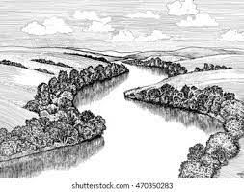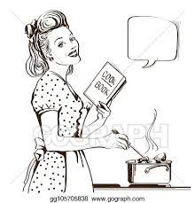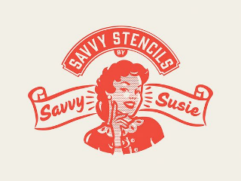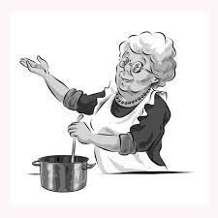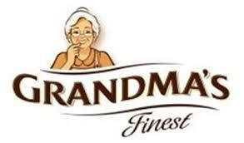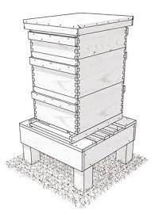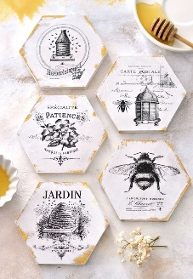
What needs to be on the label?

Front/centre label:
- Name of product: Mrs O’Connell’s Raw Honey
- Drawing to fit the logo
- Weight: 500g, 1kg or 3kg

Besides our brand and product name we also need to have the following information on the back/side label:
- Blurb: Mrs O’Connell’s bees live and work around the O’Connell River that flows through the beautiful Mackay-Whitsunday region.
- Ingredients: 100% Pure Honey
- Nutrition information panel (see table below)
- Batch number space
- Supplier information:
Mrs O’Connell’s
7733 Bruce Highway, Bloomsbury QLD 4799
mrsoconnellshoney@gmail.com
- Find us on Facebook with/or only FB Logo
- Space for a barcode
- Product of Australia logo, choice of two:
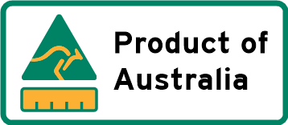

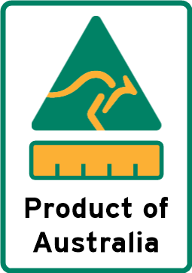

We are not too fussed in which order all info appears on your design. Even if it fits your design better to have certain information on the front or back label, different to stated above, that’s totally fine.
Weight and Nutrition Information Panel per container
500G | 1KG | 3KG
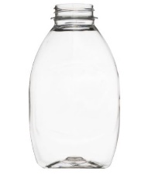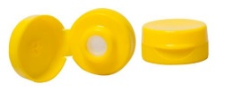 | 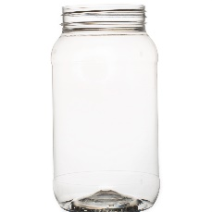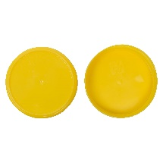 | 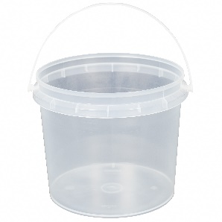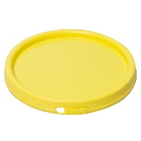
  NUTRITION INFORMATION
  Servings per package: | 25
  Serving size: | 20 | g
   | Average  Quantity per  Serving |  | Average  Quantity per  100 g
  Energy | 280 | kJ | 1400 | kJ
  Protein | 0 | g | 0.2 | g
  Fat, total | 0 | g | 0 | g
  - saturated | 0 | g | 0 | g
  Carbohydrate | 16.4 | g | 82.1 | g
  - sugars | 16.4 | g | 82.1 | g
  Sodium | 3 | mg | 14 | mg
  NUTRITION INFORMATION
  Servings per package: | 50
  Serving size: | 20 | g
   | Average  Quantity per  Serving |  | Average  Quantity per  100 g
  Energy | 280 | kJ | 1400 | kJ
  Protein | 0 | g | 0.2 | g
  Fat, total | 0 | g | 0 | g
  - saturated | 0 | g | 0 | g
  Carbohydrate | 16.4 | g | 82.1 | g
  - sugars | 16.4 | g | 82.1 | g
  Sodium | 3 | mg | 14 | mg
  NUTRITION INFORMATION
  Servings per package: | 150
  Serving size: | 20 | g
   | Average  Quantity per  Serving |  | Average  Quantity per  100 g
  Energy | 280 | kJ | 1400 | kJ
  Protein | 0 | g | 0.2 | g
  Fat, total | 0 | g | 0 | g
  - saturated | 0 | g | 0 | g
  Carbohydrate | 16.4 | g | 82.1 | g
  - sugars | 16.4 | g | 82.1 | g
  Sodium | 3 | mg | 14 | mg

