My Company’s Details

Industry: Financial and wealth planning
Describe your services: Fee-only firm providing modern-day financial planning, equity compensation guidance and investment management services. I will help simplify their entire financial picture so that they can focus on their careers and enjoying their life.
Target audience: Household income of $250K+ with roles like SVP, VP, Director, Or Critical Staff of startup technology companies. They have substantial equity compensation (i.e., stock option) considerations. Demographic: Males/Females 30 – 40 years old
Customer lifestyles: Busy start up employees that don’t have time to navigate the complex world of stock options and wealth planning
Industry competitors: Direct competition is likely limited to other small, independent financial planning firms
Why did I start the business: To be able to deliver value directly to clients that need it most. A client’s equity compensation generally represents a major portion of their wealth, so determining when to sell, maximize value and reduce risk is particularly important. There are not many financial advisors or firms that provide comprehensive and unbiased equity award guidance. Some other firms offer these services, but not usually with advisor you can work with over time.

Company Values
When explaining your brand values it might help to think of different value spectrums. Designers can render these values visually with design elements.
X marks where on the spectrum my company’s values lie
vintage
modern

sophisticated
fun

mature
young

abstract
Literal

Company Name

Provide your company name: Simplify Wealth Planning
What case do you want the letters in: Uppercase and Lowercase
Are there spaces between words: Yes
Does it matter if everything appears on one line or multiple lines: Would like to see multiple options. One line and stacked options.

Logo Style

Lean into a Lettermark logo but would like to see options of pictorial mark/wordmark versions.
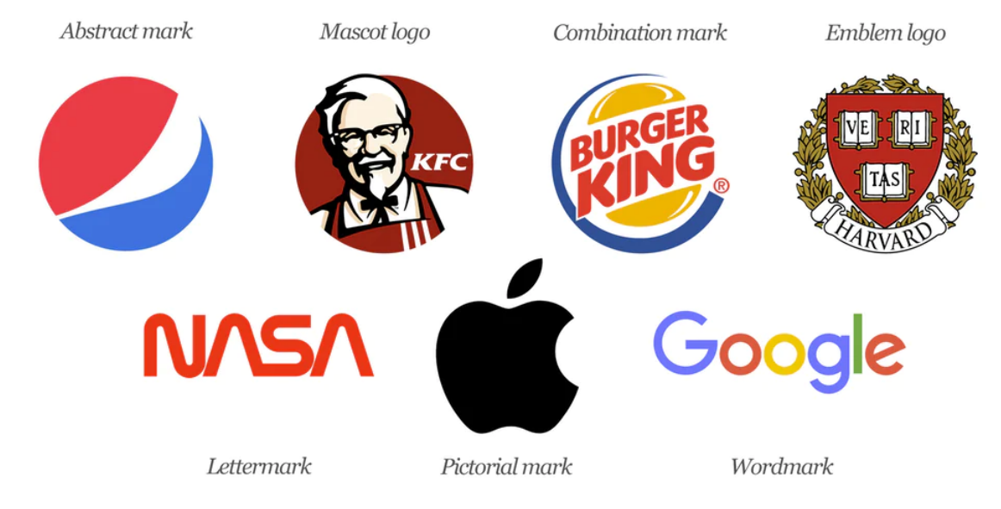

Design style

Modern and subtle design style (see table below in green)
Modern | Modern designs often feature clean lines and are quite lean
Classic | If you want something more retro, think classic design
Minimal | Often seen with legal firms, these logos contain the bare minimum of design and rely on their name
Complex | Creative companies or event companies can express their art with a complex design
Serious | Funeral homes want to portray a calm and serious business to mourning clients
Playful | Businesses aimed at children will want to choose a fun, carefree concept
Loud | Get in peoples’ faces and grab their attention with a lively logo
Subtle | Depending on your need, you may want a quieter, softer approach to your logo

Colors
Develop logos with darker PMS colors that will POP on a white background. Stick to colors that are more saturated like PMS 282, PMS 287, PMS 430 or Black

Font
Focus on San Serif fonts (younger demos prefer this). The clean lines and simplicity of sans serif fonts tend to complement the modern design aesthetics

