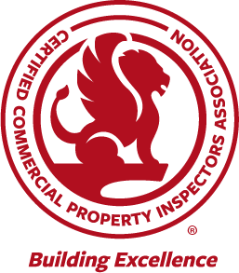
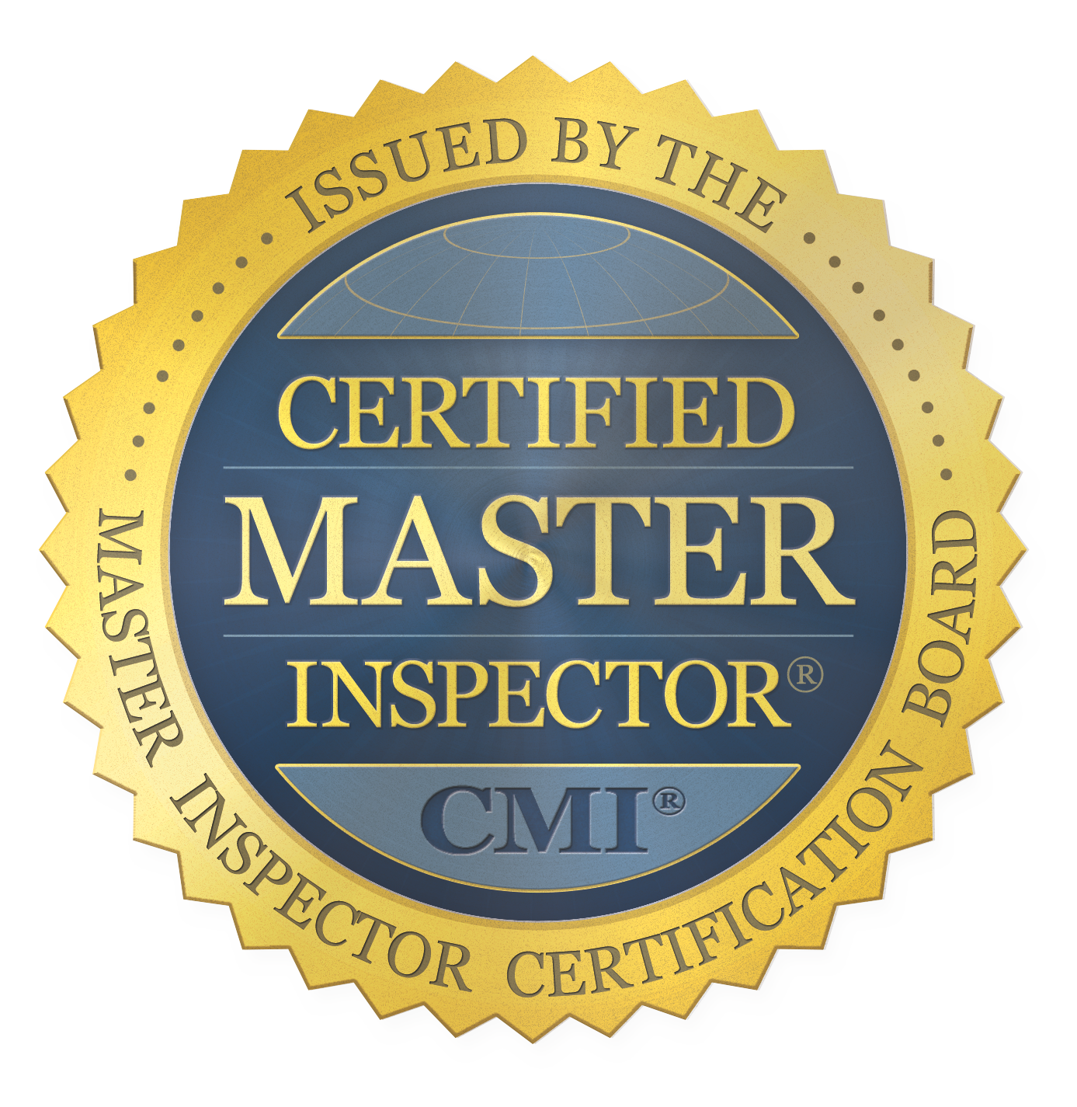
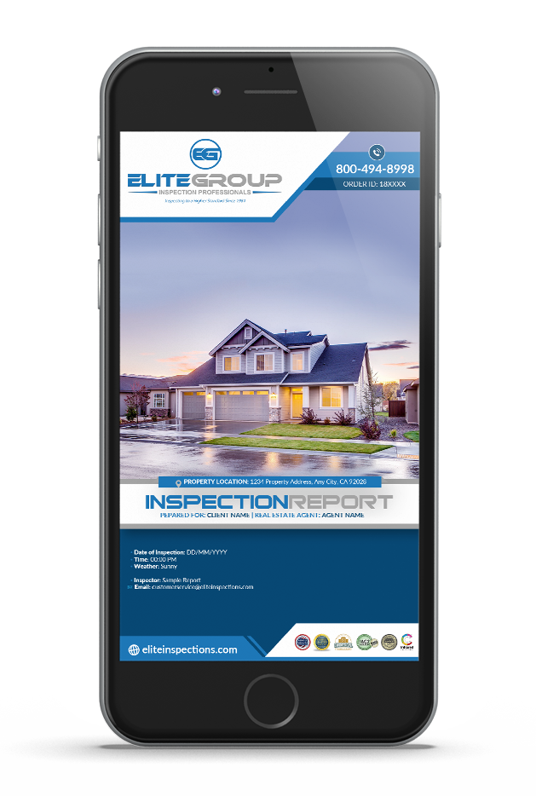
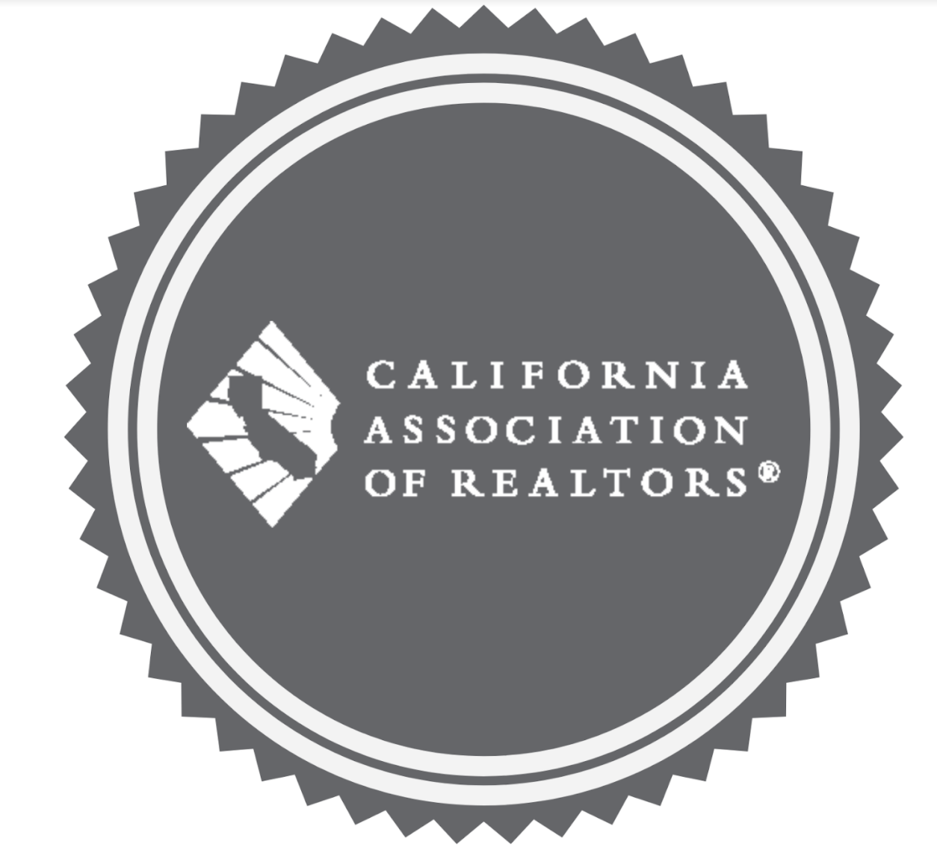
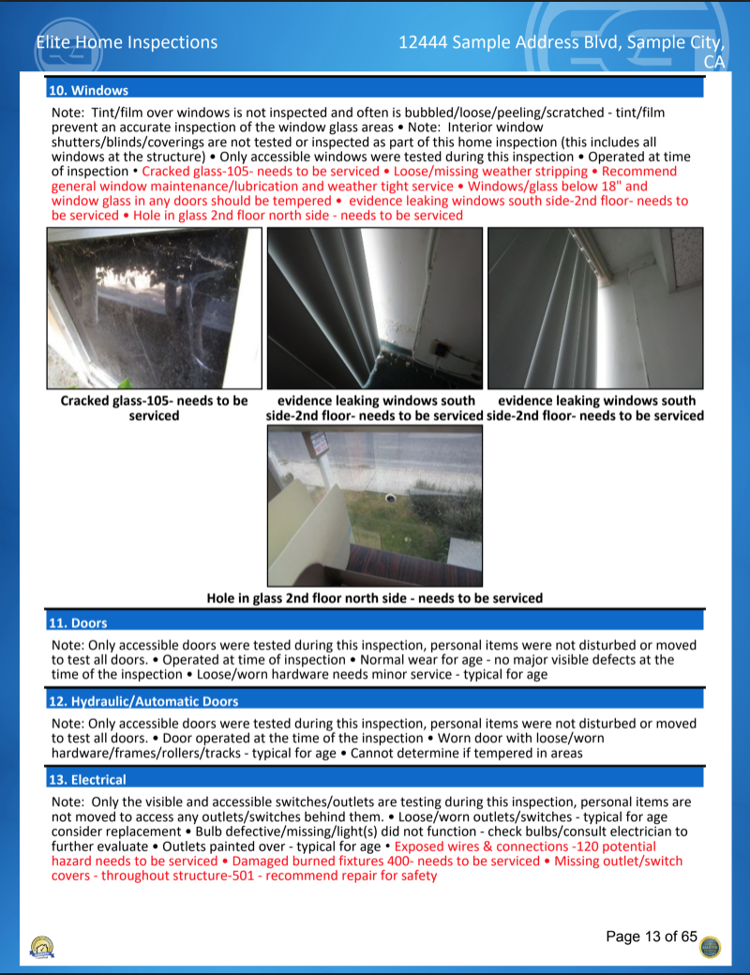
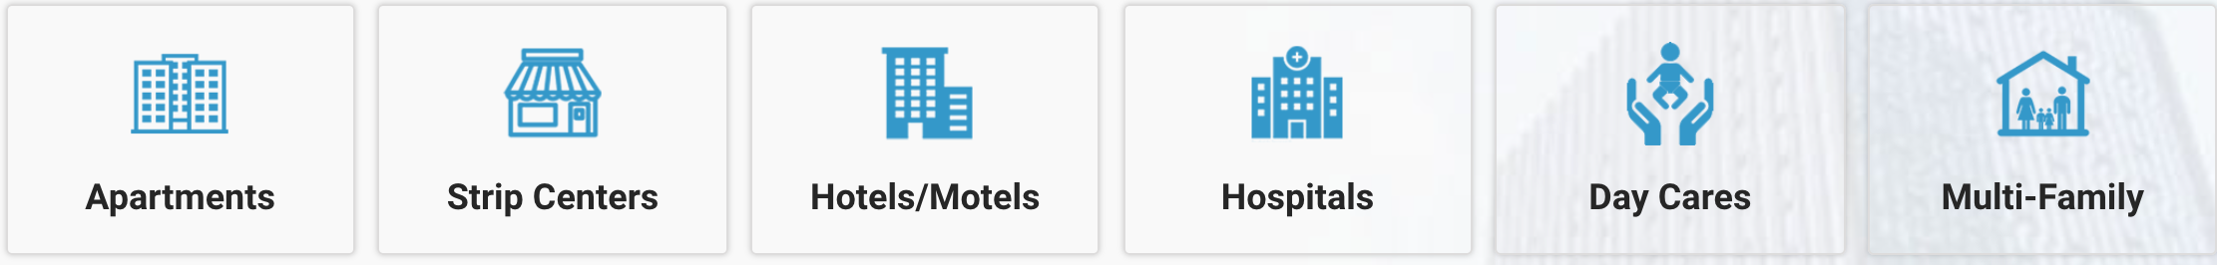

Our clients appreciate the clear and high quality information that we provide, which helps in negotiations and understanding the overall condition of the commercial property. Commercial real estate is a big investment and its highly advised you make an initial investment in an inspection with a Certified Team of Experts before finalizing a transaction. Trust our team of experts who are Certified with the industries highest accolades.
Our Commercial Inspectors are Certified
      - CCPIA- Certified Commercial Property Inspectors Association -Highest degree of training and standards adhering to the International Standards of Practice for Inspecting Commercial Properties (ComSOP)
    - INTERNACHI- Worlds largest Certifying body for the inspection industry. International Association of Certified Home Inspectors
    - C.A.R- California Association of Realtors Certified Inspectors- Verified Association Credentials, Background checks, and verified Insurance Documents.
All this to ensure your getting the most thorough commercial inspection available.

EASY TO UNDERSTAND AND READ
DIGITAL PHOTO REPORT.

SEE A SAMPLE REPORT-

ELITECOMMERCIAL.COM
OUR EXPERTISE= YOUR PEACE OF MIND
We are
COMMERCIAL PROPERTIES WE INSPECT
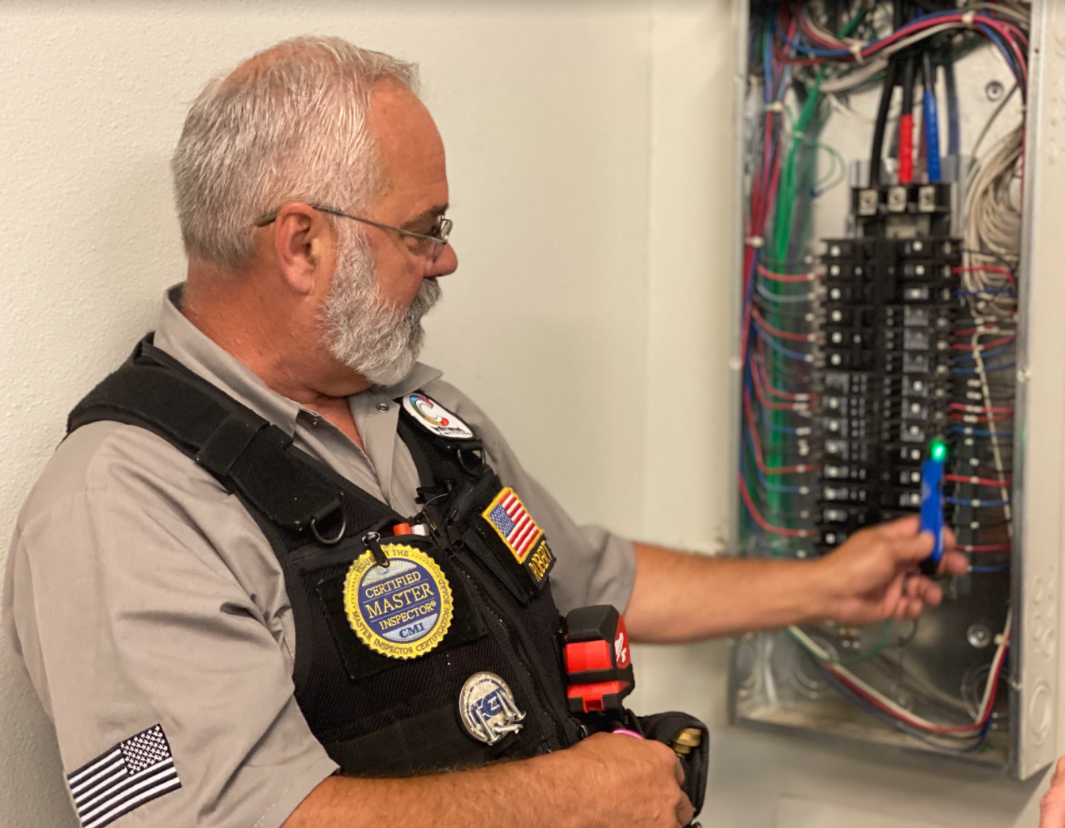

GROUNDS AND EXTERIOR
HVAC Systems

GROUNDS AND EXTERIOR
WHAT WE INSPECT
Electrical Panel and Electrical Systems

A Commercial Inspection performed by The Elite Group is based on the age, type and occupancy of the property. With over 500,000 properties inspected we know how to inspect each and every scenario.Our Inspections include the evaluation of all major components in a building, which establishes the components’ current condition, remaining design life, and any immediate and future repairs that are necessary.
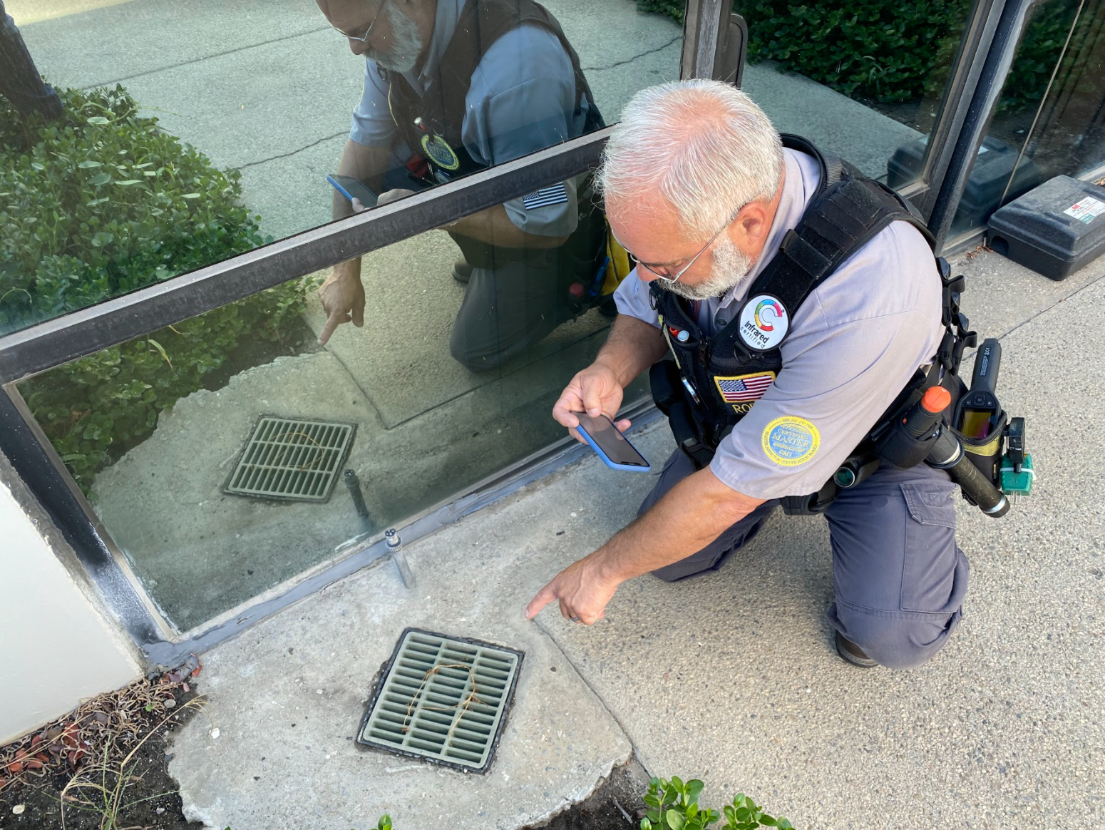


- Panel -Outlets -Wiring
- Drainage -Grade -Moisture concrete, steel and wood componentsEntry
FOUNDATION
ROOF
PLUMBING
- Air Condition -Heater -Ducting

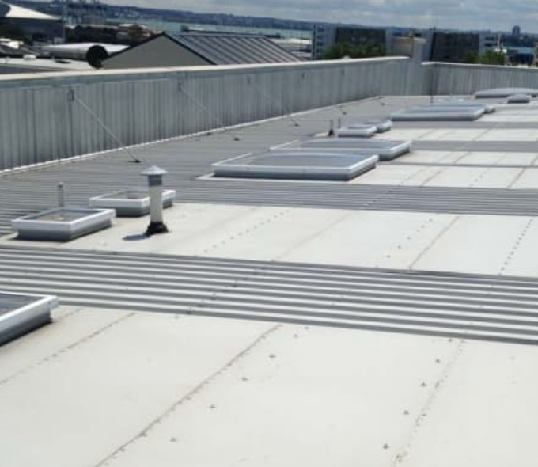

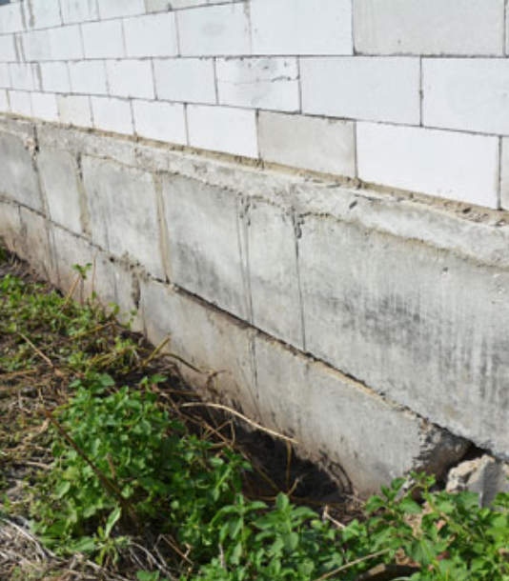

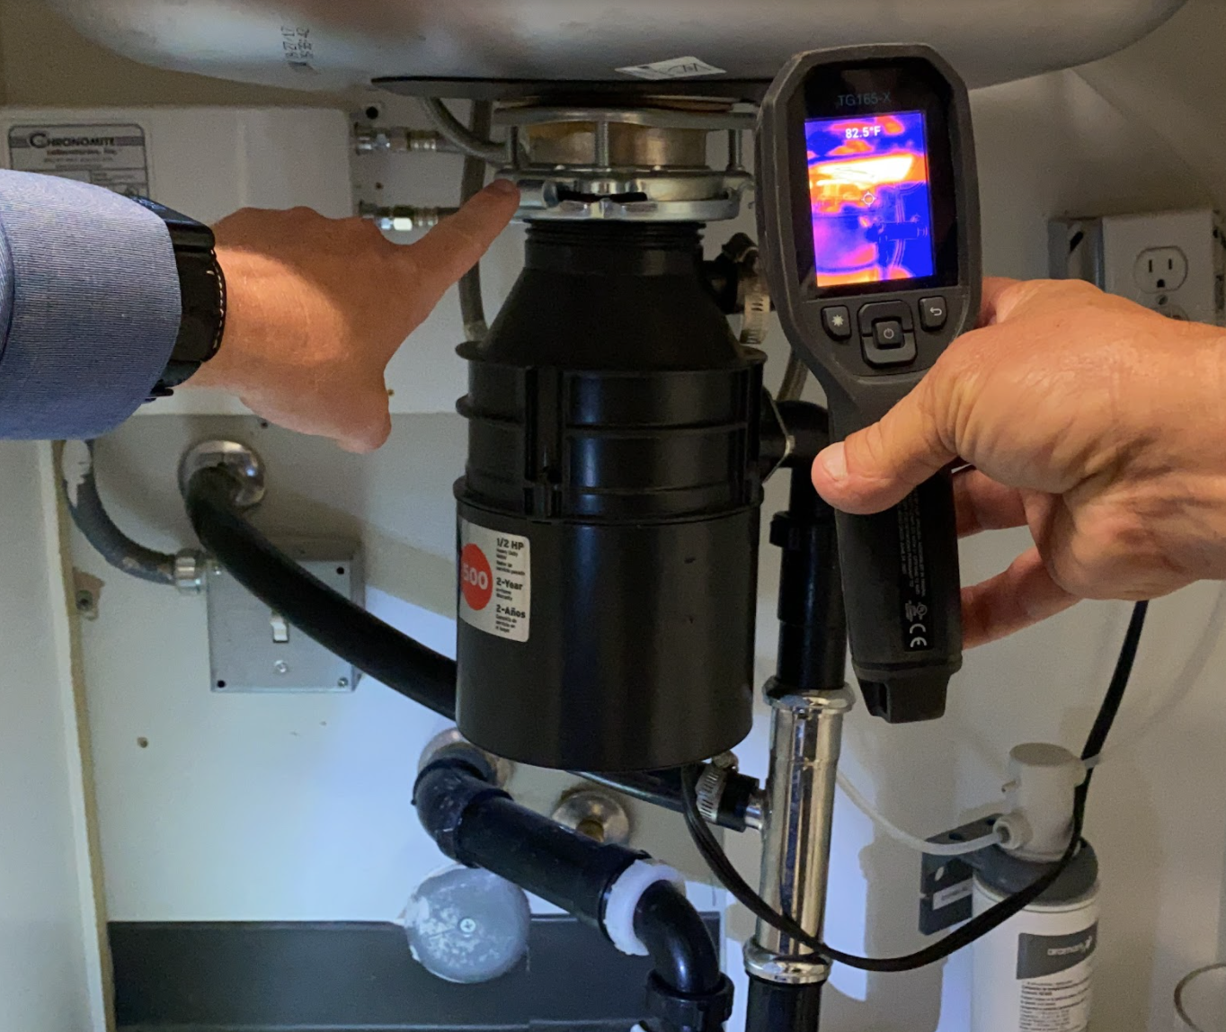


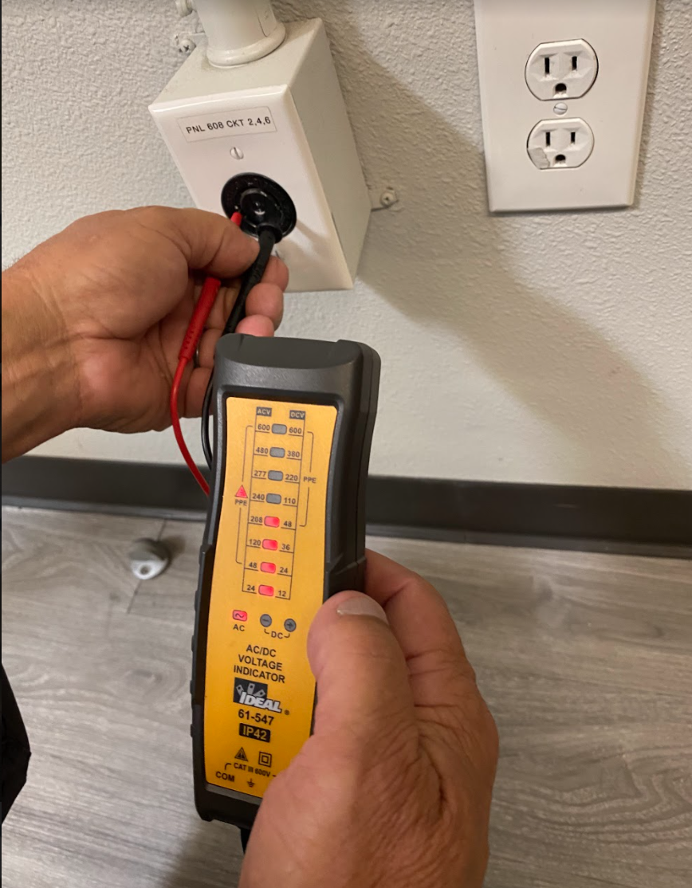

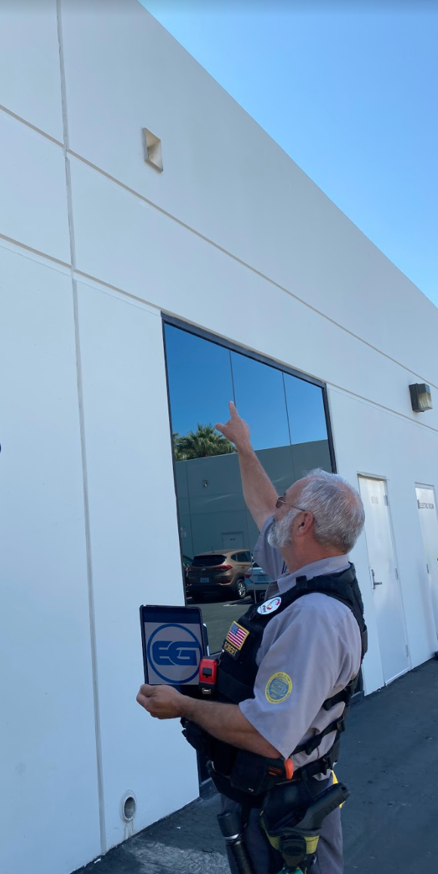

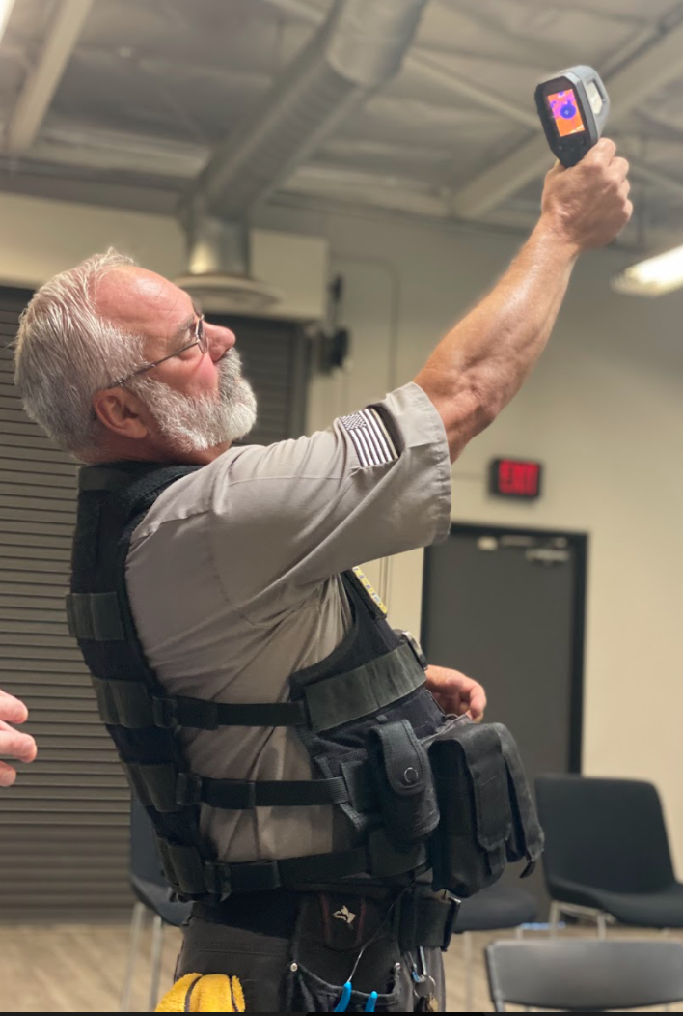


- Leaks -Type -Moisture Intrustion
- Leaks -Seals -surface material, condition, age and remaining useful life
- Cracks -Structural -Installation
concrete, steel and wood components

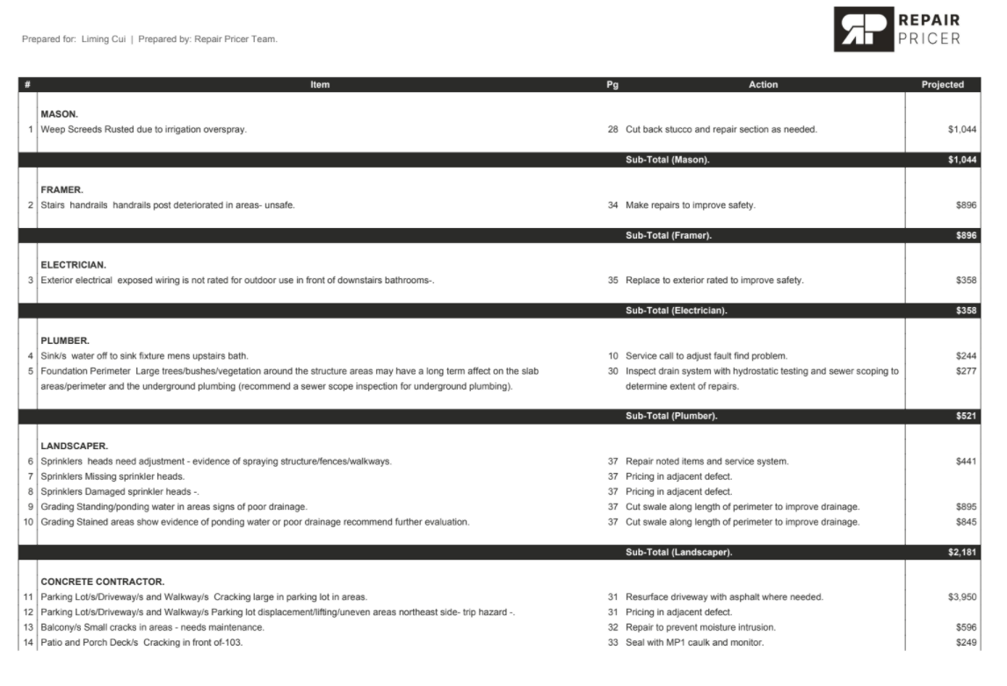
ADDITIONAL SERVICES AVAILABLE

ADA COMPLIANCE INSPECTIONS

ROOF CERTIFICATION AND MAINTENANCE - LICENSED ROOFER

MOLD AND MOISTURE ANALYSIS FROM CERTIFIED MOLD EXPERT

SEWER CAMERA INSPECTIONS

TERMITE INSPECTIONS

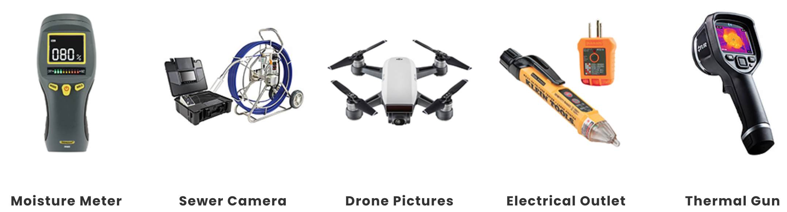


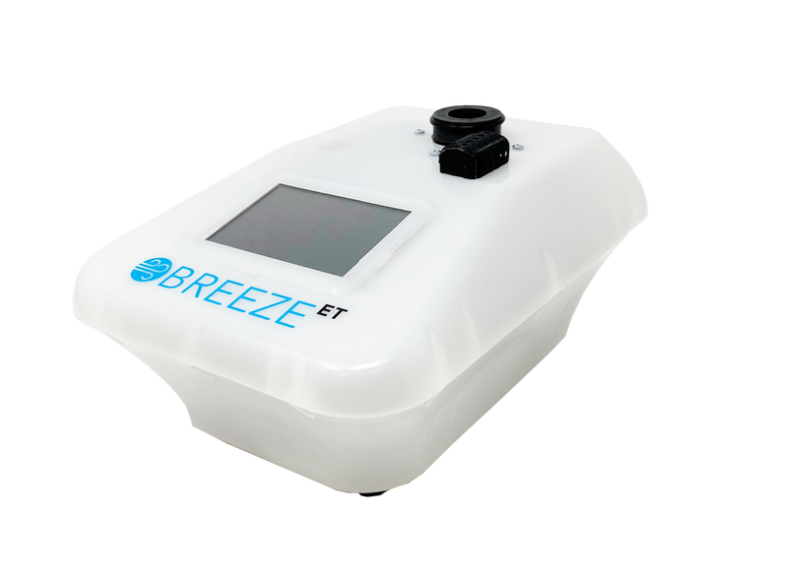
REPAIR PRICING AVAILABLE*

