
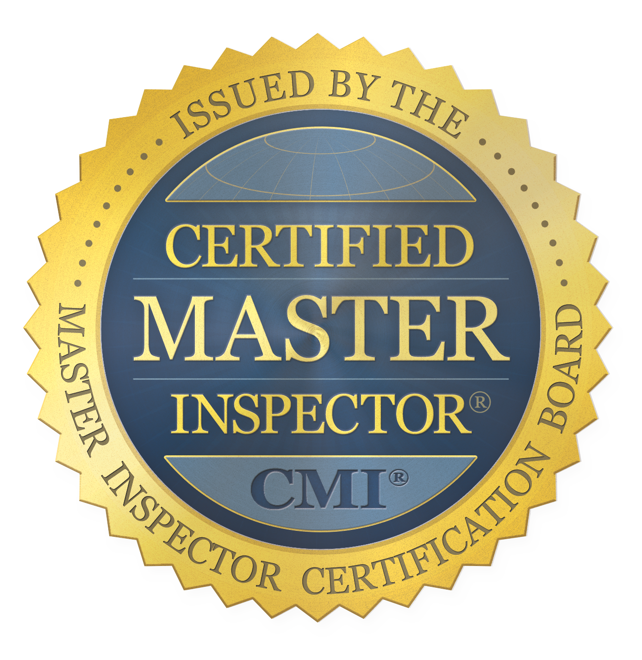
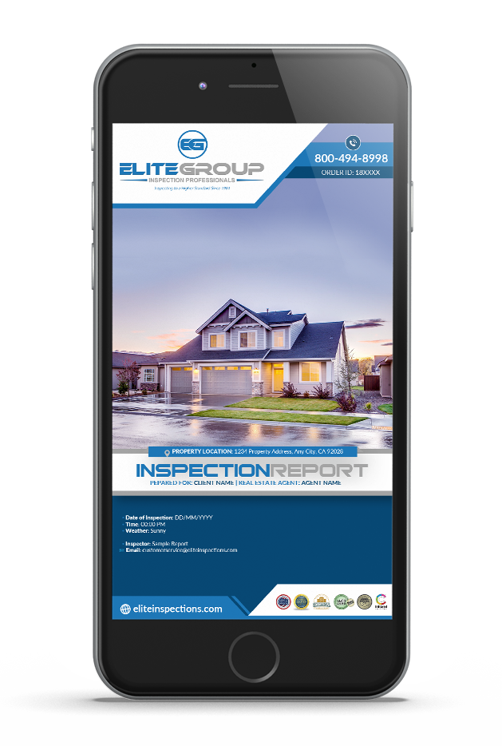
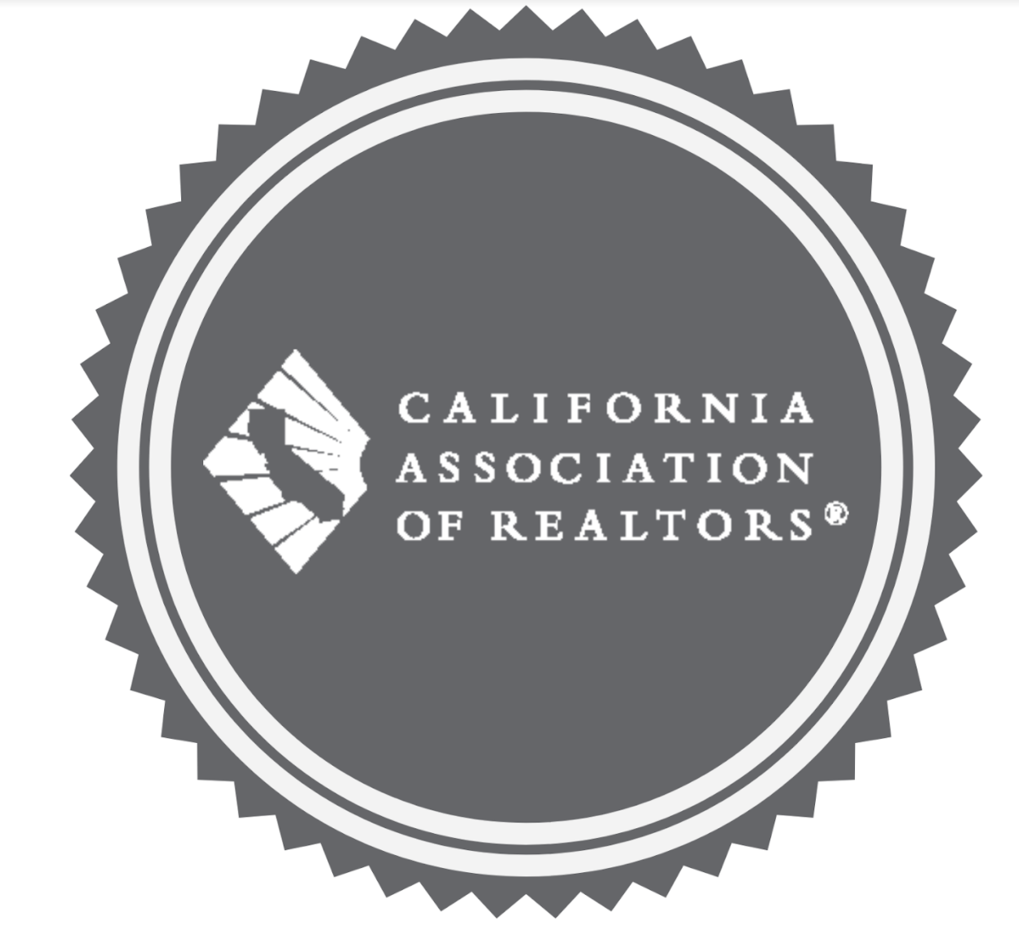
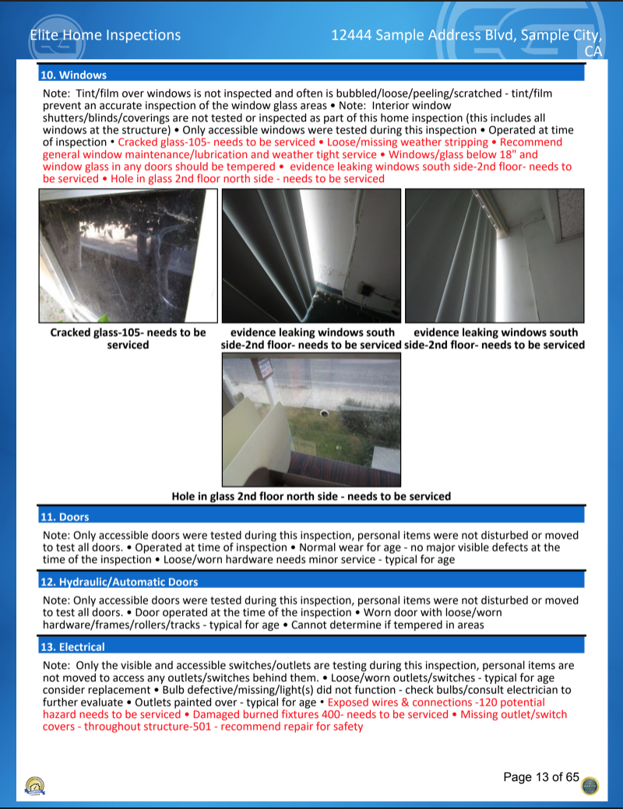
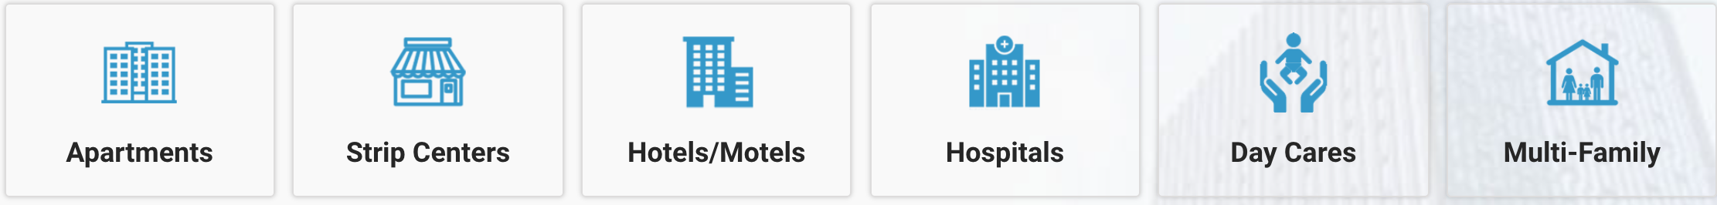

Our clients appreciate the clear and high quality information that we provide, which helps in negotiations and understanding the overall condition of the commercial property. Commercial real estate is a big investment and its highly advised you make an initial investment in an inspection with a Certified Team of Experts before finalizing a transaction. Trust our team of experts who are Certified with the industries highest accolades and over 36 years of experience.
Our Commercial Inspectors are Certified
      - CCPIA- Certified Commercial Property Inspectors Association -Highest degree of training and standards adhering to the International Standards of Practice for Inspecting Commercial Properties (ComSOP)
    - INTERNACHI- Worlds largest Certifying body for the inspection industry. International Association of Certified Home Inspectors
    - C.A.R- California Association of Realtors Certified Inspectors- Verified Association Credentials, Background checks, and verified Insurance Documents.
All this to ensure your getting the most thorough commercial inspection available.

OUR EXPERTISE= YOUR PEACE OF MIND
EASY TO UNDERSTAND AND READ
DIGITAL PHOTO REPORT.

SEE A SAMPLE REPORT-

ELITECOMMERCIAL.COM

800-494-8998 ELITECOMMERCIAL.COM
COMMERCIAL PROPERTIES WE INSPECT
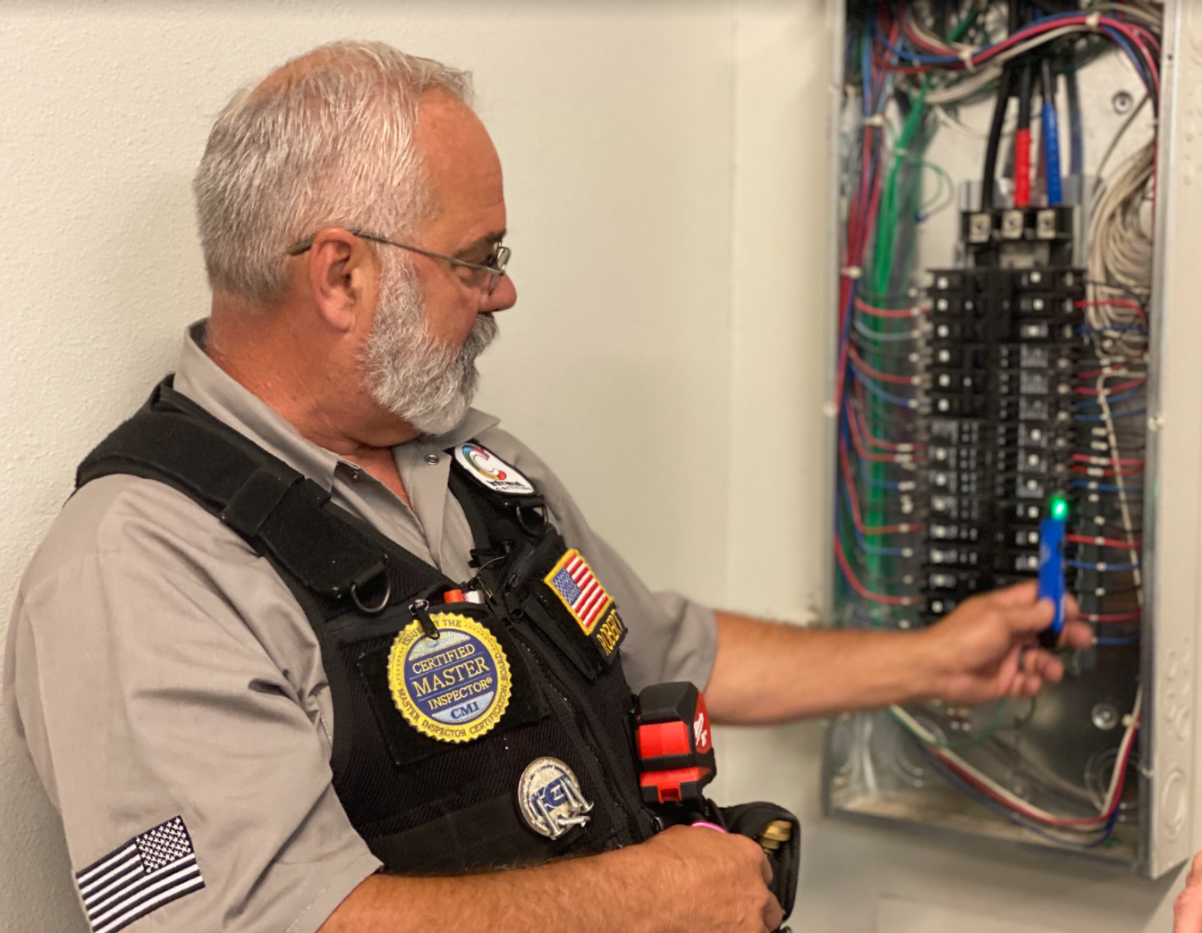

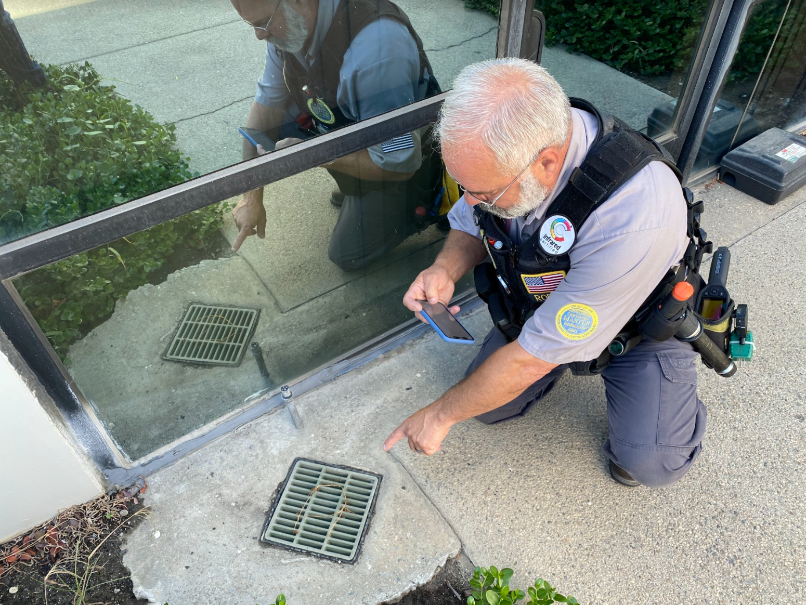

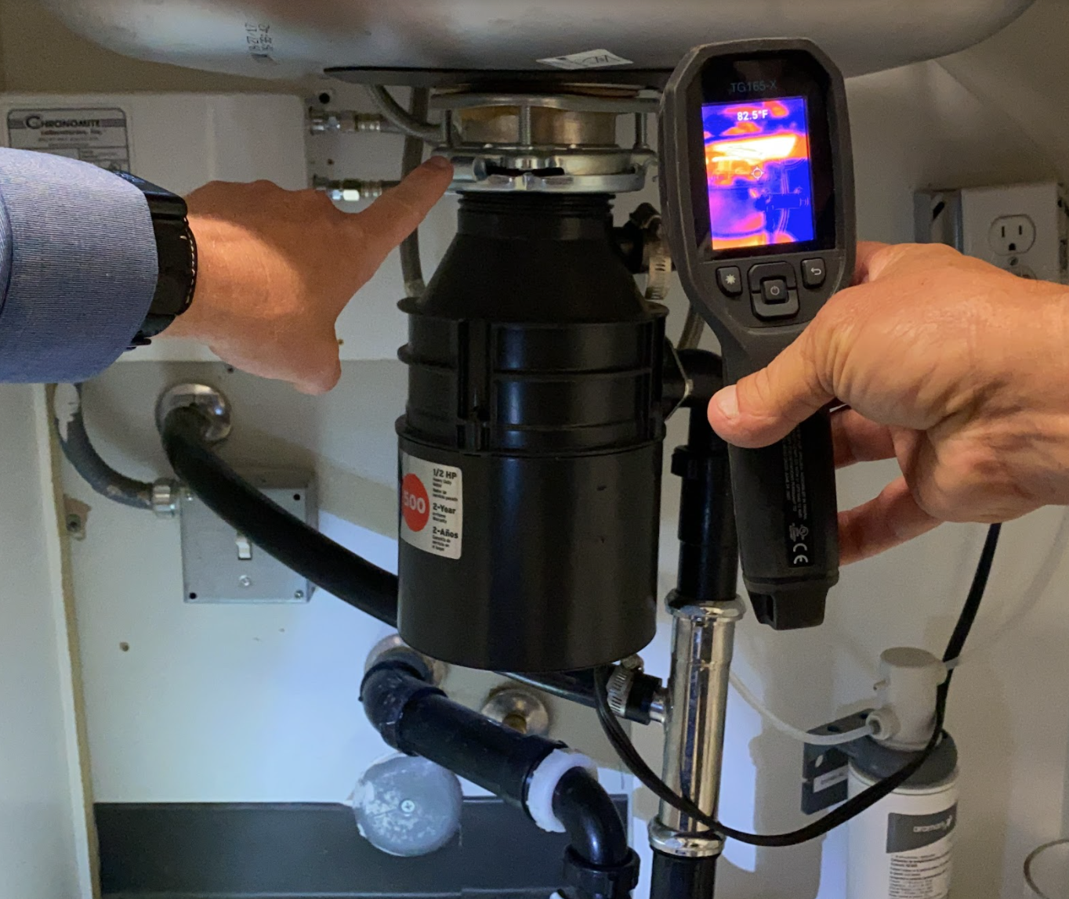

HVAC Systems

WHAT WE INSPECT
A Commercial Inspection performed by The Elite Group is based on the age, type and occupancy of the property. With over 500,000 properties inspected we know how to inspect each and every scenario.
Electrical Systems & Panel

GROUNDS AND EXTERIOR
PLUMBING
PLUMBING

- Panel -Outlets -Wiring
- Drainage -Grade -Moisture Entry
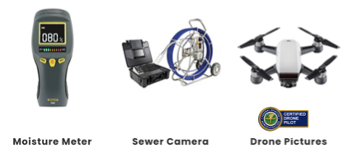

- Air Condition -Heater -Ducting
- Leaks -Type -Moisture Intrusion
ROOF
FOUNDATION
ADDITIONAL SERVICES AVAILABLE
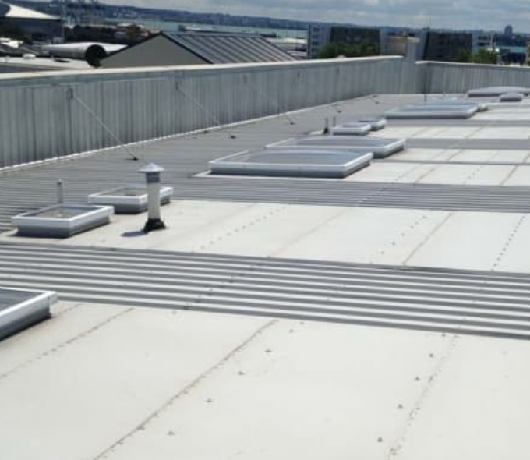

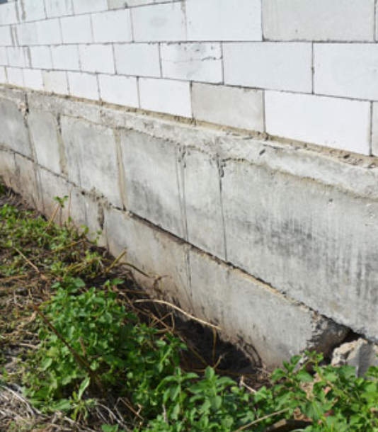


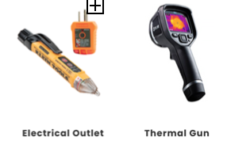
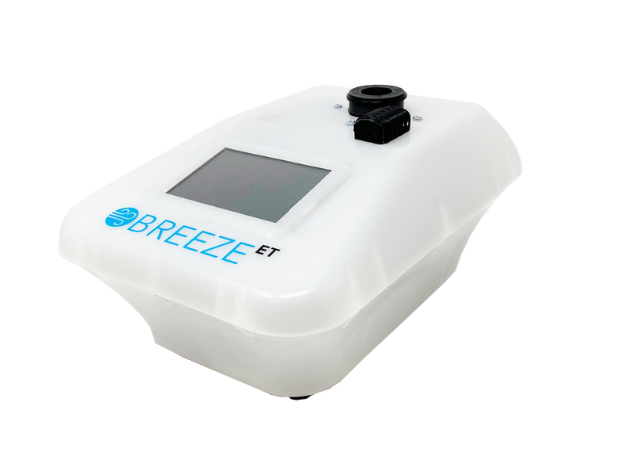

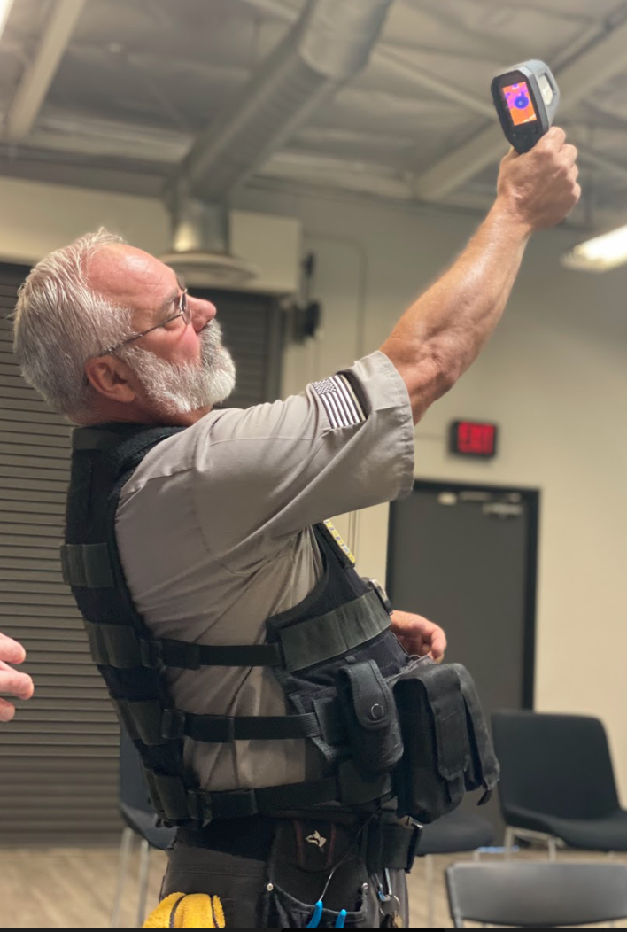

- Leaks -Seals -Maintenance
- Cracks -Structural -Installation
- ADA COMPLIANCE INSPECTIONS

- ROOF CERTIFICATION AND MAINTENANCE - LICENSED ROOFER

- MOLD AND MOISTURE ANALYSIS FROM CERTIFIED MOLD EXPERT

- SEWER CAMERA INSPECTIONS

TERMITE INSPECTIONS

MOST COMMON COMMERCIAL INSPECTION UPGRADES

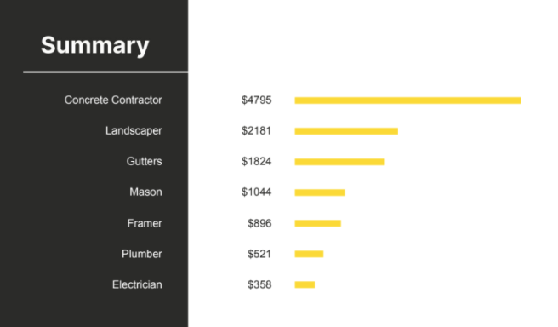
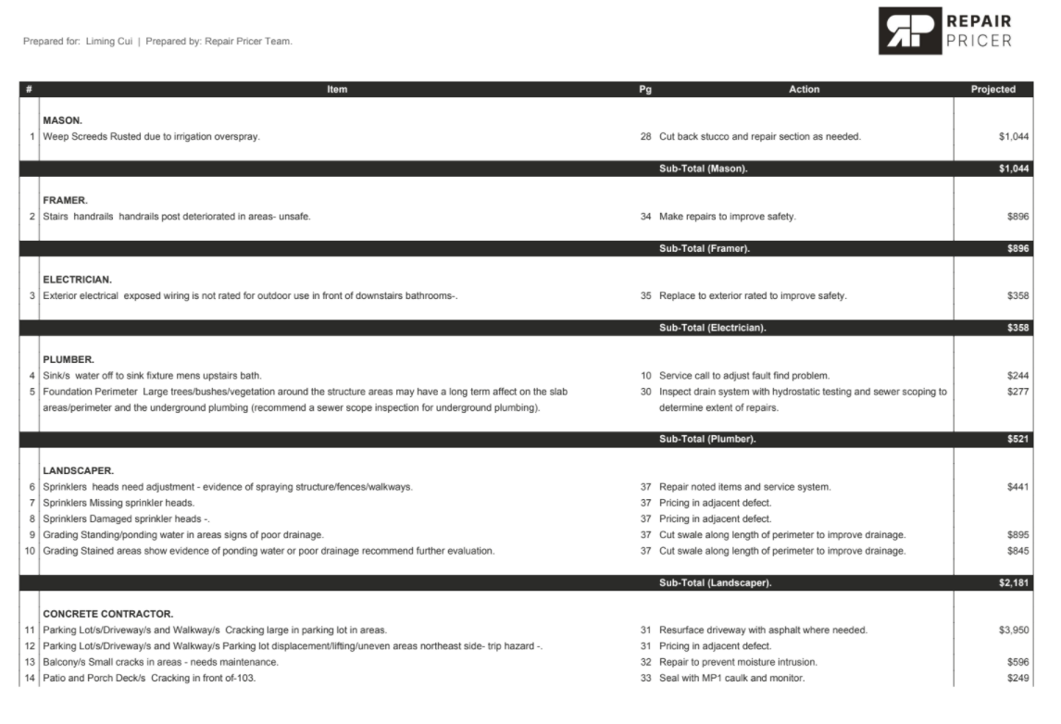
REPAIR PRICING AVAILABLE*
With our Repair Pricer report you will have more insight into the cost of repairs on the defects we point out. This is an unbiased third party estimate only based on the defect and zip code. Unbiased means this is not coming from a contractor that, it is coming from the latest AI technology and regional averages to remedy the defect mentioned in our report. More inform
MORE INFORMATION = BETTER DECISIONS
PRICING- COSTS OF DEFECTS

800-494-8998 ELITECOMMERCIAL.COM

