My Dad

My Dad plays with me. He is one of the fun ones.
My Dad hugs me. He is one of the cuddly ones.
My Dad teaches me. He is one of the wise ones.
My Dad protects me. He is one of the strong ones.
My Dad listens to me. He is one of the quiet ones.
My Dad laughs with me. He is one of the funny ones.
My Dad encourages me. He is one of the proud ones.
My Dad inspires me. He is one of the creative ones.
My Dad works with me. He is one of the driven ones.
My Dad stays with me. He is one of the devoted ones.
My Dad cheers for me. He is one of the enthusiastic ones.
My Dad dreams with me. He is one of the fantastic ones.
My Dad prays with me. He is one of the faithful ones.
My Dad comforts me. He is one of the sensitive ones.
My Dad watches over me from high above. He is one of the great ones.

{Illustration notes:
Each line will be a 2 page spread of the book. This book is written for a 2 year old boy who lost his father last year. Each line should be represented by a different child in a unique scenario, age, ethnicity, gender and culture, with lots of bright colors and interesting things for kids to look at. The last line is the exception, and will depict the people in the pictures below. There are many more pictures available of the mother and child on Instagram at @amandakloots. The mother and 2 year old boy should be on a beach in Malibu, California, USA looking up at the sky with open arms and open hearts.
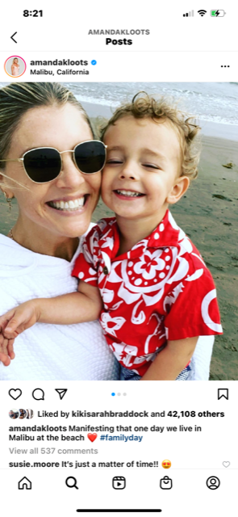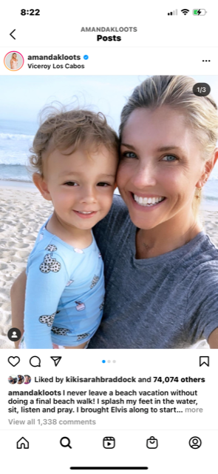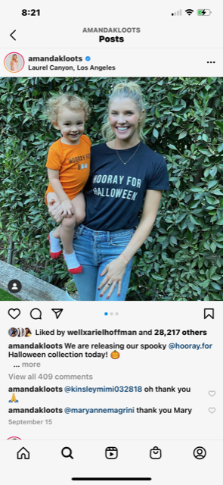
I will be creating the hard copy of the book by putting your designs as jpegs into an 8x11 template from shutterly.com. So, the 2 page spreads should be able to fit into approximately 16x11 page. Front and back cover must be 2 separate 8x11 documents. Have fun and be creative. I like to let the designer follow their instincts and do what they do best, but if you would like specific direction for any of the scenes please let me know. Thank you!

