Bottle Dimension: Height: 140mm Diameter: 38 mmm

Label Dimensions: (100 mL) 120 x 70 mm

Examples:
AFTER TATTOO
& PIERCING

Reduces inflammation,
irritation and encourages
natural skin healing

Expert skin repair
for new tattoos
& piercings

Expert skin repair
for new tattoos
& piercings

Reduces inflammation,
irritation and encourages
natural skin healing

AFTER TATTOO
& PIERCING

‘

The bottle:
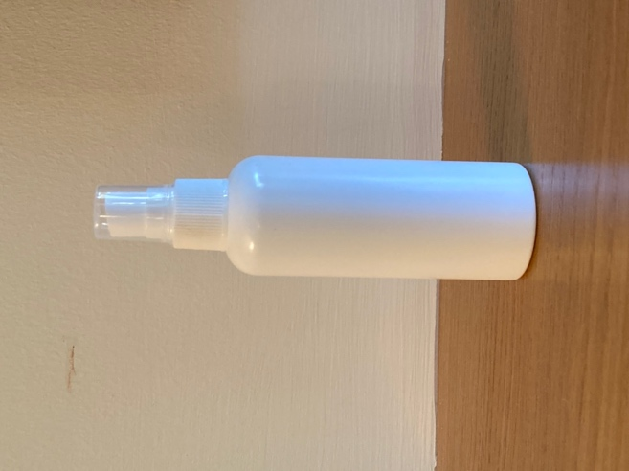

Examples:
