Company branding colors & font:
Blue. #7894a3 RGB 120,148,163
Gray #a7a9ab RGB 167,169,171
Red #ef4036 RGB 239,64,54

Main font used: Montserrat

Please refer to the attached logos as well.

Google Slides Template:
A google slides template theme pack with a number of slides containing graphics and the logo for a professional slide pack. The ‘nuuco’ logo should be used as well as the red ‘C’ of the nuuco logo. In addition some images that represent the brand which is a young, IT Consulting company. Not suits, but professional people working in a collaborative way and scenery (think Mountains, beaches etc).
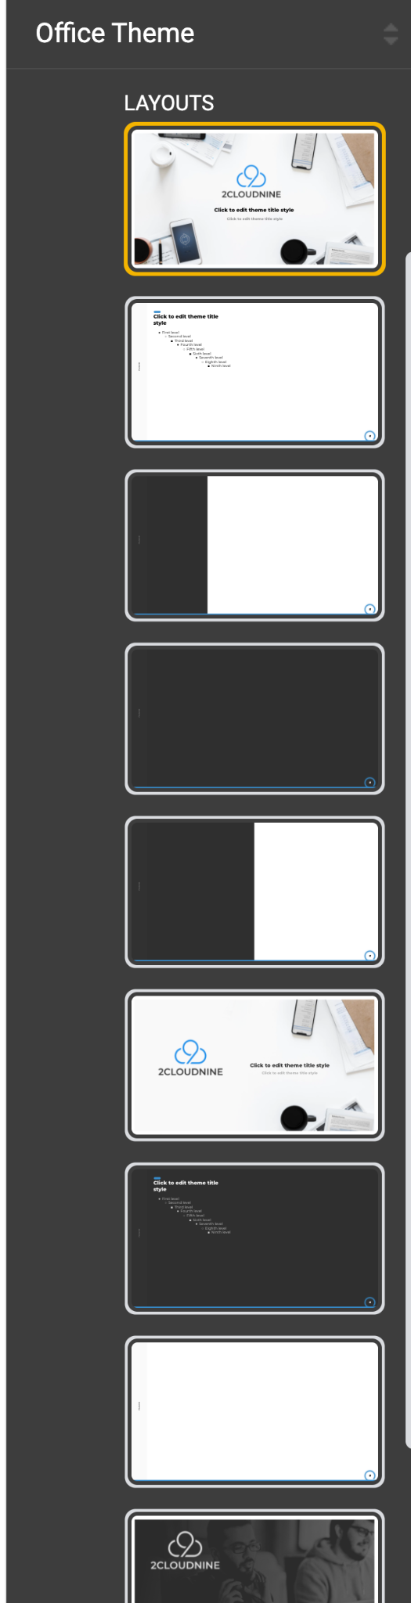

Google Docs template
A google docs template for ‘Knowledge Articles’ and ‘Case Studies’ that will be written and PDF’ed and stored on our website. Similar in theme to 1. Above.
For example:

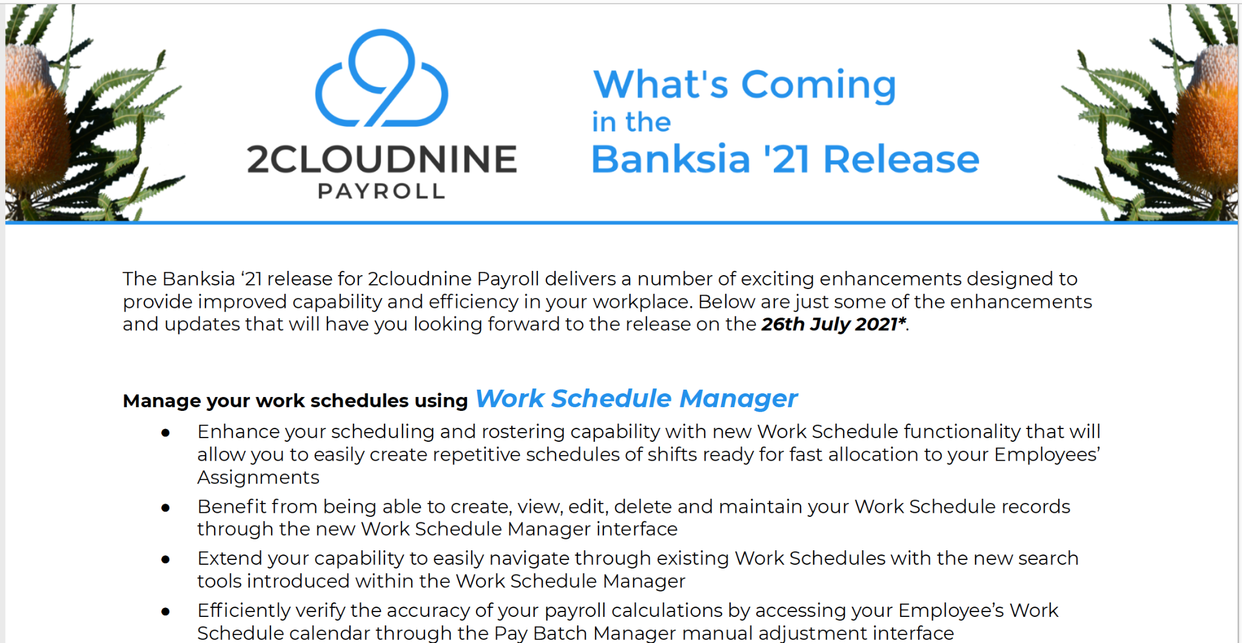

The images may be semi transparent and there can be a ‘watermark’ using the ‘nuuco C’


Graphic Images
We have a ‘customer portal’ which is a login only portal available to our customers for IT support. some graphics to support the following components:
- Knowledge Articles - Find helpful information
- FAQ’s - Answers to common questions
- Service Request - Log a case with us
- Release Notes - Read important information to releases of 2Cloudnine

