Send out announcement email first. Name of webinar should be editable as well as text of body

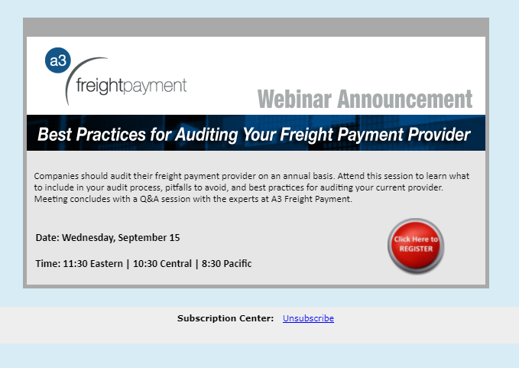

We change the title for each campaign

As well as the text in the body

Then a reminder email

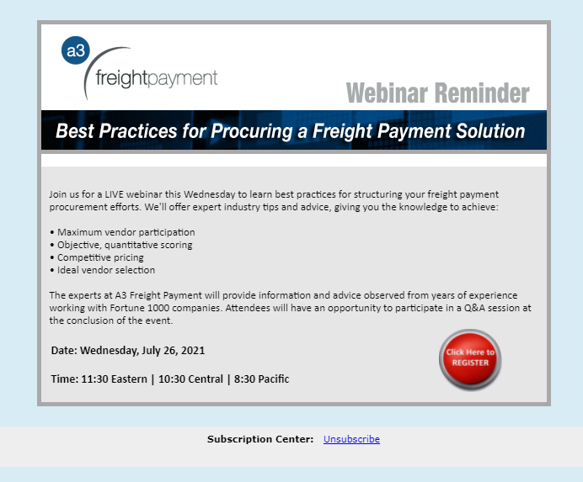

These emails are configured today in an email campaign tool which allows for editing

