Website for Ambrosiadistillery.com
Ambrosia Distillery is a boutique start-up spirit distillery located in Canberra, Australia.
Background of Ambrosia.
Meaning: “Nectar of the Gods”
Gods would drink/eat Ambrosia to sustain them and mortals consuming Ambrosia would become immortal. The goddess Hebe was the server of Ambrosia.

Scope:
Welcome page with links to:
- Our Products (Gin, Coffee vodka, lemon myrtle vodka, and apple and cinnamon vodka)
- Events (what events the distillery is attending or holding at the distillery site)
- Shop (for bottle sales)
- Stockists (where the bottles are sold)
- Cocktail recipe page
*Alcohol websites require a proof of age (18+) check before entering the site. Not sure if this can be done in the scope of this request or not, but would be great to add as well if possible.

Styling:
Ancient Greek Mythology focussing on the Olympian Gods. Greek vase (as depicted at the bottom of this doc)
Bottles have a different Greek God matching each of the flavours to make them distinctive and recognisable from a distance.
EG: Coffee vodka: Zeus with a thunderbolt in hand (gives energy, packs a punch)
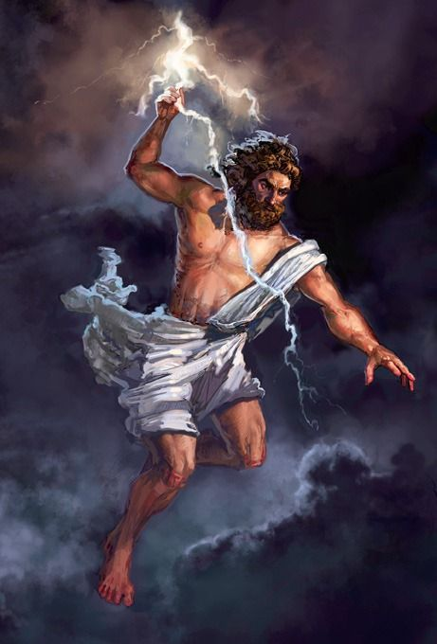

Gin: Athena (strength, weaving of the crafts/botanicals)
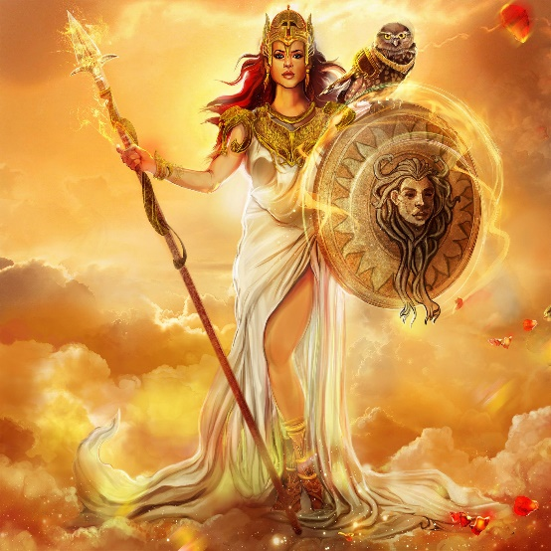

Lemon Myrtle: Aphrodite (elegant, feminine)
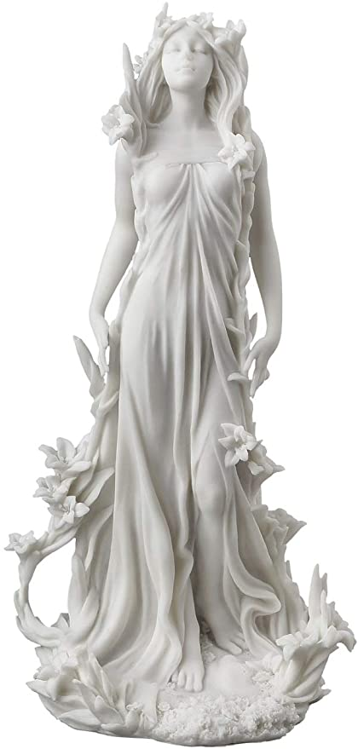

Apple/cinnamon: Gaia (Nature. Fruits of the Earth)
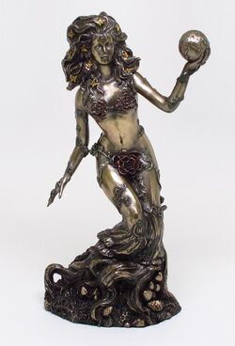

Greek Vase Styling:
