CO2 Laser Cutting Machine Case Design

CO2 laser cutting machine are to cut different material by using laser tube. Our project is to have different design then any other machine as out look and addditional some more functionalty on the case. Some sample designs are attached below to take as reference but final design shouldnt be very close to sample designs as out looking.
There is 2 phare of the project. One is out look only and once out look finish then we will start working on insde of the machine such as placing linear rails, laser head etc..
- Phase features
Features that we need on it
- Dimention of the machine 2000-2200 x 1600-1800 x 1100-1300 mm those numbers are reference it may change but working table is 1600x1000m.
- Colors are Green and Gray same color code that Engel machine uses. Can see picture below
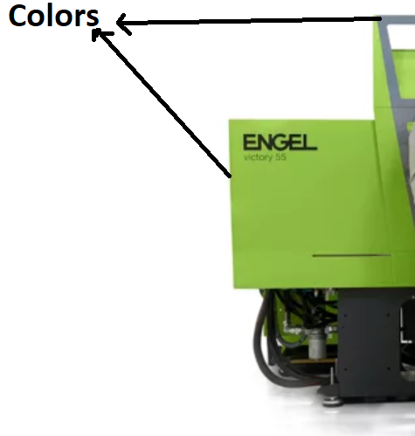
- Left and right side doors which pointed below picture should be one pcs as much as possible. So that user only remove one pcs of door to reach parts to adjust or clean. On Right side there will be electornic panel as well.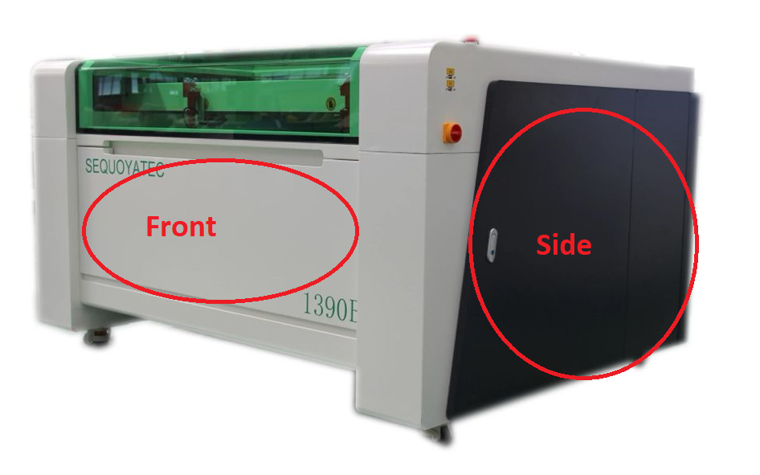
- Front metal part also removable. Should be early removed and replaced. You can see Front pointed on above picture. But on this above picture machine missing one feature that we need. In front panel there must be drawer. So that users can pick up small items that they cut and dropped to there easly.
- Cover is prefered transparent glass or plexi and one peace. Prefered to be glass because plexi can be burned if laser hits on it.Making curve glass expensive that’s why on top cover consider to use 2pcs glass on top and front parts.
- Control panel model is Control panel should be somewhere on right place because mostly people use right hand. Below is technical spec of the controller panel so there is size dimention to make hole. Control panel can be in small its own housing and top of them there is sliding panel (transparent plexi) to close it while machine is working so that it protects control panel from dirt. It doenst have to be placed flat. I let designer imagination and creativity.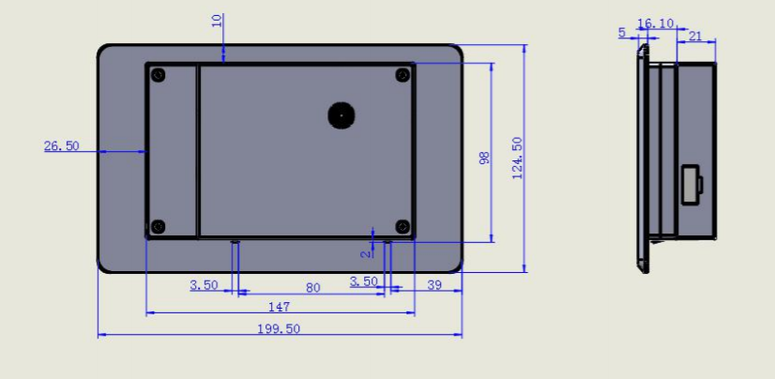
- Front of the machine close to control panel there must be below items as well
  - Open/Close button or switch like picture above machine.
  - Emergency stop button
  - USB port
- Right corner of the machine there will be light indicator and buzzer sistem. Only Green and Red lights like below.
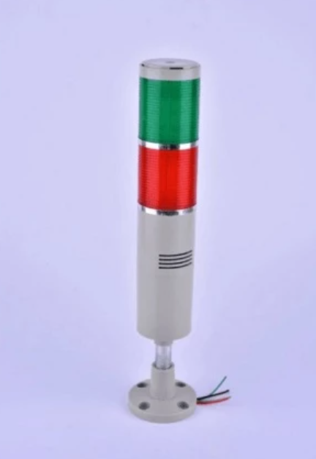
- Back side of the machine also 1 cover and doors. Back side top cover will be fully metal no need to see inside. In this place CO2 tube will be fixed. Also Back side panel need to be removed. Picture below seems used 2 doors but we need to make it one pcs removeable cover like front side.
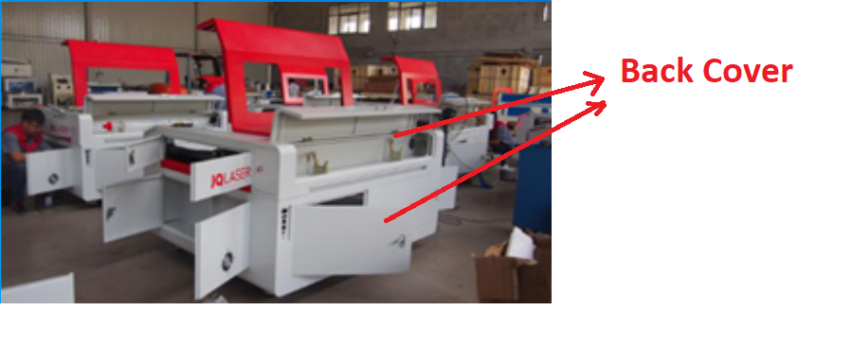
- Back side of the machine there will be plugs
  - Electric plug
  - Water in and out
  - Air in

Some design references below. Please consider above items that listed then check reference machine pictures. Below picture machines doesnt meant to be same to create
