Meet Eddie Evers: a hard-drinking PI with a talent for finding missing children. While on a case, Eddie is hit by lightning, super-charging the biophotons in his brain and opening his eyes to other dimensions. Electric and electronic devices now tend to misbehave in Eddie's presence as well.
Assisted by a savant cat named Max, a Sikh taxi driver called Singh, and a secret society of scientists, Eddie treks through the dark alleys and hilltop mansions of Los Angeles trying to discover who’s been killing elementary school teachers and students. Can he solve the case and save lives or will his glimpses into other times, places, and dimensions trap him within his own mind?

***
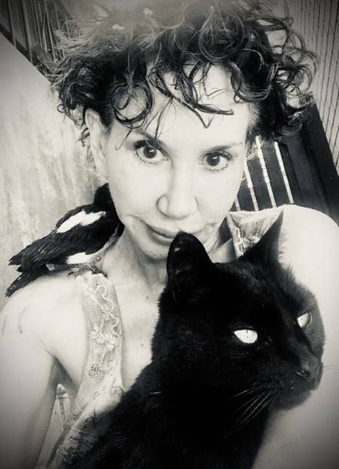
E.E. King is an award-winning painter, performer, writer, and naturalist - She’ll do anything that won’t pay the bills, especially if it involves animals.
Ray Bradbury called her stories, “… marvelously inventive, wildly funny and deeply thought-provoking. I cannot recommend them highly enough.”
She’s been published widely, including Clarkesworld. Her stories are on Tangent’s 2019 and 2020, Year’s Best Stories list. She's been nominated for five Pushcart awards in 2021. She's shown her art at LACMA, and Internationally, and would be quite happy if you'd buy some.
Check out paintings, writing, musings, and books at: www.elizabetheveking.com and amazon.com/author/eeking.

