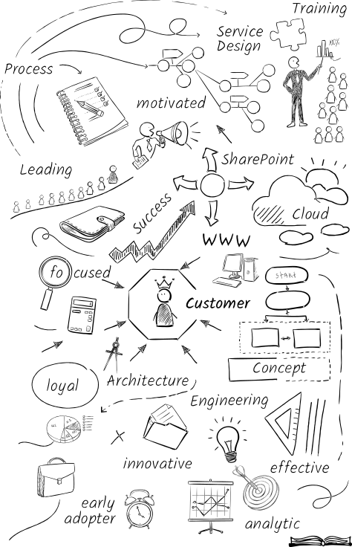

Head-IT, Manager and Coach
Andreas Gapsch
Agile leadership and coaching experience for globally distributed teams (up to 30 employees)
Profound expertise in project and cost management
Many years of experience with collaboration infrastructures, engineering, and architecture

Seestrasse 18
CH-5712 Beinwil am See
andreas.gapsch@protonmail.com
+41 791762764

Lebenslauf

Personal Details
Birthday / -place 25.03.1985 in Tuttlingen (Germany)
Nationality German
Marital Status Married (2017 Haist)
Children Two girls

Areas of Expertise & Experience
- Agile Leadership | - Design & Engineering | - IT Consulting & Support
- Service Design & Transition | - Project Management | - Personnel Training
- Coaching | - PowerShell Scripting | - Experience Abroad
- Microsoft 365 | - Migration & Architecture | - Change Management

Professional Experience
since 12.2018 Head IT Hero Schweiz & Head ICT Cluster Central Europe
Hero AG / Schwartauer Werke GmbH & Co. KGaA
- Operational and personnel responsibility for the IT organization in Switzerland
- Operational and personnel responsibility for the ICT organization in Germany
- Support of the global export organization and HQ
- Planning, organization and development of IT infrastructure and application
- Operation of the Service Desk Organization in Switzerland & Germany
- Coordination and implementation with the Group IT strategy
- IT Change and Project Management
07.2017 - 11.2018 Manager and Coach of DWP Platform Engineering & Operations
Swiss Re Management Ltd (Switzerland)
- People management for 31 employees (MBO, hiring, escalations, etc.)
- Personal development coaching (systemic)
- Drive change management and cultural development
- Organization transformation to adopt agile principles
- Shape and support the Digital Workplace strategy
- Support sourcing activities
- Drive and support the strategic planning of our global platforms
(Exchange, SharePoint & Skype / UC)
05.2014 - 06.2017 Expert SharePoint Engineer & Project Manager
Swiss Re Management Ltd (Switzerland)
- Project Manager of the SharePoint 2016 & Hybrid project
- Defining and Engineering Office 365 / SharePoint online implementation
- Technical responsibility for the SharePoint infrastructure
- Project lead for SharePoint 2016 migration and the preparation of an Office 365-based hybrid solution
- Support and consulting for introduction projects for Microsoft Business Intelligence, SharePoint for mobile devices, taxonomy and access management during development and implementation phases
- Level 4 support and problem management for the SharePoint infrastructure
- Execution of a Microsoft SharePoint Risk Assessment RaaS+
- Engineering and implementation of need-to-protect solution for personal sensitive data on SharePoint via PowerShell automation
- Harmonization of PowerShell scripts and introduction of script logging and error handling functionality
- Introduction and documentation of the SharePoint vulnerability patching process
- Assignment of tasks and planning of resources for SharePoint within the SharePoint team
- Design & Build Work Stream Lead for a IIS .Net service project
- Organization and Communication for the SharePoint 2016 / 2019 TAP program
01.2010 - 04.2014 SharePoint System Engineer
Bank Julius Bär & Co. Ltd., Zürich (Switzerland)
- Specialist responsibility for MS SharePoint infrastructure
- Engineering, automation, performance optimization and life cycle management of global SharePoint farms (intranet, application and collaboration platform)
- Technical design and engineering of SharePoint-based solutions
- Support for collaboration and infrastructure projects in a Microsoft environment
- Consulting for .NET developers and application officers with regard to the optimal usage of Microsoft SharePoint
- Assistance with .NET configuration and release management
- Responsibility for deploying .NET applications in test and production environments
- 2nd and 3rd level-Support of the global Microsoft SharePoint infrastructure
- Management Reporting
06.2007 - 12.2009 IT Consultant
Avanade Deutschland GmbH (Germany)
- Consulting-for key accounts from telecommunication, energy and automotive industries
- Technical realization of an MS SharePoint Enterprise Search pilot project
- Setup and maintenance of an infrastructure based on MS SharePoint as well as MS SQL servers
- Design and creation of an intranet environment Microsoft SharePoint 2007
- Design and technical realization of several MS SharePoint 2007 environments
- Project coordination and documentation, preparation of status meetings and reporting
- Completion of a trainee program as part of the „Systems Engineering Consulting Academy“
09.2006 - 02.2007 Full-time Training as an IT Security Specialist
Lutz & Grub AG, Karlsruhe (Germany)
- Design of Windows-Server 2003-based infrastructures
- Consolidation of network knowledge (routing, RAS, VPN, LB)
- Complex DNS environments (replication, master-slave concept, stubzone)
- Designing and building complex domain-infrastructures (forests, trusts, branch offices etc.)

Education and Vocational Training
03.2018 - 06.2018 Fachhochschule Nordwestschweiz FHNW
Course of Studies: CAS Digital Business Development
08.2017 - 01.2018 Fachhochschule Nordwestschweiz FHNW
Course of Studies: CAS Cloud Computing
02.2017 - 06.2017 Fachhochschule Nordwestschweiz FHNW
Course of Studies: CAS IT Management
11.2013 - 12.2016 IFA Weiterbildung AG
Course of Studies: Business Engineer with Bachelor’s Degree
Dipl. Wirtschaftsinformatiker HF (equivalent to bachelor’s degree)
09.2003 - 06.2006 IT+S GmbH, Freudenstadt (Germany)
Apprenticeship as an Information and Telecommunication Technician
Certified by the German Chamber of Industry and Commerce (IHK)
08.2001 - 08.2003 Heinrich Schickardt Technical High-School, Freudenstadt (Germany)

Additional Trainings and Seminars
11.2017 Prosci - Change Management, Prosci Inc
10.2017 CAL 1 - Certified Agile Leadership, Flowdays & Scrumalliance
11.2015 Advanced training as an SVEB Adult Educator & CompTIA CTT+ Trainer, Digicomp AG
07.2015 Certified Project Management Associate IPMA Level D VZPM
07.2015 Advanced Training as a Vocational Trainer, Berufsbildner AG
03.2013 Business English Certificate Vantage (B2), Cambridge ESOL Level 1 Certificate
09.2006 - 02.2007 Advanced training as an IT Security Specialist, Lutz & Grub AG, Karlsruhe
03.2005 - 07.2005 Network administrator with IHK certification, IHK Nordschwarzwald

Further Qualifications
Languages German, native
English, very good written and spoken

IT Skills Operating Systems: Windows Server & Client
Middleware: SharePoint 2007 – 2016, SQL Server, IIS
Products: SharePoint 2007 – 2016, Azure, Office 365, MS-Office, MS-Project, AvePoint DocAve, Nintex Workflow & Forms, ControlPoint, Show Me SharePoint, Luxid 7
Scripting: PowerShell, DSC, CMD
Tools: Visual Studio, Power GUI, Sapien PowerShell Studio, ExamDiff
Additional technologies: Active Directory, DNS, GPO, VPN, ISA Server, Network Load Balancing, Windows / SQL clustering

Certifications CAL 1 - Certified Agile Leadership
Prosci - Change Management
MCSE: Productivity / SharePoint 2016
CCC Big Data Foundation
DevOps Foundation
IREB® Requirements Engineering Foundation Level
ISTQB® Certified Tester Foundation
IPMA Level D
EXIN Secure Cloud Services integrator
EXIN Agile Scrum Foundation
ITIL v3 Foundation
MCSA 2008
MCSA Office 365
MCSA Windows Server 2012 R2
MCSE 2003 + Security
MCTS SharePoint Server 2007 / 2010 / 2013
Linux Junior Level Administrator LPIC [1]

Driver’s License German Class B (full, clean license)
Honorary Office Expert member of the examination board PK19 for informatics professions
Hobbies / Interests Travelling & foreign cultures, electrical engineering, Blockchain (mining), sailing, destructive technologies

Beinwil am See, 18.06.2021
Andreas Gapsch

