Trade Show Materials brief

Client: MAGTEC Products www.magtec.com
Product they wish to promote: Safespeed®

MAGTEC has created a technology (hardware/software) that when installed in a truck or bus, can control the speed and restrict the vehicle to the posted speed limits (even if the driver floors the gas). It’s called Safespeed®. The company will attend and display a booth at the upcoming National Safety Council tradeshow on October 11th. This will require the following to be produced:

- An updated 10X10 booth background. This will need to be designed in a layered file using supplied logo and headline text. The background image is TBA but will be a composition of an image(s) and graphics. This is the idea:


- A folded card-stock display that is a MAX of 18 wide X 25 high X 10 inches deep
As part of the trade show, MAGTEC will also have a small un-manned display in a nearby room. This is a glass display case where the client can place their Safespeed® device (It’s as small as a cell phone) and a printed display. We require a creative approach to this printed item so that is is eye catchy and can fit in the display case
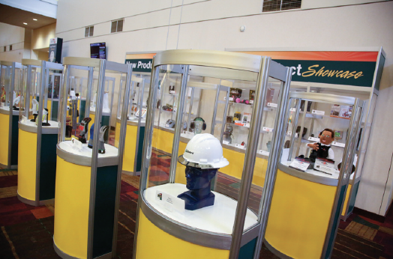

. Maybe a 11X17 poster that we can print two sides on a foam board and hang it inside the showcase using wire and clips. i.e.



2A – Option. Use LIMIT 55 sign (with damaged lower corner as if a burning truck hit it) You can buy these signs on Amazon, then we bend them and add some burn marks. Or Mitch can do this. Hand the damaged sign as an eye catcher
Then a smaller foam board with CTA and book location + SafeSpeed® device.

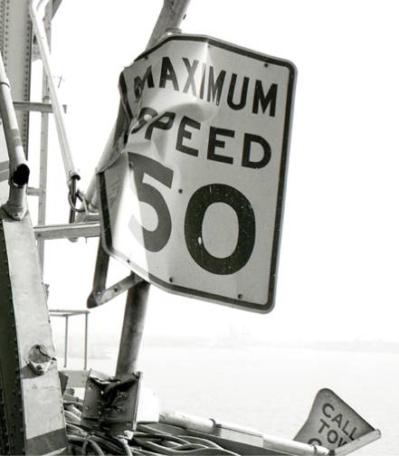

Key messages for the postcard and display case:

Let’s face it – speeding related crashes harm people and businesses. A company whose vehicle was speeding in a serious crash will have its reputation and financial health damaged. SafeSpeed® helps backstop exposure to excessive speeding resulting in fewer accidents, injuries, and fatalities by lowering operating risk. Come and see a demo firsthand at booth #2966.

DON’T LET A SPEEDING DRIVER TAKE A LIFE.
Safespeed® remotely limits speed to the posted limits and helps safety officers deliver breakthrough coaching programs. Come see a demo at booth 2966.

Key message for trade show booth:

DON’T LET A SPEEDING DRIVER TAKE A LIFE.
Safespeed® remotely limits speed to the posted limits and helps safety officers deliver breakthrough coaching programs.

