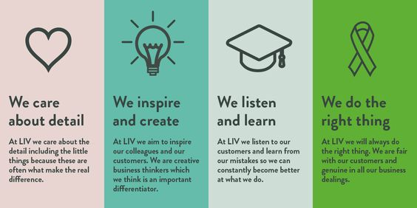

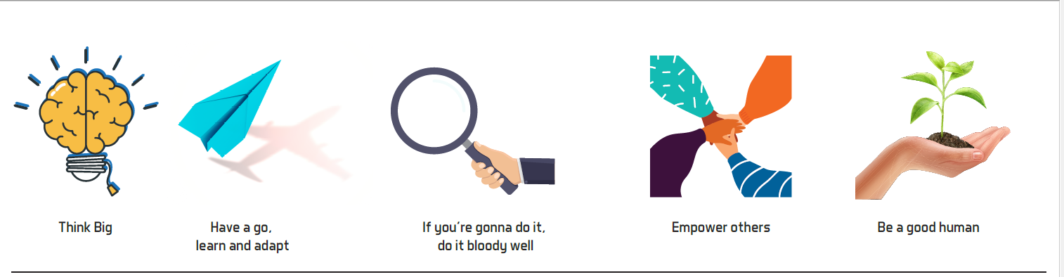
We had a go at completing the images but aren’t really happy with look and feel.

