

COMPANY OVERVIEW
LSP non-listed public company that operates offices in Australia, New Zealand, Singapore and the United States of America.
LSP is a guest and patient facing technology innovator that connects solutions focused on a better end-to-end experience for guests, patient, employees, managers, owners and partners.
With extensive industry experience and over 10,000 endpoints– LSP is able to bring together the best outcomes for your facility.

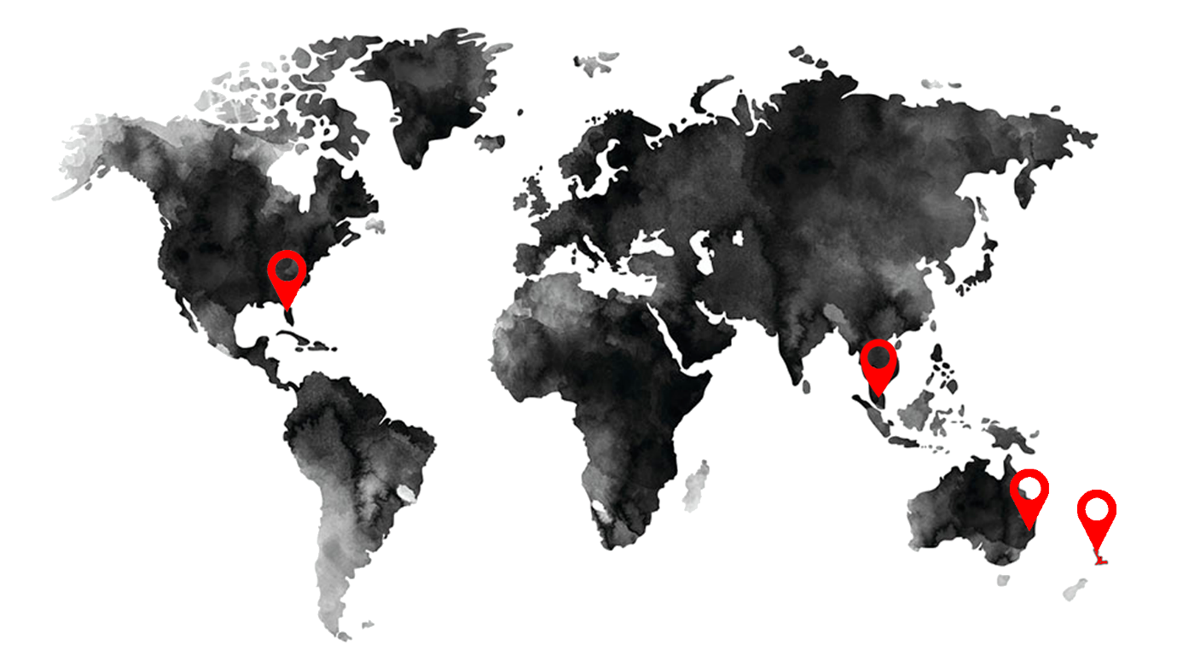

OUR VISION
To be the first-choice solution provider through dynamic and flexible integration platforms, extending to hospitals, aged care facilities, hotels, resorts, and mining camps.
LSP understands our reputation is earned one customer at a time, that is why we focus on the delivery of industry best practice outcomes that minimise the risks and always consider whole of life benefits.


PART PERFOMANCES & PARTNERS
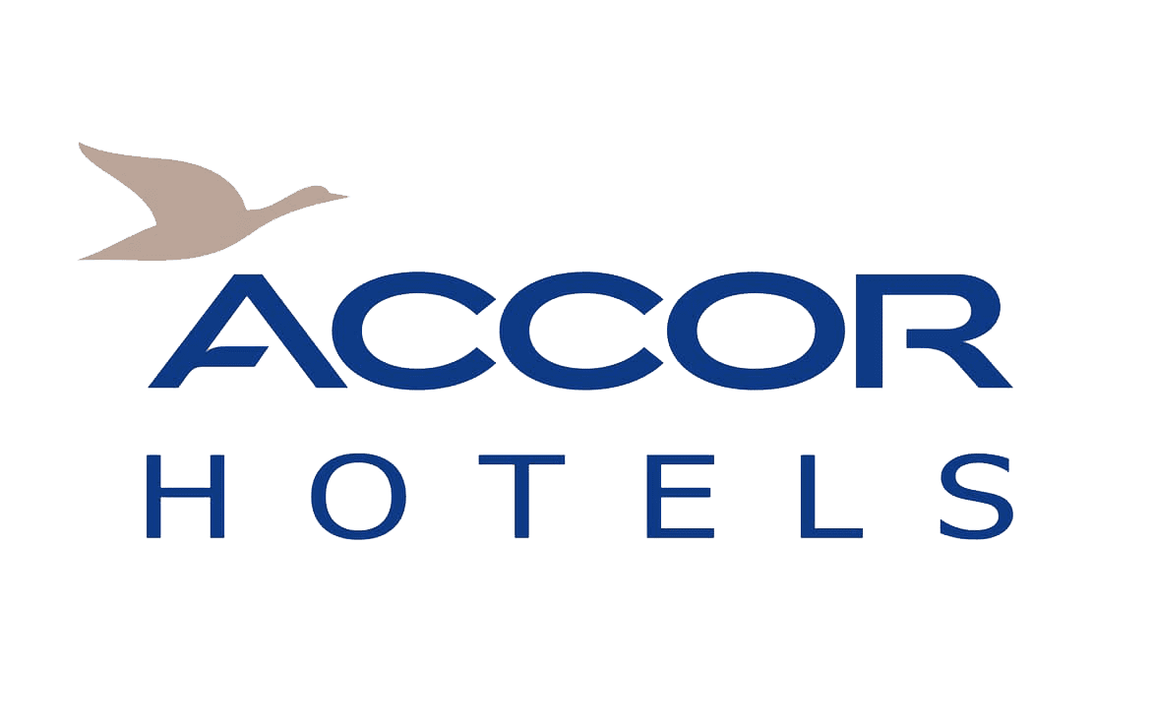

DEVEOPMENT PARTNERS


CAPABILITY STATEMENT

WHAT WE DO
Consult | Construct | Commission | Service
We work with our clients to develop and shape concepts into a clear, fit-for-purpose plan. | We bring concepts to reality with the utmost  accuracy and attention  to detail. | We remove risk  by maintaining the strictest adherence to safety and compliance standards. | Bla Bla
Whether it’s a major hospital or local primary school, we understand each and every facility inside and out.  Our clients’ benefit from LSP’s early involvement. Our in-depth understanding of what the end user needs combined with extensive industry experience means we can influence whole of life project outcomes, right from the outset. | We employ a team of highly skilled and trained trades, but more importantly, a team who  shares our passion for driving end user and client focused outcomes.  The LSP team is proud of  how we do business, working collaboratively, safely and pro-actively with our clients while remaining sensitive to  facility users within operational environments. | At LSP it’s not just words, we really are specialists in our field.  Working at the forefront of industry technology, we leave our clients with a safe and compliant installation. | Bla bla

PRODUCTS & SOLUTIONS
Smart Guest TV  Smart TV solution provides and manages quality of service, viewing experience, security, interactivity, and reliability. With vast IPTV & MATV experience, our Lifestylepanel engineers can assist with network design, product build and deployment of guest & Patient interactive systems to add value to your property asset. | 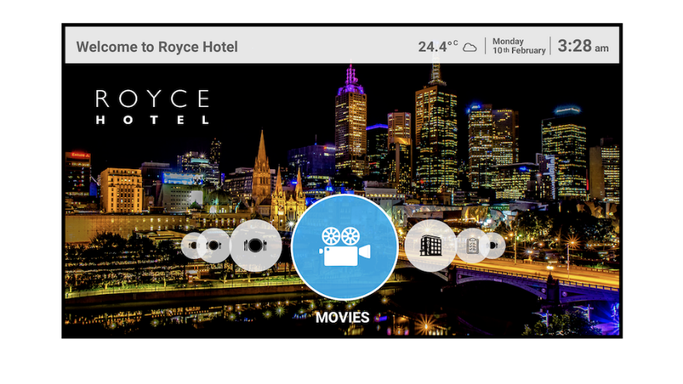
RTLS  LSP’s Real-Time Location Systems (RTLS) is an important component in modern facility management, enabling businesses to better track assets and personnel, improve workflow, and deliver better safety and security while cutting costs and bolstering the bottom line.  Included in the solution is a staff duress functionality. | 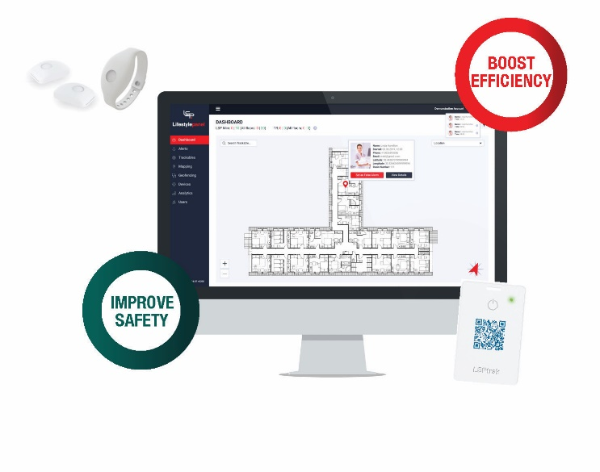
Guest Wi-Fi  Connectivity is a critical component in today’s modern world whether for business, keeping in touch with family or entertainment. LSP’s Guest Wi-Fi includes a secure managed network, managed bandwidth, pricing and devices & remote monitoring. |  | 
Chromecast  Enable guests to bring their own devices and content to seamlessly connect and play on the in-room TV. LSP’s casting includes a fully managed network, monitored bandwidth, and device, Wi-Fi connectivity, data and analytic reports. |  | 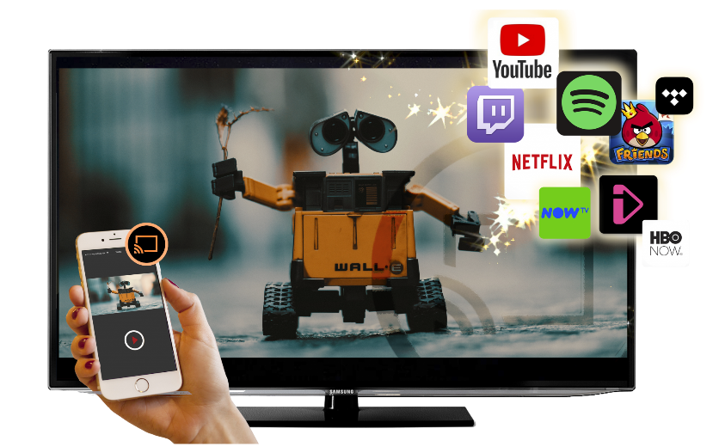
LSPcare  Patient engagement solutions (PES). With extensive industry experience, LSP is able to build the best outcomes together for this offering. LSPcare is a new generation software and hardware designed to meet the objectives of the Healthcare markets. |  | 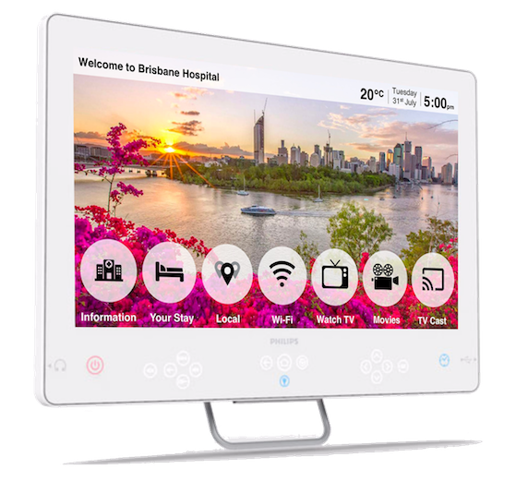
Food Ordering  Increase revenue across internal Food & Beverage outlets. Get the taste buds moving with hi-res images and facilitate simple on-screen Food & Beverage ordering via the TV from the comfort of the guest room. |  | 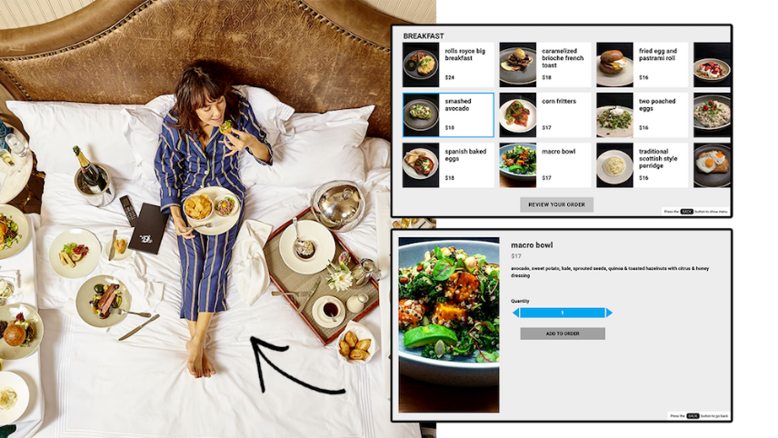
Digital Signage  Promote in-house services and specials throughout bars and restaurants, conference space or public areas. |  | 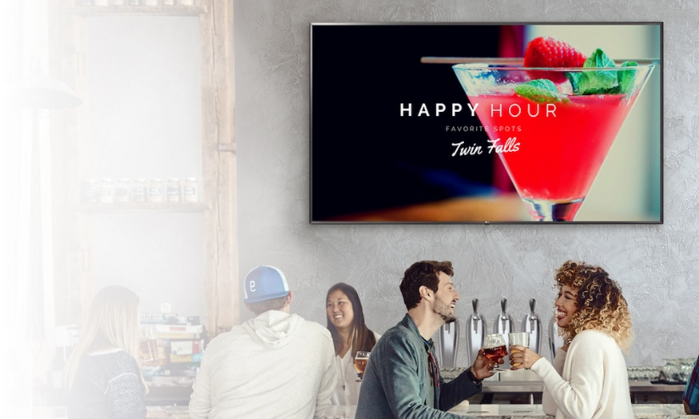

.

SALES & SERVICE

77 Logistics Place
Larapinta QLD 4110
Australia

2295 S Hiawassee Road, Suite 306
Orlando, Florida, 32835
United States of America

CONTACT

Australia: +61 7 3164 1100

USA: +1 951 660 1967

