Who We Are

Message from our CEO
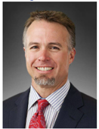
As President and Chief Executive Officer of Meritage Midstream Services II, LLC and its subsidiaries, Thunder Creek Gas Services, L.L.C. and Thunder Creek NGL Pipeline, LLC, (Meritage), I am excited to share our inaugural Meritage Environmental, Social, and Governance (ESG) Report. We believe that safety, integrity, passion, customer focus, investment stewardship, employee commitment, strong relationships, and positive impacts can only thrive in an environment of innovation and continuous improvement. This environment fosters safe, sustainable, risk managed value creation, enabling us to move forward with our goal to create sustainable value for all our stakeholders, including our investors, employees, customers, landowners, and the communities where we work. To do so, we will lead by example and inspire by working to become a premier midstream, best in class company that is a champion of innovation and sustainability and a model for customer service, value creation, and communication, creating mutual understanding and trust for our stakeholders. Our progress towards this vision is critical; it will enable us to improve our stakeholders’ quality of life, contribute to our nation’s energy independency, and work towards a sustainable collective future. We will continue to provide midstream services safely, sustainably, reliably, and responsibly in Wyoming’s Powder River Basin as we transition to a low carbon economy.
With this report, we demonstrate the strides we have made as corporate stewards, examining our climate change initiatives through our environmental impacts, recognizing our stakeholder impacts, and detailing our sustainability governance structures. We assess our material issues, risks, and opportunities for our midstream business as a responsible corporation and in the communities we work. We are committed to continuous transparency and accountability, and we look forward to discussing our process. Our achievements to date would not have been possible without our talented, innovative, and dedicated employees. They are key to our success.
I encourage you to read more about our company, performance, and sustainability focus, and I invite you to share your thoughts with us as we will continue to disclose our metrics and work to improve our performance while engaging with our stakeholders and minimizing our economic, environmental, and social impacts through strong corporate governance. We will communicate our progress and accomplishments on an annual basis as we work to become a premier, sustainable midstream company, creating value for all our stakeholders.
Nicholas O Thomas
Chief Executive Officer & President

Our overarching theme is Stewardship. Stewards of the environment. Stewards of stakeholder value. Stewards to our employees safety and wellbeing.
Needs to be kept in mind for theme. Slogan:
“Stewarding a sustainable path to stakeholder value in the Rockies”
- Story
- Stategy
- Principals / Values
Logo idea to blend – tree or some graphic that is growing / stewarding.


The Meritage Midstream Story
Founded in 2009, Meritage Midstream Services II, LLC (Meritage) and its subsidiaries in the Powder River Basin (i.e., Thunder Creek Gas Services, L.L.C. and Thunder Creek NGL Pipeline, LLC) provide oil and gas producers across North America with innovative midstream solutions and opportunities for growth. From our headquarters in Denver, Colorado and the strategic location of our assets in Wyoming, we deliver high quality integrated services to our customers while working to reduce the impacts of our operations, increase our efficiency, and ensure the safety of our workforce and assets. We are focused on building strong, long-term relationships with all of the stakeholders in our value chain, including our investors, employees, customers, landowners, and the communities where we work; we put our customer's critical business concerns first and act as a strategic partner. We have the financial support and expertise to act quickly and decisively, enabling our customers to take full advantage of opportunities in unconventional shale plays across the country.
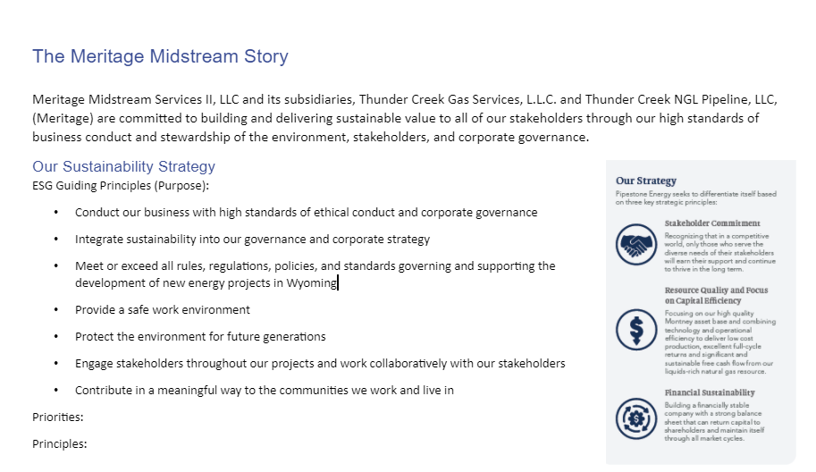

Need these graphs done up / graphically. Blended and created on a page.
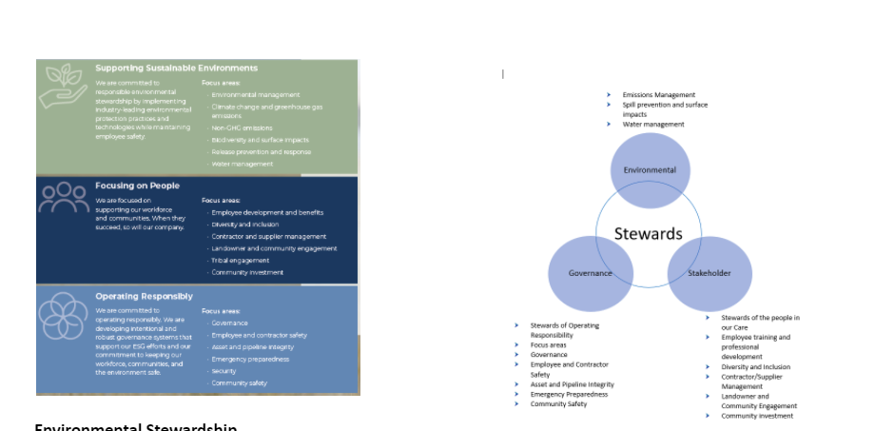
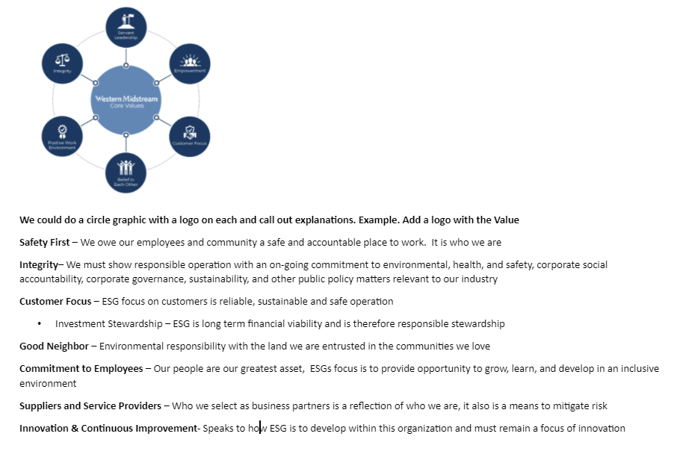

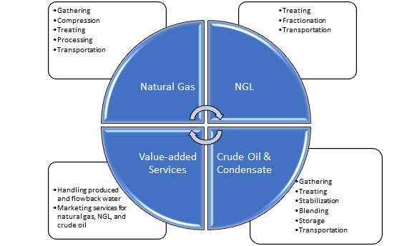
Here’s a graphic of the Meritage midstream services. Looking to add an oil and gas / better cleaner graphic with same info.

Meritage Midstream Timeline:
Hoping to make a neat graphic with a simple timeline. Showing large steps in history, along with increase in pipeline length and emission intensity. Different “bubble”s for different aspects.
See attached excel sheet with a timeline of key events for graphic creation.

Environment

We recognize that climate change is a prevalent global issue and that the world is transitioning to a lower-carbon future. We believe environmental stewardship is needed understand potential climate change risks to our business, so we can reduce our negative impacts, increase our positive impacts, and maintain our focus on our economic viability. We are committed to being proactive in our environmental work, utilizing Industry Best Practices, operating equipment efficiently, minimizing our emissions, and purchasing new low-carbon equipment, so we can avoid resources issues and mitigate negative issues resulting from our projects.

Emissions
As environmental stewards, we are committed to reducing our greenhouse gas (GHG) and non-GHG emissions to protect the environment and safeguard our stakeholders while we continue to operate safely and efficiently and transport our customers’ products to market. To track our emissions and measure our performance, we developed a reporting approach that includes mandatory and voluntary reporting requirements.
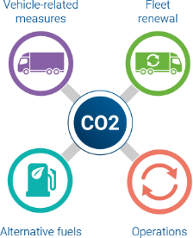
In 2020, our direct emissions intensity per BOE was 2.99%, which is a 9% increase from our 2019 intensity but accounts for the increase in our gross BOE throughput in 2020.
**Use figure to show that the 9% increase is equivalent to 132,694 barrels of oil being consumed

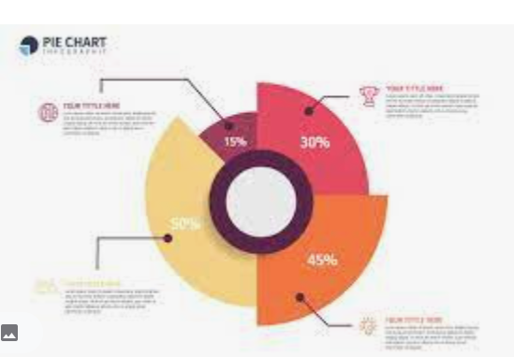
**Create figure/pie chart as per sample
**Percentage to show in Figure | **Verbiage –place as per sample
23% | Venting  Increased 23% from 2019 with the commissioning and operation of our 200 MMcf/d Steamboat Natural Gas Processing Plant in 2020.
1.6% | Flaring  Decreased 25% from 2019 with the completed construction and commissioning of Steamboat.
75% | Fuel Combustion  Increased 75% from 2019 with the commissioning and operation of Steamboat throughout 2020.
0.39% | Fugitives  Increased marginally by 0.39% from 2019 as we increased our measurement of these unintentional pneumatic leaks.

**Figure/Icon to add to page:
Flaring decreased 24.5% from 2019
**Use a car symbol to show the flaring % decrease is equivalent to 528 cars reduction driven in 1 year BOE increased 2.68%
 | Venting (CO₂e) | Flaring (CO₂e) | Combustion (CO₂e) | Fugitives (CO₂e) | Total | Gross Throughput (BOE)
2018 | 119,588.26 | 3,667.91 | 262,955.49 | 2,178.54 | 388,390.21 | 131,011
2019 | 89,527.97 | 9,899.99 | 370,684.49 | 1,230.22 | 471,342.67 | 173,713
2020 | 123,390.90 | 7,473.02 | 400,116.97 | 2,066.16 | 533,047.05 | 178,489

Emission Reduction Initiatives

See table below for graphic creation / improvement. Attached in better format for reading ease.
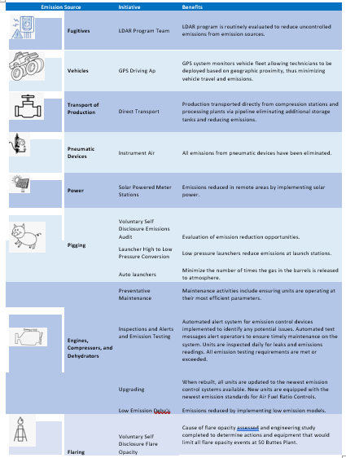

Would like to see a 2 large info graphic like these trees with call outs on side with the below as the call outs. Red is the start of each section for the graphic.

Can we use the Meritage Logo Leaves as the leaves or any ideas??

Environmental

Enviro
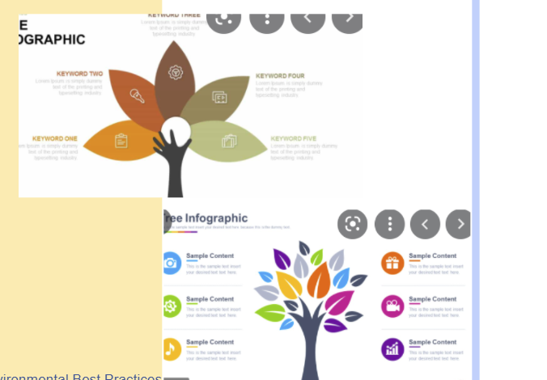

Water
Effective water stewardship creates value for our stakeholders, so we manage produced and flowback water by putting cost effective solutions in place at the well pad, creating value. We recover wastewater and provide takeaway and disposal solutions, resulting in safer, environmentally responsible operations and substantial cost savings by minimizing water-specific expenses and environmental and community impacts associated with trucking and emissions.

Biodiversity

Water Crossings
When land access restrictions prevent full delineations of potentially jurisdictional waters of the U.S. (WOUS) crossings and require subsequent threatened and endangered species assessments and historic property evaluations, we either bore the crossing or reroute the project to avoid the crossing or impact to a potential wetland.

Cultural Resources
There are cultural resources throughout the PRB that are important to landowners and other stakeholders, so we protect known historic properties and sites of potential traditional or religious cultural significance to Native American tribes through avoidance by resorting or boring our projects.
Wildlife
Meritage’s asset base is located in the Powder River Basin within the northern Great Plains. Home to bald and golden eagles, ferruginous hawks and other raptors, greater sage-grouse, and Ute Ladies’-tresses . . .

The below here would be another tree or something like that graphic with the bullets as graphical call outs

Best Practices in Action for Natural & Cultural Resources (Callout)
Meritage complies with the Bald and Golden Eagle Protection Act (BGEPA) and Migratory Bird Treaty Act (MBTA),
We implement best practices (e.g., like raptor nest avoidance) when we start a project . . .

- Dedicated Air Quality (AQ) team to manage company state and federal air compliance requirements.
- Spill Prevention Control and Countermeasure (SPCC) Plans in place for all of the company plants and stations.
- Stormwater Pollution Prevention Plans (SWPPP) permits in place for all ground disturbance activities for facilities and pipelines. Extensive pre-job planning program used for all company construction projects.
- Waste Management program to ensure compliance with state and federal waste regulations. Waste reduction program to continually look at ways to reduce or eliminate company generated waste streams.
- Community involvement program to work with landowners, the general public, and regulators on company initiatives and operations. Full compliance with Public Awareness Program (PAP) requirements on our company operations.
- Company team in place to permit and manage all environmental permitting addressing wildlife/biological, wetlands, cultural resources, and historical surveys/assessments and associated permitting.
- Regularly work with Environmental Consultants to build and manage a robust environmental program that ensures full compliance with federal and state laws and regulations, including the Clean Water Act, Endangered Species Act, Migratory Bird Treaty Act, National Historic Preservation Act, Wyoming State Executive order on Greater Sage-grouse, and Wyoming stormwater regulations. Part of our typical permit-related project pre-planning process involves review of natural and cultural resource concerns—including potential Waters of the U.S. (WOUS), plant and wildlife concerns, and any previously recorded historic properties or sites of potential concern to Native Americans, for cultural resources—and to conduct any associated fieldwork to avoid potential impacts to any identified natural and cultural resources of concern. For projects involving federal lands, which are subject to additional permitting requirements, this also includes preparing and submitting additional permit-related documents—including a Plan of Development which details results of the natural and cultural resources review, and reclamation, weed management, and stormwater plans—and conducting associated fieldwork and reporting.
- Company practice in place to bore all waterways and wetlands on pipeline construction projects to reduce impacts to environmentally sensitive areas.

Social
Meritage is committed to our relationships with our stakeholders, including our employees, local and state officials, investors, landowners, and the communities we work in. We are stewards of the people in our care. We are a growth-oriented company, and the success of our company is built on the successes of the people who drive that growth. The diversity of perspectives, skills, and backgrounds that make up our team equip us to effectively evaluate and execute projects and create sustainable, risk managed, long term growth plans.
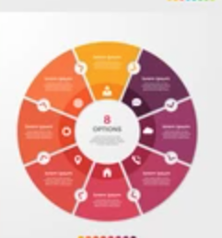

**Use the above template to create a social diagram with explanations; in the middle it should say: Stewardship of our Stakeholders
- Community Involvement – Good Neighbor: Our foundation is built on the communities that we serve and who serve us. With a long-term investment approach, we are growing with our communities by local employees, sourcing local service providers and contractors, supporting local contractors, consulting with these communities, supporting and volunteering with local charities and supporting local development through tax contributions and revenue generation
  - Volunteer examples:
    - Golf tournament that helps families with energy bills/ purchases
    - Friday lunch packing
    - Landowner relationships
    - Local high school, 4H
    - Donations
- Employee Engagement & Commitment: Establishing an inclusive work environment where our employees are engaged and motivated to reach their full potential requires that employees feel valued and respected
  - We put people first; we see value in our employees and their wellbeing
  - We have a high regard for employee health & safety
  - We utilize employee feedback surveys and performance evaluation system to understand our employee impacts
- Training & Development: Meritage encourages continuous personal and professional development for all employees. We believe that employees want to grow and be challenged, and we are committed to providing our people with a platform for that growth and the tools they need to pursue their goals and continue progressing
  - Professional development training
  - Diversity and Inclusion training
  - Corporate leadership development program – Command Ready
- Contractor and supplier management
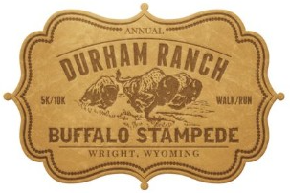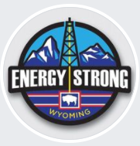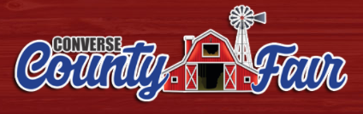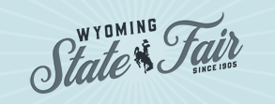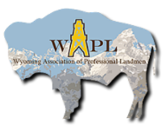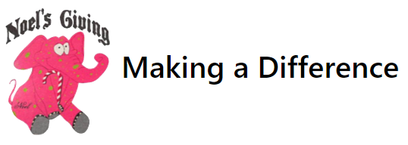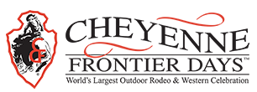

Safety
At Meritage, we believe safety performance is an integral part of our business success and corporate responsibility. Our culture emphasizes safety first, incorporating it into every aspect of our operations and level of our organization. By valuing life above all else and protecting our people, we are protecting their families, friends, fellow worker, management, the public, and the environment from far-reaching effects of serious accidents.
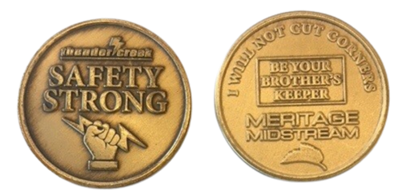

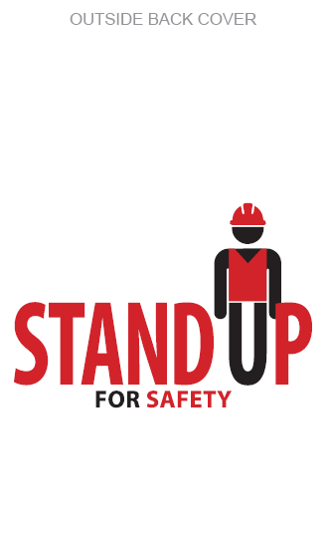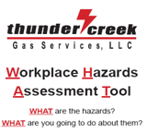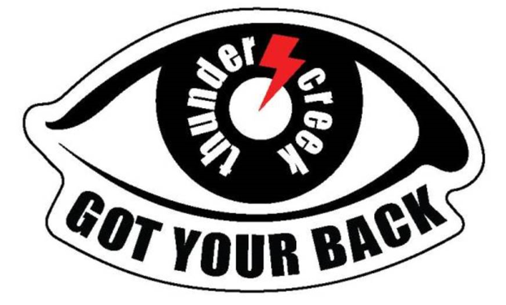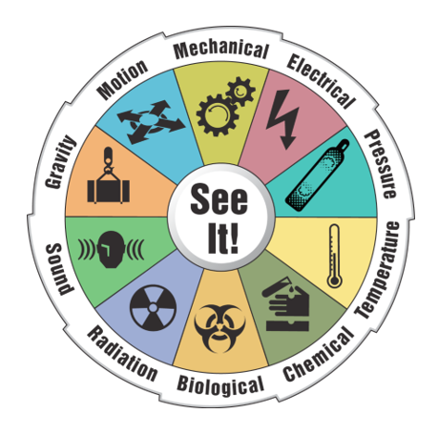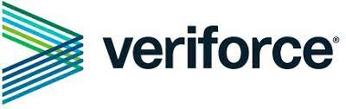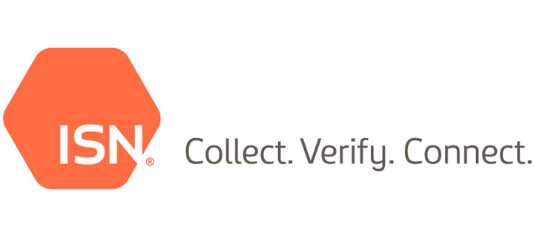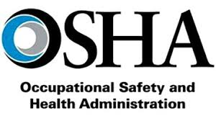
**Create a safety report card with icons from the following
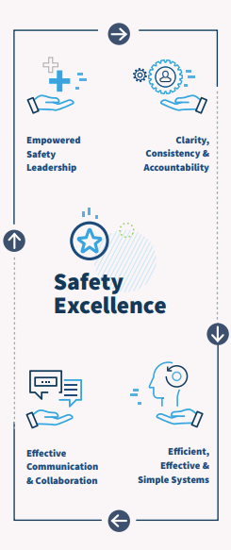

Safety First
- Empowered safety leadership
- Clarity, consistency, & accountability
- Safe working conditions
- Safety working programs & effective responses
          - Monthly safety meetings
          - Covid plan and response
          - Coyote program and incentives
- Safety training and development
          - Monthly Veriforce training
          - Cyber security training
          - E Computer-Based Training (CBT) required for all operations and office staff that work in the field.
          - HAZWOPER Emergency Response Training required for all operations and office staff that work in the field.
          - Routine operations training on compliance requirements covering state and federal environmental regulations and reporting requirements.
          - Operator training on spill response.
          - Operator training on DOT PHMSA pipeline Emergency Response plans.
          - Operator training on plant Emergency Response plans.

TRIR
For the last three years, Meritage has achieved below industry average based on GPA Midstream TRIR data

Governance & Business Practices
Our Board of Directors and leadership team believe strong corporate governance is essential to superior performance and stakeholder engagement. This past year we expanded our governance structure and improved our risk management processes to include sustainability risks.

Governance Structure
**Turn the following into a hierarchy using Meritage’s leaves.
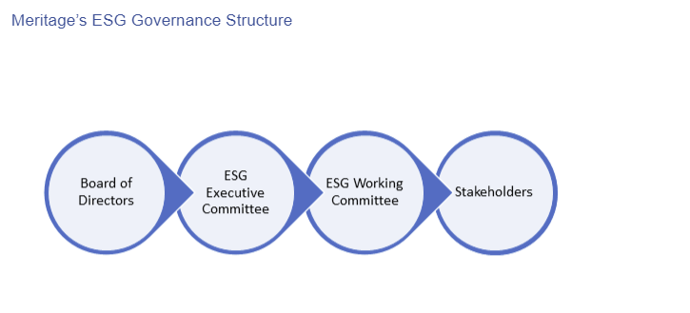
Board of Directors: Oversee climate-related and other sustainability risks and opportunities
ESG Executive Committee: Responsible for charting and executing the Company’s sustainability initiatives; comprised of all our C-Level resources, including our VP of HR and Director of Business Optimization
ESG Working Committee: Responsible for charting and executing Meritage’s sustainability initiatives; led by the Director of Business Optimization, this committee has representatives from each of the Company’s departments
Stakeholders: Engaged in Meritage’s sustainability initiatives and impacts

Risk Management
At Meritage, we are in the process of adding sustainability risk to our risk management process.

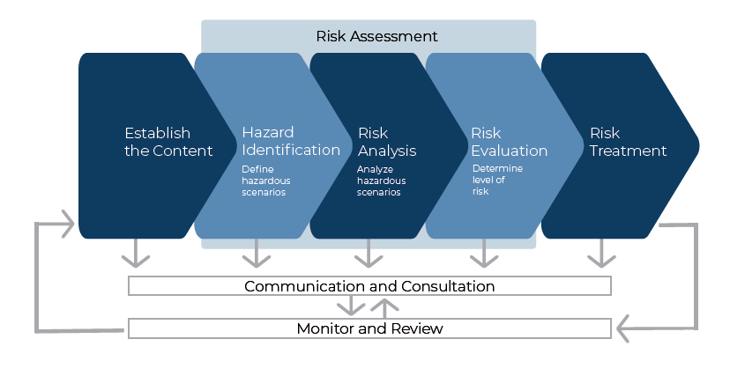
**Turn sample blocks into Meritage leaves. Risk Treatment: Avoidance or Mitigation
**Add icons to Environmental, social, and governance sections and then to each risk.
 | Risk | Risk Evaluation | Avoidance or Mitigation Technique
Environmental | Emissions to air | Emissions result in negative impacts on the environment and, emissions violations result in DEQ fines | Mitigate impacts and reduce emissions intensity with several initiatives, technology, and process measurement
Environmental | Waste management and hazardous materials | Liquid leak/spill in a High Consequence Area (HCA) | Mitigate leaks and potential negative impacts to biodiversity in high consequence areas through NGL Leak Detection System (i.e., CPM Leak Detection System install best available control technology (BACT) for detecting a pipeline leak with a computation pipeline monitoring (CPM) system)
Environmental | Asset integrity and process safety | Damage to asset base  Pipeline ruptures, leaks, or spills | Ensure asset integrity and process safety through avoidance by using complying with proper process safety throughout each asset's life and adhering to Meritage's leak detection and mitigation program.
Environmental | Permitting, compliance and enforcements | Noncompliant events | Mitigate by ensuring DOT Transmission Pipeline Risk Analysis - Risk Analysis/Assessment and Management throughout the asset's life
Social | Occupational Health and safety | Severe injury and potential workplace fatalities | Avoid injuries and fatalities through training and development, including the adoption of habits-based safety culture and best in class safety record
Social | Emergency Planning and Response | Unprepared actions or first responders in the event of an emergency | Mitigate through Emergency response plans to train employee base and local first responder on correct emergency action procedures
Governance | Business ethics and competition | Poor business climate and lack of competitive advantage for talented employees | Utilize ethical business best practices and positive work culture to mitigate lack of stakeholder engagement
Governance | Business resilience | Risks to credit worthiness and litigation | Develop risk committee and business controls to mitigate exposure
Governance | Cyber security | Data breach or damage to critical IT infrastructure and operations continuity | Utilize training and development, including cyber security training and security best practices to mitigate potential breaches and damage

