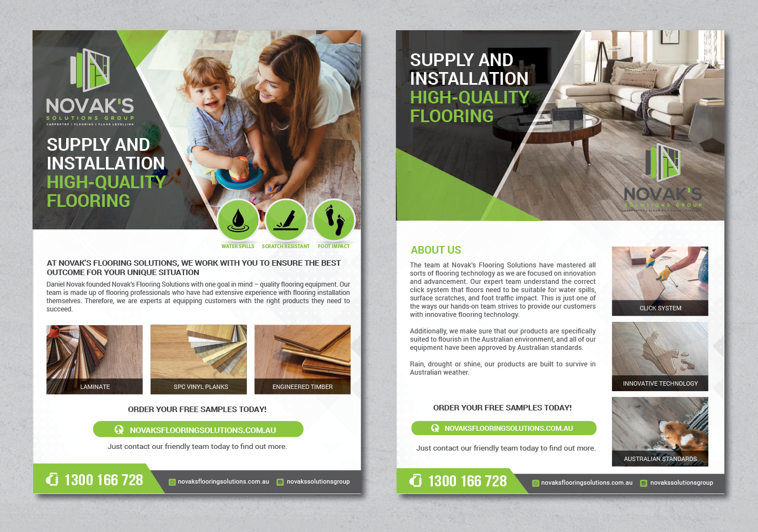
High-quality flooring
Supply and installation
---
Novak’s Flooring Solutions works with you to ensure you receive the best flooring solutions for your situation.
It is our mission to provide you with superior flooring materials to ensure that your project is stunning, long-lasting, and secure. Our skilled team of flooring professionals have had extensive experience with sourcing flooring equipment and flooring installation. We’re confident we can equip you with the flooring products and services you’re looking for.
---
ORDER YOUR FREE SAMPLES NOW
Contact our friendly team to find out more.
Why choose us?
The team at Novak’s Flooring Solutions have mastered modern flooring technology. Whether you’re flooring a residential or commercial property, we will ensure your flooring is suitable for water spills, surface scratches, and foot traffic impact.
Any product you receive from Novak’s Flooring Solutions is specifically designed to suit the Australian landscape and to meet Australian standards. Rain, drought or shine, our flooring supplies are built to last.
We service a range of project types, including:
- flooring office spaces
- flooring commercial apartments
- floor levelling
- floating floor installations
- flooring houses and apartments
- existing floor removals and disposal.

