The idea is to have a 360 degrees half sleeve (shoulders until just under the elbow) showing beautiful things in life. Black and white tattoo with some touches of colours.

I was seeing it as follows;

- This is what I have right now on my arm. The star represents Conquering challenges, so we need to connect it to the rest of the design. The triangles represent Balance. They need to also be connected to the rest of the sleeve being designed :

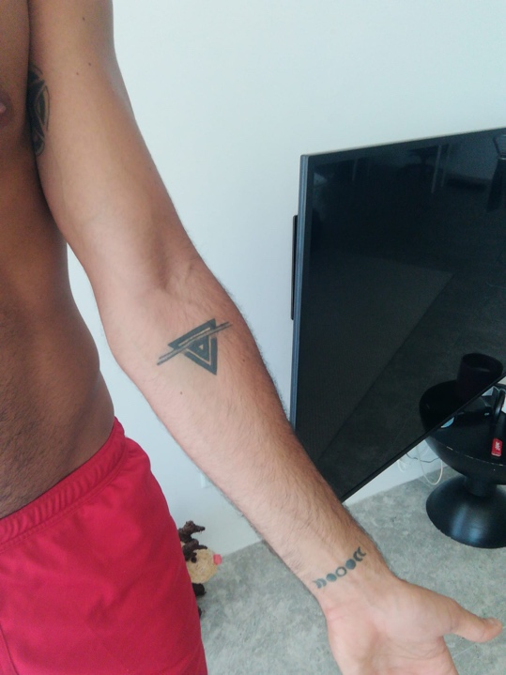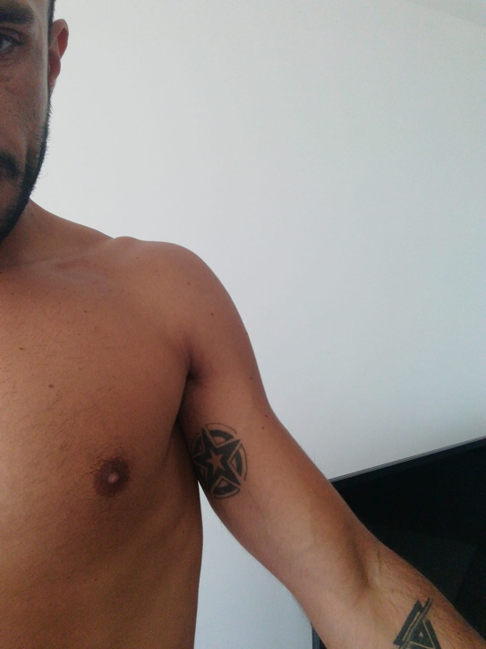

- Origin of Life. Example, Flower of life. I've shared some examples in the photos :

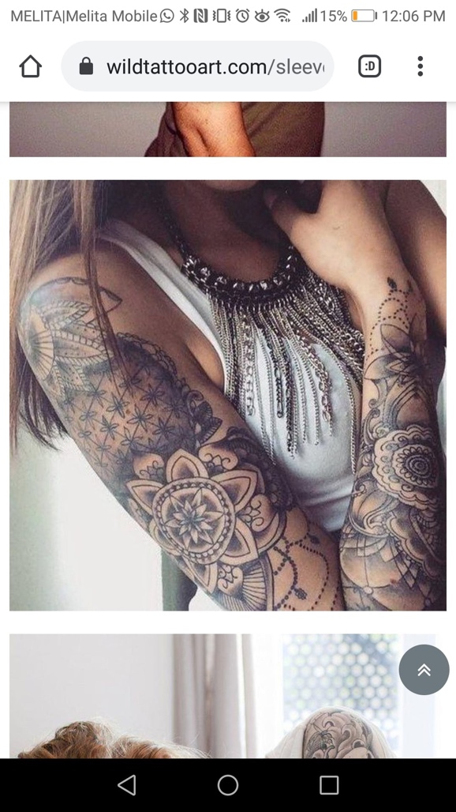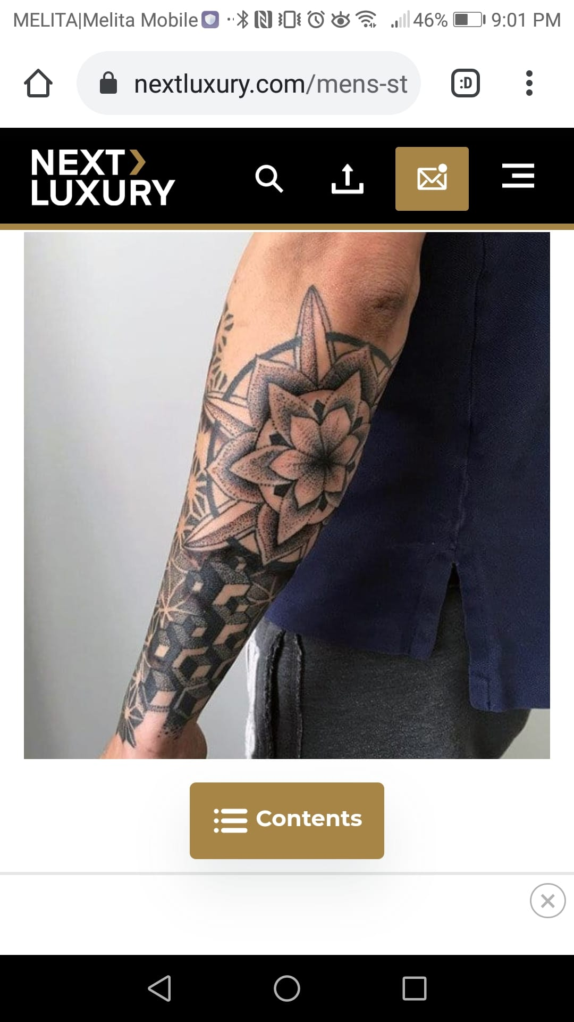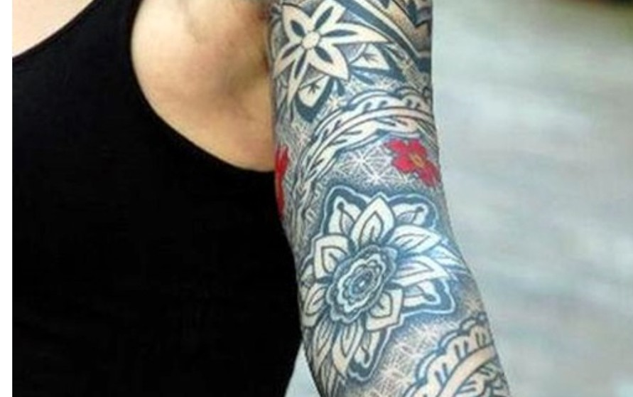

- Music connects people - I'm attaching something I like with a lion and a guitar in this case, which has to be changed to something related to people. Perhaps lion replaced with a face and keep the music keys around? This should be placed on the outside part of the arm :

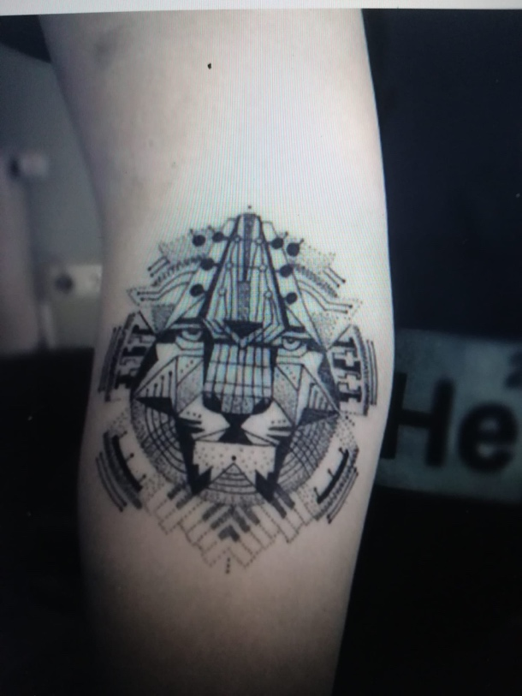

- Joy/Kindness - A grain. Shared two photos, one for the grain and one for colour shades. This should be placed at the tricep part at the back :

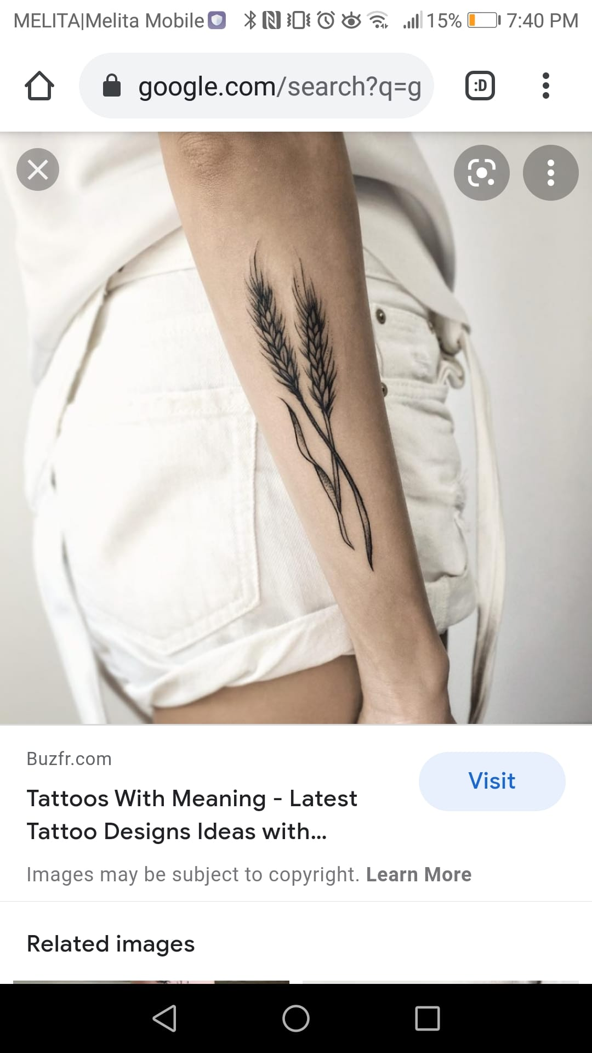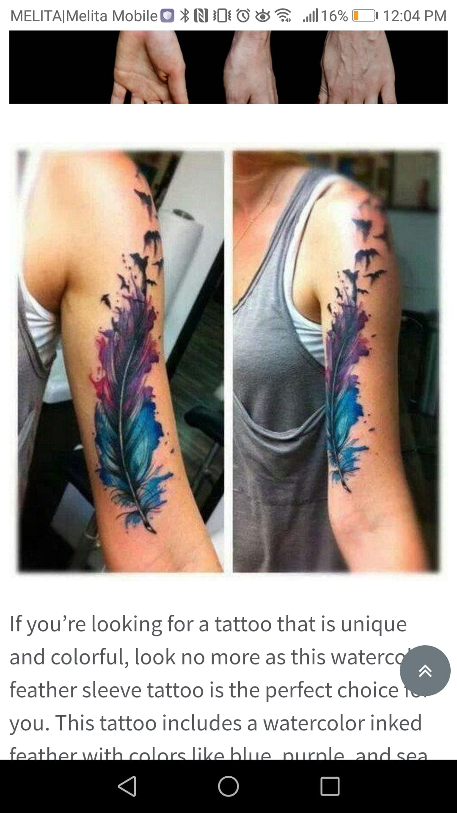

- Additional elements to combine (if necessary) :