Name your Project | Logo Design for Trendswear, a wholesale apparel brand
Project Description | Trendswear is an apparel brand, developed by the market leader in the Australasian promotional product industry. Our goal is to forge a place for Trendswear in the apparel industry.  Our quality unisex, men, women’s, and kid’s apparel is designed and developed in-house for wholesale distribution.  Our ideal Trendswear logo is straightforward, bold and reflects us as the leader we are.  The new logo will mostly be used on inner labels/ care labels and promotional material - it is not something that will be branded over the clothing as the apparel is designed to be custom branded by clients.  Please note: This is NOT a retail brand and will not be seen in stores or on the apparel.
Target Market | Promotional apparel resellers and distributors across Australia and New Zealand.
Logo Text | Trendswear or TRENDSWEAR
Must Haves | Black, text-based logo  Bold  Ambitious  Direct  Contemporary
Nice to Haves | We are open to a dot or something else to separate TRENDS and WEAR
Should Not Have | - Decorative, complicated font  - Cursive  - Colour

Logo Specs
Colours | Black
Logo Style
Look and Feel
  Elegant | o | o | o | o | o | o | o | o | o | o | Bold
  Playful | o | o | o | o | o | o | o | o | o | o | Serious
  Traditional | o | o | o | o | o | o | o | o | o | o | Modern
  Personable | o | o | o | o | o | o | o | o | o | o | Professional
  Feminine | o | o | o | o | o | o | o | o | o | o | Masculine
  Colourful | o | o | o | o | o | o | o | o | o | o | Conservative
  Economical | o | o | o | o | o | o | o | o | o | o | Upmarket
Font Styles | All Caps or Sentence case

Logo inspirations
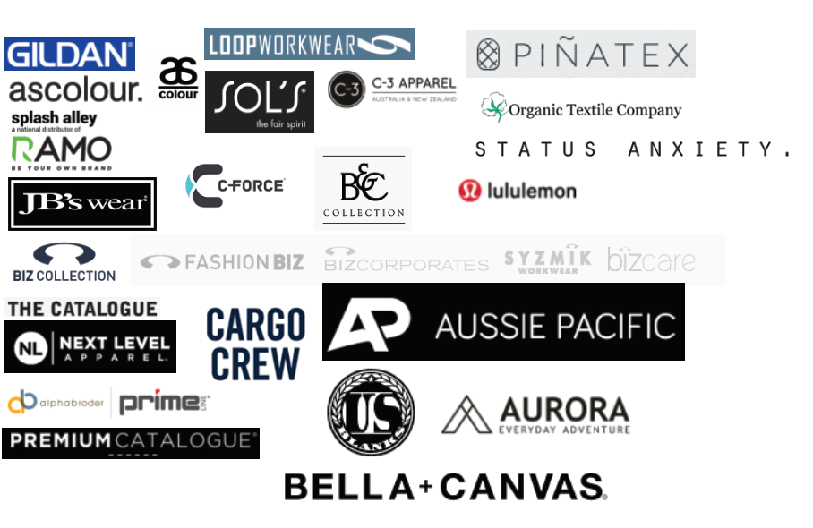
Font Inspiration
