
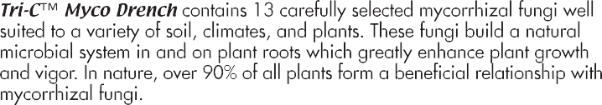

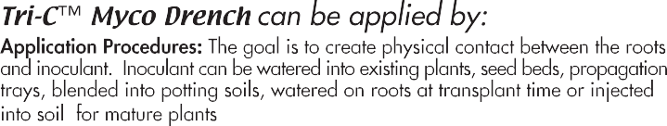


Beneficial Fungus | Propagules per CC
Endomycorrhiza:
Glomus intraradices | 4 per cc
Glomus aggregatum | 4 per cc
Glomus etunicatum | 4 per cc
Glomus mosseae | 4 per cc
Glomus monosporum | 4 per cc
Glomus deserticola | 4 per cc
Glomus clarum | 4 per cc
Gigaspora margarita | 4 per cc
Paraglomus brasilianum | 4 per cc
Ectomycorrhiza:
Pisolithus tinctorius | 1,100,000 per cc
Rhizopogon villosulus | 220,000 per cc
Rhizopogon luteolus | 220,000 per cc
Rhizopogon amylopogon | 220,000 per cc
Rhizogogon fulvigleba | 220,000 per cc

**Keep out of reach of children. May be harmful if swallowed.
Statement of Claims: Tri-C certifies that this product contains the indicated mycorrhizal fungi and propagule rates stated on the label. The mycorrhizal symbiosis is sensitive to environmental conditions and Tri-C is unable to make guarantees beyond the above statement.
May be mixed with mechanical equipment that allows passage of No. 50 screen
(300 microns) or larger particles.
Landscape / Trees / Shrubs Existing | Mix 1/2 of 1 lb. bag in 100 Gallons  Or 1 lb. bag in 200 Gallons of Water | Inject 1/2 Gallon per hole  Covers up to 400 trees or shrubs | 2 times per year  *More frequently for stressed plants | Spring and Fall March-June September-December  Use anytime roots active
Backfill Planting | Mix 1/2 of 1 lb. bag in 100 Gallons  Or 1 lb. bag in 200 Gallons of Water | Spray or pour on root balls until saturated, just before backfilling | Usually 1 application | Spring and Fall March-June September-December  Use anytime roots active
Nurseries | Mix 1/2 of 1 lb. bag in 100 Gallons  Or 1 lb. bag in 200 Gallons of Water | Soil drench in porous media  1 lb. treats 2000 sq,ft. small plants  1 lb. treats 4000 sq.ft. one gallon+ plants | Usually 1 application | Spring and Fall March-June September-December  Use anytime roots active
Turf | Mix 1/2 of 1 lb. bag in 100 Gallons  Or 1 lb. bag in 200 Gallons of Water | Spray 1/2 lb. per 1,000 sq.ft.  During Construction or Aerification  Porous Soils | 2 times per year | Spring and Fall March-June September-December  Use anytime roots active

EXPIRATION DATE:
Note:
Mycorrhizal fungi grow in a mutually beneficial association with plant roots. The mycorrhizal association occurs with nearly all turf, crop plants, ornamentals, herbaceous plants, shrubs, and trees. Tri-C Myco Drench™ contains mycorrhizal fungi that colonize plant roots and extend the root system into the surrounding soil greatly enhancing the absorptive surface area of root systems, forming an essential link between plant and soil, producing seedlings of the highest quality. The plant enjoys improved nutrient and water uptake, enhanced disease resistance and superior field performance. Tri-C Myco Drench™ can be stored in a cool dry area for 24 months without loss of viability.
1-800-927-3311 Fax: 909-590-3301 www.naturalSOILutions.com
email: sales@Tri-Corganics.com P.O. Box 1367, Chino, CA 91708-1367 USA

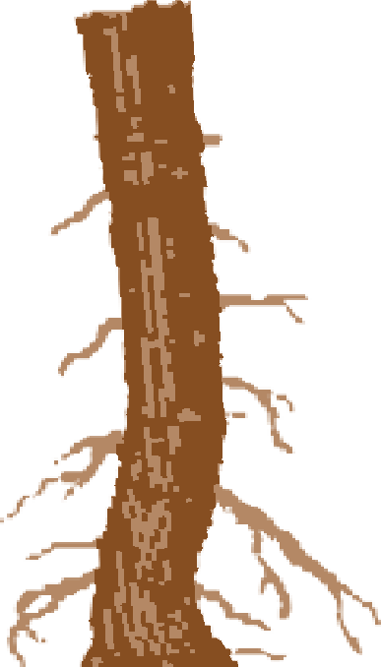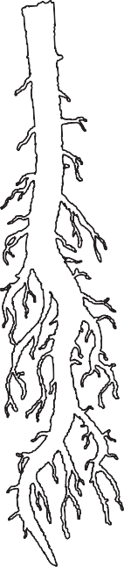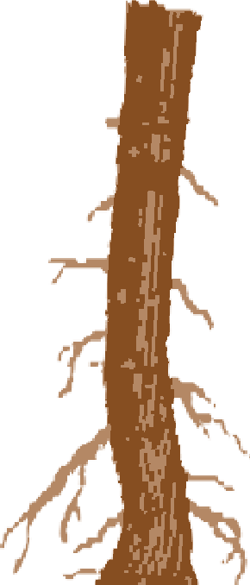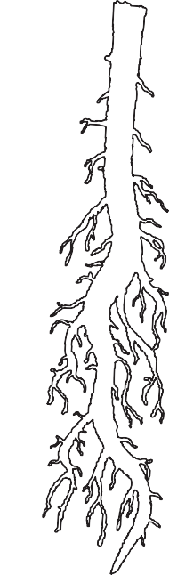
NON PL ANT FOOD INGREDIENT
25% Humic Acids derived from Leonardite

