Home
Membership packages
6.99 – buys you a membership + one entry to the Rolex …. draw
10.99 – buys you a membership + two entries to the Rolex …. Draw
15 – buys you a membership + three entries to the Rolex …. draw

WHO WE ARE
A 100% Australian owned company whose main goal is to create a community for people who love what we love – luxury watches!
Our Values
Loyalty – We always have our customers and the community at the heart of what we do.
Trust - We’re open and honest.
Respect – We do what we say and say what we do.
Commitment – We ensure that we dedicate our time to deliver the best experience for you.
Our Mission
To create a community where all members can feel a sense of belonginess with another. Our mission
Our Vision
To help
Our Purpose
Help us rebuild Australia one tree at a time.
How to Play.
Step 1. Pick a package.
Step 2. Enter Details
Step 3. Wait for draw – its that simple!
Contact us
Address – 26 Everingham Road Altona Meadows Vic 3028. info@thedeluxecollective.com.au – 0403 412 206.

About Us
We are a group of friends from Melbourne, Australia, who all share a common passion – a love for watches. We aim to provide an equal opportunity for all watch lovers in Australia, whilst, more importantly, paving the way for a cleaner, eco-friendlier world. We strongly believe that all communities, regardless of interests, should share a common goal, which is why we have joined forces with (TO BE CONFIRMED), whose main aim is to help plant trees across Australia to prevent deforestation in our own backyard. Our services are one of a kind, as each package sold goes towards planting trees in the much-needed regions of Australia. We hope you are excited as we are as we embark on this journey together!

Sample home pages
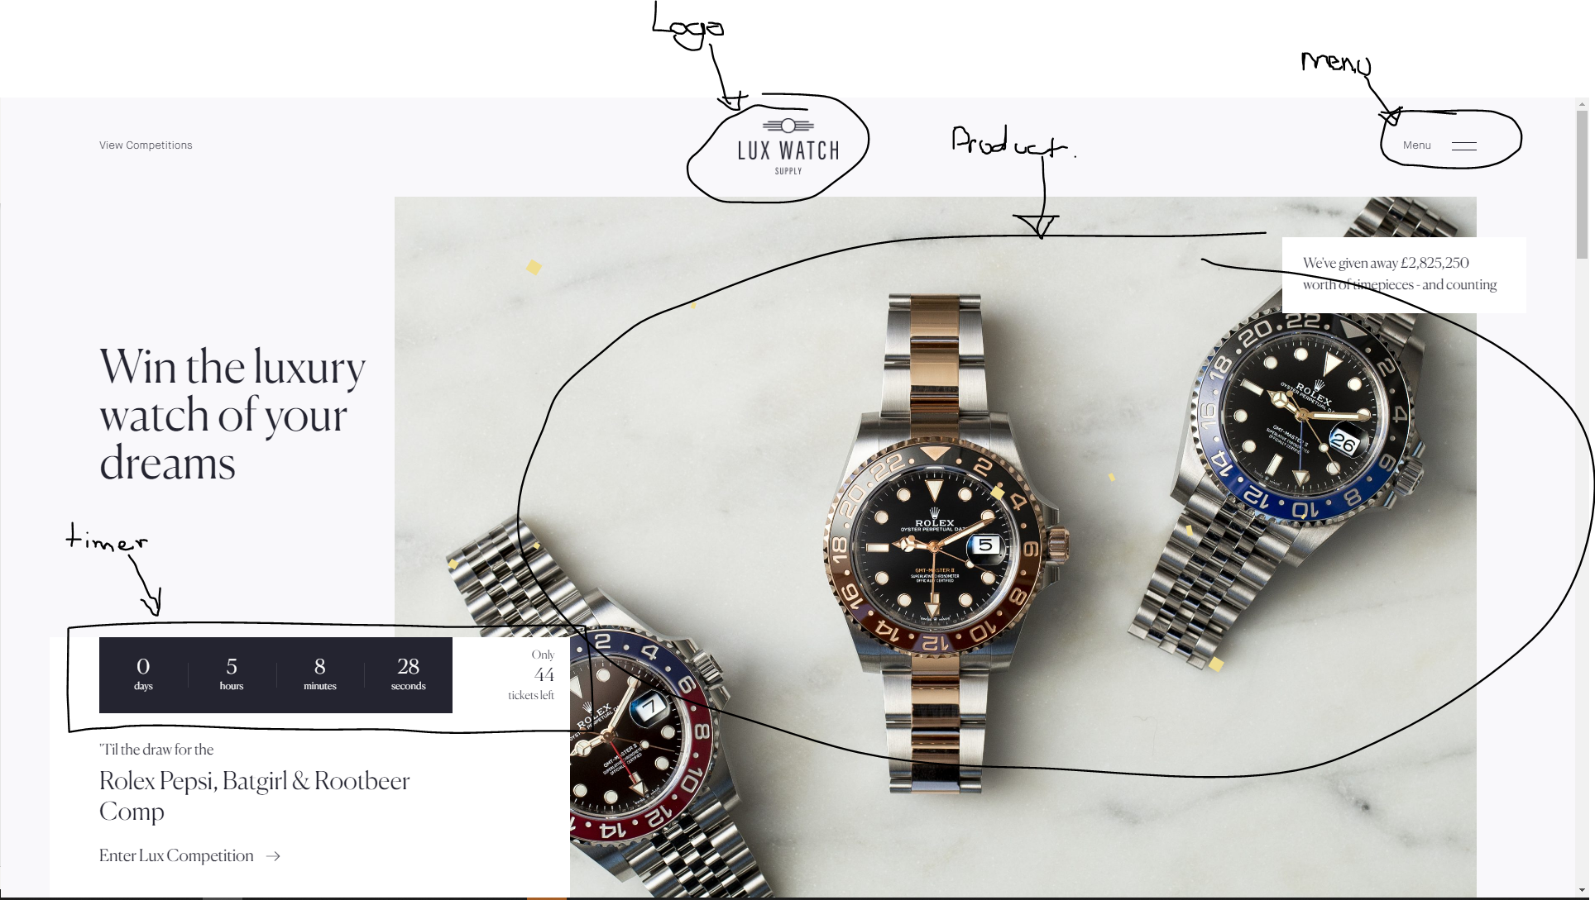

Terms And Conditions
The Deluxe Collective – (Name of item description here)
The Deluxe Collective Pty Ltd (hereinafter referred to as ‘The Deluxe Collective or ‘We’ or ‘Us’ or ‘Our’) is conducting a draw (hereinafter referred to as the ‘Contest’) for Individuals (hereinafter referred to as ‘Participant’ or ‘Participants’ or ‘Members’ or ‘Entrants’ or ‘Them’ or ‘You’ or ‘Your’). The Contest will commence on (insert date) at (insert time) and will conclude on the (insert date) at (insert time). The draw will take place at (insert time) on the (insert date) and will be held at (insert company name), (address). The winner will be drawn and contacted immediately via phone and email.

- Conditions of participant entry into the contest
We are giving away our (item) Valued at (price) and. For a participant to be eligible to enter the contest. They must purchase one of our official Memberships which will automatically enter them into the contest. Access to our Memberships will be provided by us on all our advertisements, Social media platforms and via contacting us directly. Please see our website for details on our Memberships at motorcultureaustralia.com/benefits
The contest is open to all Australian residents over the age of 18 who enter in accordance with the terms and conditions of entry.
- The participants are required to purchase one the available ticket packages via thedeluxecollective.com.au or via the links we provide on our social media platforms, which will automatically place them in the contest.
- By purchasing a ticket pack, depending on which option is selected, you will receive the follow amount of entries
1 ticket = one entry
2 ticket(s) – two entries; and so forth.
- The contest is going to be held at The Deluxe Collective, on the (insert date) at (insert time) (‘the event’). We welcome all participants and the public to attend.
- Our total prize pool is valued at (insert item value) which is made up of and will be drawn in the following order;
- 1st prize – (insert item description and value amount)
The winners of the contest will be drawn and announced live via our social media platforms at (time and date). The Winners will be published to our Facebook, Instagram and Website on the 17th July 2021. You can view the winners via this link: www.thedeluxecollective.com.au
- The 1st prize winner may alternatively opt to take a cash prize of $(lesser dollar amount value) instead of the vehicle
- The contest will be scrutinised by an official scrutineer and the winner will be contacted immediately via phone if they are not present at the event.
- We will deliver the prizes to the winners Australia-wide, within 21 business days of the event.
- If the prize is unclaimed for longer than the period of 90 days from the initial draw. This will be announced on the (date) and we will conduct a redraw and a new winner will be announced on the (date and time), at The Deluxe Collective. The winner of the redraw will be published to our Facebook, Instagram and Website on the 18th October, 2021. You can view the winners via this link: www.thedeluxecollective.com.au
- Items will be sent via express registered shipping with signature
- Items within Victoria will be delivered to in person.
- A photo of the winner and an official handover will be posted on all social media channels
- The contest is limited to the first 2,500 entrants only. Once we reach 2,500 participants, our draw will automatically be closed. We will announce this via our social media platforms shall we reach the limit. Please note, 2,500 entrants means 2,500 individual participants may enter, all of which may hold more than one entry in the competition. We will not publish how many individual entries are held by the participants combined.
- All purchases of Memberships are final and cannot be refunded.
- Every entrant has an equal and fair chance of winning each prize. Meaning, one entrant can win multiple prizes in the competition.
- Conditions of entry
- Participants shall be allowed to enter the contest given the following
- They agree to the terms and conditions of the contest
- Representation and Warranties of Motor Culture Australia
The Deluxe Collective Warrants the following;
- The vehicles involved in the contest are owned by The Deluxe Collective
- The purpose of this contest is to promote The Deluxe Collective brand and bring awareness to our brand and our community.
- Entries to the contest are strictly, and only provided as promotional prizes to The Deluxe Collective
- Entries cannot be purchased and will not be sold separately.
- The contest can be won by any participant who purchases a Membership from our website, or any official link.
- The contest is funded in whole, by Motor Culture Australia.
- The contest is solely promoted by (company name and abn)
- Representation and warranties of the participant
The Participant represents and warrants that it shall not contact any affiliate, employee, sponsor, or partner of Motor Culture Australia in order to manipulate the Contest results.
DISCLAIMER
By becoming a Member or Customer of Motor Culture Australia the Participant agrees to enter the Contest and Agrees that:
- Any and all disputes, claims and causes of action arising out of or in connection with the Contest and the promotional prizes shall be resolved individually with any form of class action;
- Any claims, judgments and awards shall be limited to actual out of pocket costs incurred in entering the Contest, but under no circumstances will Motor Culture Australia be responsible for any legal fees;
- Participants hereby waive all rights to claim punitive, incidental or consequential damage and any rights to have damages multiplied or otherwise increased and any other damages, other than damages for actual out of pocket expenses incurred in entering the contest.
- In no event will Motor Culture Australia, their licensees, parents, affiliates, subsidiaries and related companies, their advertising or promotional agencies or their respective officers, directors, employees, representatives and agents, be responsible or liable for any damages or losses of any kind, including direct, indirect, incidental, consequential or punitive damages arising from access to, or use of, this website, electronic or computer malfunctions, or entrant participation in this contest, even Motor Culture Australia was advised of the possibility of such damages.
- Motor Culture Australia reserves the right to disqualify any Participant found to be tampering with or otherwise abusing any aspect of this Contest as solely determined by Motor Culture Australia.
- In the event the Contest is compromised by non-authorised human intervention, tampering or other causes beyond the reasonable control of Motor Culture Australia, that corrupt or impair the administration, security, fairness or proper operation of the Contest, Motor Culture Australia reserves the right to suspend, modify or terminate the Contest.
- Any attempt by a Participant to deliberately damage the website or undermine the legitimate operation of this contest is a violation of criminal and civil laws, and should such an attempt be made, Motor Culture Australia reserves the right to seek damages from any such Participant to the fullest extent permitted by Law.
- Motor Culture Australia assumes no responsibility for any problems or technical malfunction of computer systems, servers, software, internet service provider, or e-mail systems, failure of any entry to be received on account of technical problems or incomplete, late, lost, damaged, illegible or misdirected electronic communications, or any combination thereof.
- The Contest is void where prohibited or restricted by law.
the administration, security, fairness or proper operation of the Contest, Motor Culture Australia reserves the right to suspend, modify or terminate the Contest.
- Any attempt by a Participant to deliberately damage the website or undermine the legitimate operation of this contest is a violation of criminal and civil laws, and should such an attempt be made, Motor Culture Australia reserves the right to seek damages from any such Participant to the fullest extent permitted by Law.
- Motor Culture Australia assumes no responsibility for any problems or technical malfunction of computer systems, servers, software, internet service provider, or e-mail systems, failure of any entry to be received on account of technical problems or incomplete, late, lost, damaged, illegible or misdirected electronic communications, or any combination thereof.
- The Contest is void where prohibited or restricted by law.
- This Terms and Conditions is the property of Motor Culture Australia, you may not copy or distribute any part of this material without prior written approval from Motor Culture Australia. Any plagiarism or misuse of this material will carry legal consequence.
Licence Number: ACT TP 21/00896, TP/01099

