T-shirt and hoodie design
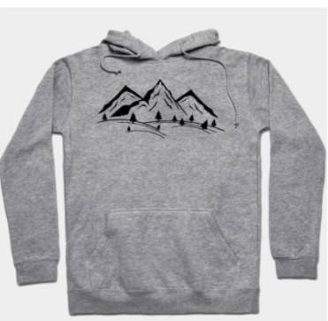
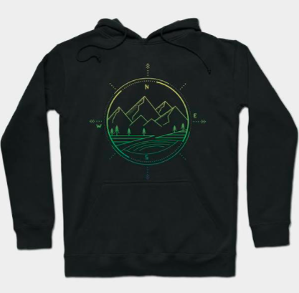
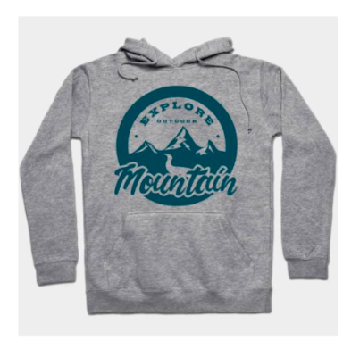
Sample Designs

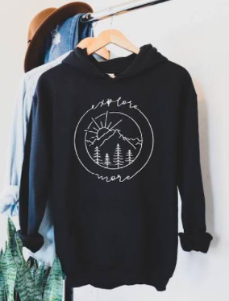
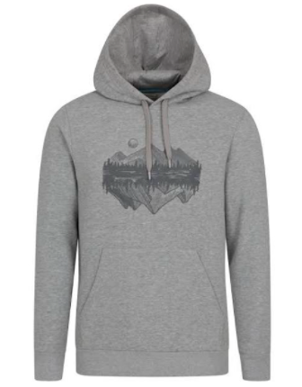
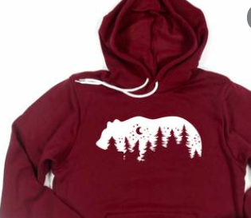

Kickback Outdoors Logos

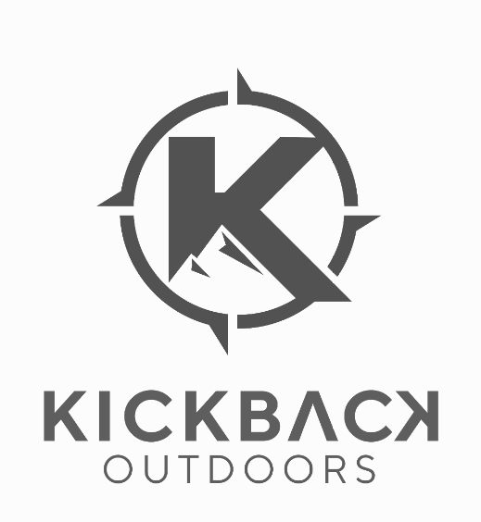

Description
- Images on front of hoodie/s-shirt only (nothing on back)
- A unique design based off the attached Kickback Outdoors logos
- It should in some way have the logo or brand name (Kickback Outdoors in it)
- It should capture the essence of the outdoors/camping/hiking
- I like the way the words are a part of the circle in the largest sample design above
- I don’t want too large of an image on the front of the hoodie/t-shirt

