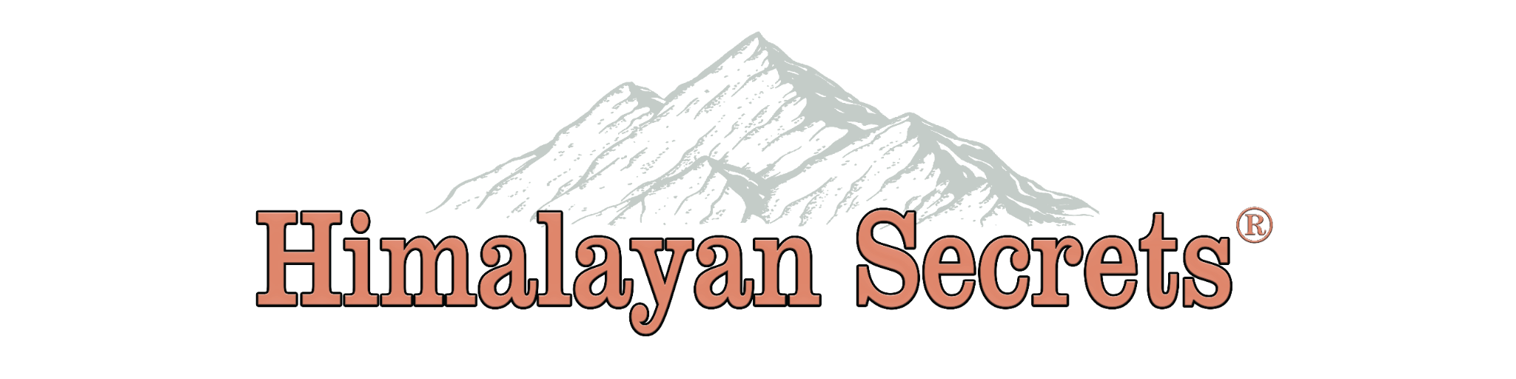

Himalayan Secrets Logo Development
We are looking to UPDATE and/or RE-INVENT our current logo, “above”

- Logo should be very similar to current logo, just more modernized
- Logo should be versatile and able to adapt to any digital media/ social media platform
- Logo should be able to adapt to different color types, such as black & white, or other projects like “Rainbow Colors” for pride month, and other events in similar nature
- Looking for minimalist design, that stands out and is simple and sleek at the same time

Current Cons
- Bland, does not stick out, getting outdated
- Issue with printing, mountain design always trouble with printing. Especially embroidery
- Font is no longer available, have a lot of trouble maintaining logo
- It is too wide, so it is difficult to fit into squares, FB profile pic or other social media
- Has been copied a lot. A lot of companies have copied the mountain above the work mark type logo. We want to change and be different from others, competition

Current Pros
- Nice colors
- Easily readable and recognizable
- The mountains go alongside the work “Himalayans”

Special Request
- We are debating whether to get rid of the mountain design as so many companies selling similar products have a similar logo, but afraid to do so unless someone is brave enough to create a design that eliminates the mountain, or makes it stand out differently from what is on the market.
- Products are imported from Pakistan, we were hoping or wondering if the Pakistan Flag could somehow secretly be embedded somewhere in the logo. This is not a must, but a cool idea.

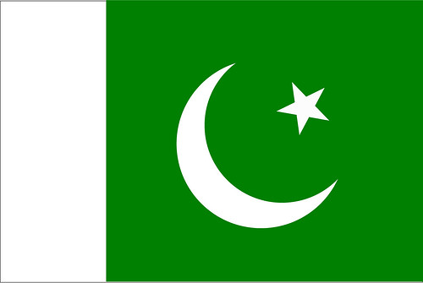 Pakistan Flag
This Photo by Unknown Author is licensed under CC BY-NC-ND

