Our background:
Since its inception in 1998, Road Rules Driving School has strived to help drivers maintain their driving independence while leading safe and productive lives. Our motto “making drivers safe for life” drives our vision of helping drivers across industries and at all stages of our driving careers.
Road Rules started out working with school boards to deliver driver training to beginner drivers. Thousands of students have graduated from our ministry-approved curriculum. We are also ministry-approved to instruct defensive driving (DDC) and driver improvement courses (DIC), for drivers with speeding tickets, demerit points and at fault crashes.
Road Rules has also evolved to provide comprehensive driver rehabilitation to those who have lost, or are at risk of losing their license for medical reasons. This includes mobility issues requiring adaptive equipment, as well as traumatic crashes resulting in cognitive impairments and PTSD. We work with clients before the courts charged with impaired driving (alcohol, cannabis, opioids), road rage and stunt driving.
Founder Matthew Rivers started driving at an early age on his parent’s farm. Driving professionally and doing so safely is in his DNA. Matthew has a degree in Business and Psychology and is a certified in-car and in-class driving instructor.

Maintaining
driving independence,
while leading
safe and
productive
lives!

For more information:

Call: 705-874-9220
mrivers@roadrulesdrivingschool.ca
www.roadrulesdrivingschool.ca

Road Rage
Enjoy the ride

A 1-day educational course for those
charged with Road Rage.



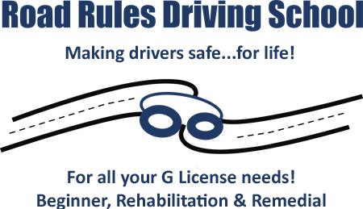

A 1-day, 7-hour, intensive remedial measures course for those charged with road rage.

Our goal is to equip our customers with knowledge and to help them avoid something devastating and/or irreversible from happening in the future.

Topics covered:
Law:
- Highway Traffic Act (privilege vs right)
- Federal and Provincial
- Implications of criminal record (financial, work, relationships, etc.)

Road Rage:
- Triggers
- Personality types (Type A); Holmes & Rahe stress scale
- Aggressive driving (overlap between aggressors and victims)
- Psychiatric issues/PTSD: Not uncommon to have professional drivers come through the course due to over-exposure to stress from driving (both on the job or the commute to their driving job)

Physiology and the negative impacts of stress on the body
- Fight or flight response: how it works
- Hormones (Adrenaline, Cortisol, etc.)
- Chronic levels of exposure/Immune system suppression, hypertension
- Substances (will do brief overview of drinking and driving if relevant i.e., individual risk factors and thresholds)

Strategies to manage:
- Window of tolerance (hyper-arousal vs hypo-arousal)
- Breathing: how to have the cerebral part of the brain making decisions and not “lizard” part of brain
- We look at how our bodies have not kept up from an evolutionary point of view to manage daily stresses and stimuli
- Our habits: approx.. 50% of our decisions are made with little to no decision-making process; stages of change theory

Personal context:
- Genetics & socialization (role models & predispositions)
- Analysis of triggers leading up to event; what is really causing it, e.g., sometimes it can be systemic such as our commute

Defensive Driving skills:
- The golden rule: Following distance
- Defensive stopping (what we should do every time we apply brakes)
- Using your eyes and strategic driving
- Driving in adverse conditions-they exist every time we drive (human, environmental, machine)

Courses are individually tailored
one-on-one.

OFFERED REMOTELY!



Course Cost: $775.00 + HST.

