Iron Deficiency Anemia
Common foods in your community
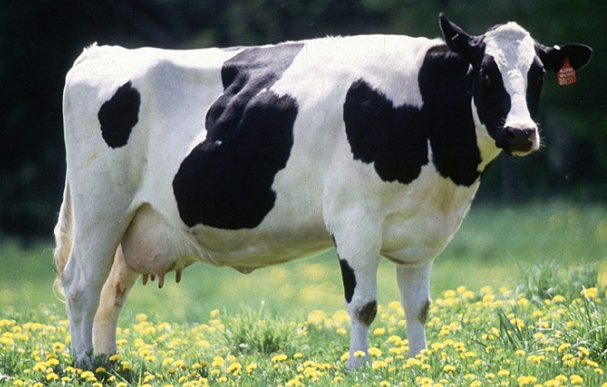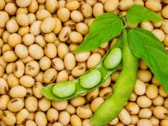
Sheep/lamb goose whale winged bean rice bran white bean pig/pork kidney bean cowpea black bean mung bean natto teff amaranth yardlong bean chili/pink bean lentil yellow bean duck lima bean chicken clams pumpkin seen squab pigeon pea fava bean sesame seed aduzki bean cranberry bean masa split peas cuttlefish bear sunflower seed bagel sardines ckickpeas shrimp spinach beet brussle sprouts egg collard greens muschrooms nuts potatoe tortilla turkey blackberry broccoli carrot califlower halibut tomatoe

Either same page or next page:
Symptoms of Anemia
Fatigue headache dizziness blurry vision muscle weakness

Signs of Anemia
