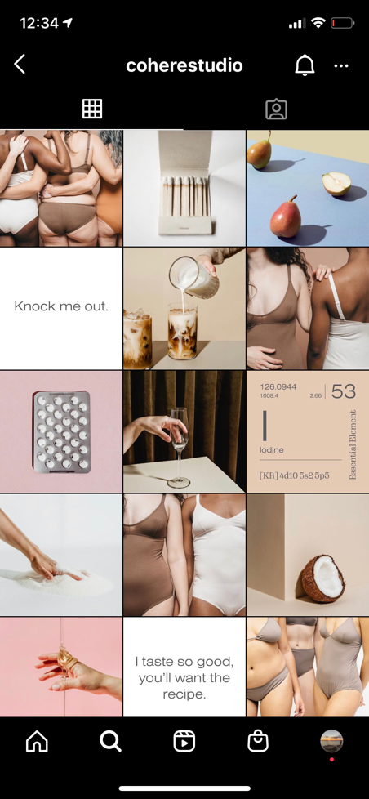
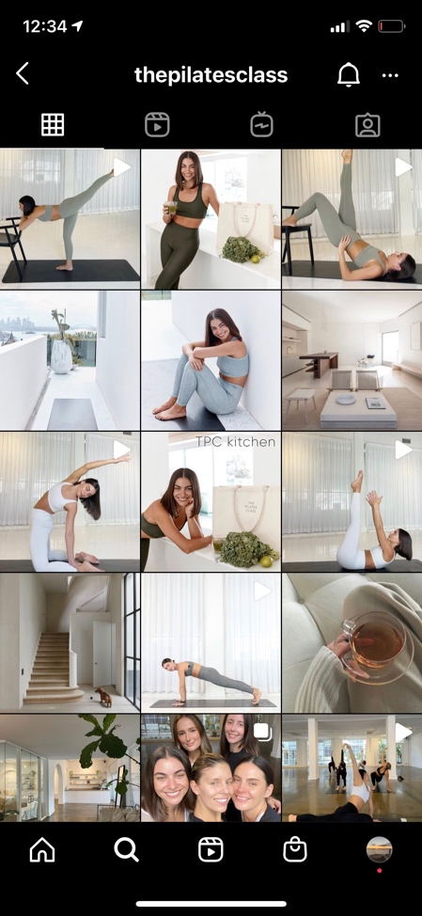
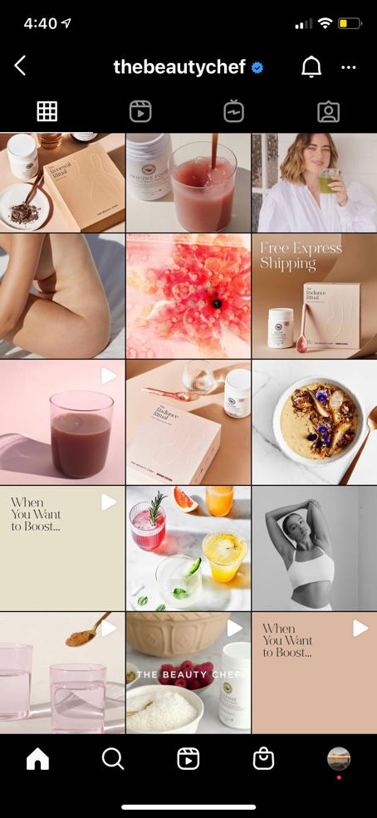

- Simplicity
- Colours – soft palette
- Different body shapes, food, alcohol and also exercise positions
- Text boxes that lead you onto another slide or recipe
- The Pilates class – reels or slides of workouts
- Does weekly challenges for followers

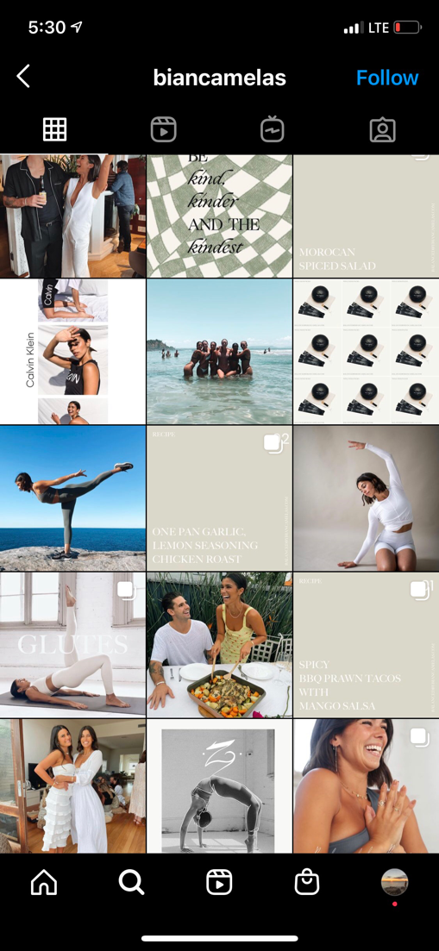
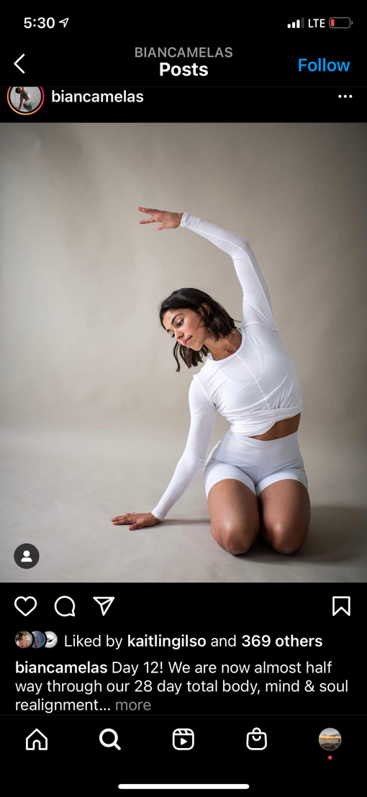

- Incorporates both fitness lifestyle with her own personal – cooking, boyfriend, friends etc
- Soft, subtle colour palette
- Text squares that lead onto another slide – captures the reader more
- Love the simple poses and also a slide show of a workout

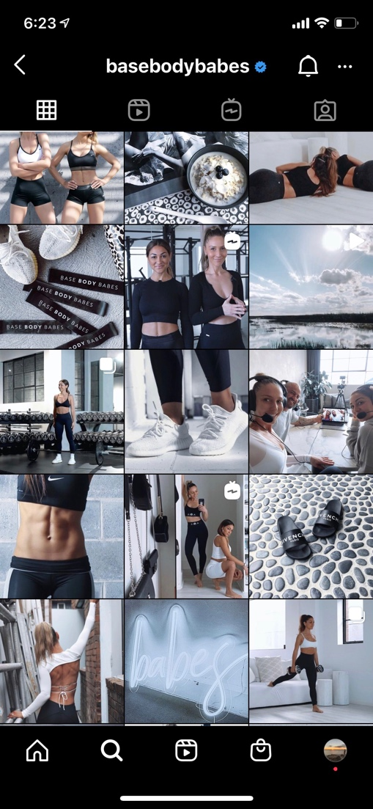
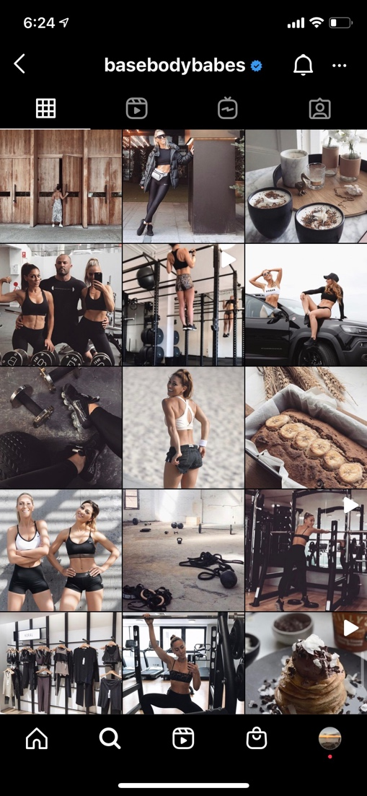

- Colour scheme; changes colour tone throughout their page
- Encourage strength training for women -post workouts, technique cues and warm up/mobility exercises
- Cooking/baking food included
- Incorporate photos of brands they have tried and tested – being authentic with readers

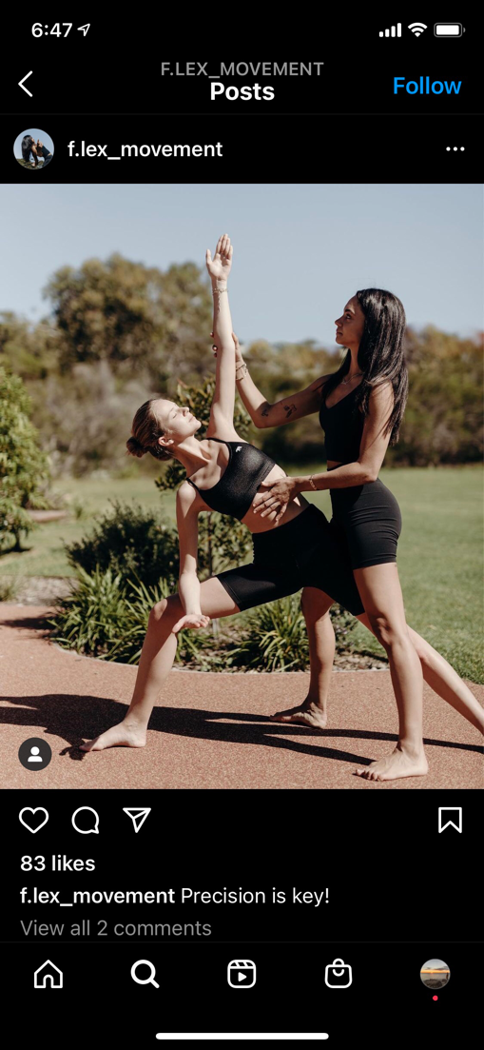
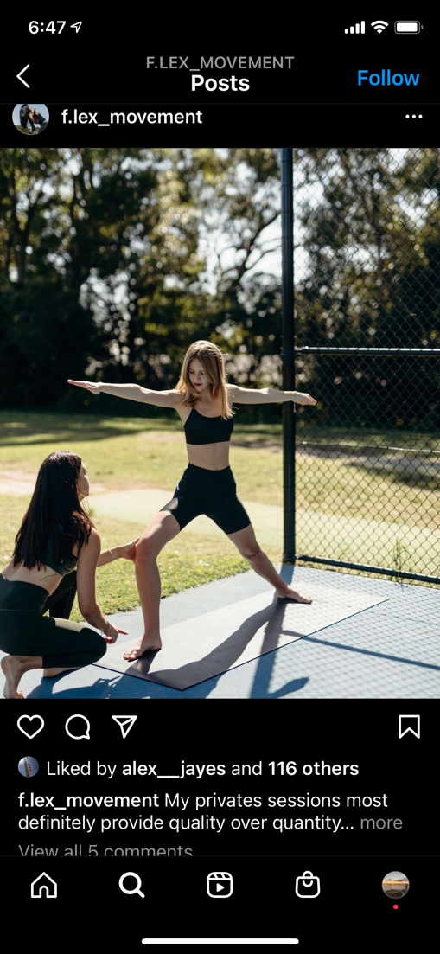
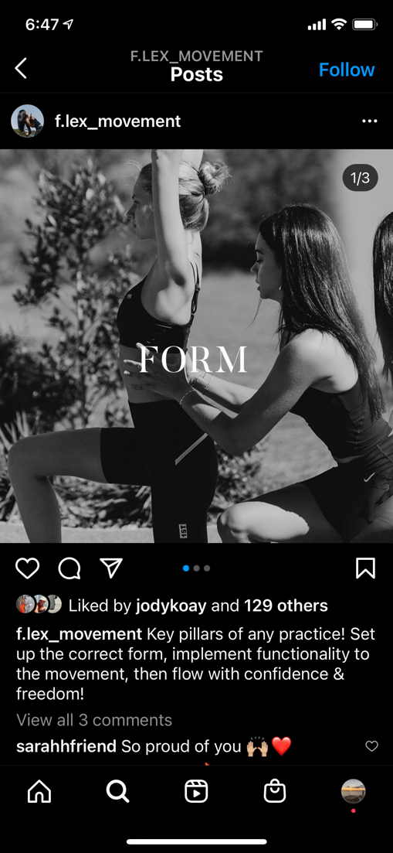
- Focuses strongly on form and technique
- Not just another page of clients doing a group workout, instructor there to correct and cue each exercise- unique
- Focuses a lot on the principles of Pilates throughout her feed
- Posts about common conditions – aches and pains and simple stretches/exercises to help eliminate them

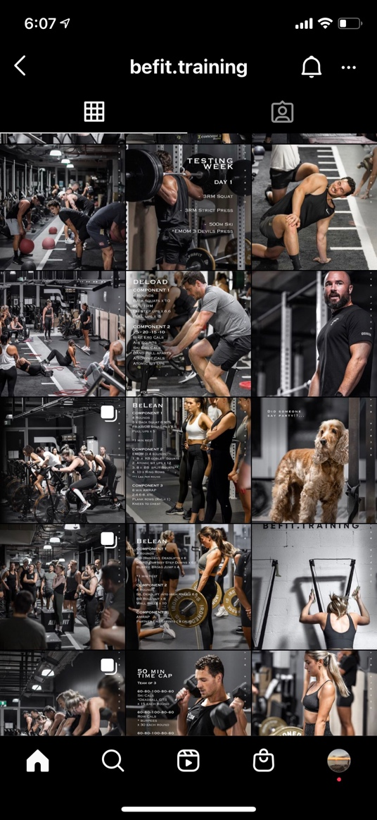
- Their style of training I personally love (strength and conditioning)
- Love the community feel they portray throughout their page
- Style of their page – down the middle is written workouts to do at home, sides are groups or singles

Bio

Born and raised on the beaches of Clovelly, Sydney – my new home in Dubai has grown on me and I love the opportunities we have – to meet people, experience things, be ourselves and generally embrace life.
An energetic and active lifestyle has always been at the core of my upbringing and Dubai only ignites this passion further
I have a degree in nutrition and have always been fascinated with the human body – looking after it, nourishing it, improving it – and of course having fun.
Food, culture, people, experiences, travel – and my two beautiful cats are just some of the things I love most

- Holistic approach
- Training with no judgment – desserts, treats and our infamous Dubai brunches are part of our lifestyle and I can help find the right balance for you to do the things you love and love the things you do
- Focus on form and technique and not just numbers and repetition

