The photos marked (A) are the photos I would like on the catalogue. The photos marked B and C are lower grade and use as needed.
ENSURE PHOTOS, VISUALS, DESIGNS ARE ALL INCLUDED. THIS IS WHY I HAVE PROVIDED THE DRAFT.
RECREATE THE DRAFT AND WORK FROM THERE.
USE THIS GOOGLE DOCS FOLDER FOR ALL THE SPRITES YOU NEED
https://drive.google.com/drive/folders/1cLYjcgBm1oh6T4ELjb26GTzgGU-TP5Tr?usp=sharing

[[[COVER DESIGN]]]
Similar to draft but using the photo IMG_0457 (A). Color grade this to suit the design.

[[[PAGE 1]]]
Use the About us page (https://www.firstchoicelabour.com.au/about/)

INDUSTRY LEADING RECRUITMENT & LABOUR HIRE AGENCY IN NEW SOUTH WALES
At First Choice, we’re all about ensuring our clients achieve their goals and succeed in their field. This is why so many construction companies have trusted us in providing qualified workers for their projects. Make an enquiry and watch these words be put into action.
INSPIRING OTHERS.
ACHIEVING GOALS.
WORKING TO SUCCEED.
We are extremely passionate about what we do, excellence in the Labour Hire industry has become second nature for us. We work to give you many reasons to engage with First Choice services. We have become a well renowned Recruitment & Labour Hire company by upholding the following values:

[[[[PAGE 2]]]]
WHY US?
[REFER TO 'ABOUT US' PAGE - UNDER 'OUR PROCESS'. Use the 'EMPLOYER' side.

[[[[PAGE 3]]]]
A BIT OF AN INSIGHT
We are an industry leading permanent recruitment and labour hire company who pride ourselves on having the highest of quality workers whilst maintaining greatest efficiency possible for clients. We are no strangers to the industries we serve and possess extensive experience and knowledge in our field.

Our mission is simple – to leave a profound service of excellence in the construction industry without the exorbitant staffing costs for client requirements. We achieve this outcome through stringent screening processes in aim of engaging only the most experienced candidates for our clients. We deliver highly competitive pricing through maintaining low overheads and efficient processes in place to ensure your project budgets are met.
Add some photos here, blend them in with the design. Add some icons like the draft.

[[[PAGE 4]]]
OUR SERVICES
Similar to the draft with the icons, add:
- Labour Hire
- Crane Supply
- Rigging
- Traffic Control
- Commercial Cleaning
- Tiling (Supply & Install)
- Machine Hire
Please allow a little space under each title to add a brief description.

[[[PAGE 5]]]
LABOUR HIRE
Include this from the home page:
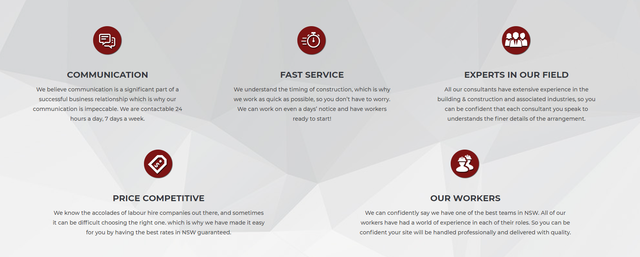
Refer to https://www.firstchoicelabour.com.au/employers/labour-hire-vacancy/
Under ‘WHY DO I NEED LABOUR HIRE?’ Lay out the processes.
Include ‘POSITIONS WE PROVIDE’ and their icons.

[[[PAGE 6]]] – Obviously add some graphics to make this page look appealing.

Why use a Labour Hire company within Construction?
With all industries, particularly the construction industry and related sectors, there are certain stigmas that tend to be attached with the concept of labour hire, these stigmas potentially stem from bad experiences, hearsay or just inexperience in engaging with labour hire companies.
The concept of “spending too much money on labour hire companies”, can make it quite daunting and potentially cause companies to become overly focused on the expenses associated in the process. If this was the case, the word “investment” would arguably become nullified. In practical terms, engaging in labour hire services vs sourcing candidates internally can appear to be costly. However much like any investment, the consideration of other factors is imperative to the success of any process.
Some of the key advantages of engaging with labour hire include:
- Eliminating the time consuming and lengthy procedures in finding the right candidate.
- Ensuring the quality of candidates by pre-screening and reference checking.
- Candidates engaged through labour hire come with additional skills and expertise that may otherwise be absent among in-house employees.
- Flexibility of engagement terms, there is a very minimal commitment to available work provided to the Candidate.
- Reduction and potential elimination of some procedures and processes relating to WHS, RTW, and insurance costs.
- Efficient and effective systems ensuring an immediate supply of personnel.
- Simplification and elimination of payroll procedures and processes.
All the above-mentioned benefits of engaging in labour hire services are there to save the client time, heartache and ultimately reduce costs and still retain professional staffing services. All the client needs to focus on the delivery of the project.

According to the Australian Bureau of Statistics, approximately 600,800 people (about 5%) of all people employed, found work through via a recruitment agency. From this figure it is evident that an increase in the confidence and engagement of recruitment agencies is on the rise and can truly be considered a value adding process for the related industries. Prediction of an annual growth of approximately 2.4%, indicates that the industry will continue to go from “strong” to “stronger” in the near future.
In summary, you can be confident that price is only a minor factor of the greater picture when engaging labour hire services. Added-value factoring outweighs the negative stigma related to labour hire companies being overpriced. At First Choice we offer a wide variety of services, if you are looking for a company to engage with for your staffing needs without the fuss, look no further, submit a vacancy today.

[[[PAGE 7]]]
PERMANENT RECRUITMENT
Refer to https://www.firstchoicelabour.com.au/employers/permanent-recruitment-vacancy/
Under ‘OUR RECRUITMENT PROCESS?’ Lay out the processes.
Include ‘POSITIONS WE PROVIDE’ and their icons.
[[[PAGE 8]]]
OTHER SERVICES
Titles: Cleaning, Traffic Control, Rigging, Machine Hire
The titles should have descriptions under them with some icons or photos. Integrate the photos properly – do not just throw a photo in there.

[[[PAGE 9]]]
CLIENTS
A list of our clients, logos provided. DO NOT INCLUDE THEIR COLOUR. EITHER INTEGRATE THEM WITH OUR COLOURS OR JUST LEAVE THEM BLACK AND WHITE.

[[[PAGE 10]]]
PROJECTS
A list of our projects, refer to https://www.firstchoicelabour.com.au/projects/

[[[PAGE 11]]]
CONTACT US
https://www.firstchoicelabour.com.au/contactus/
Try to include as much info as possible from the page.

[[[BACK COVER]]]
Similar to draft, use our photos instead.

