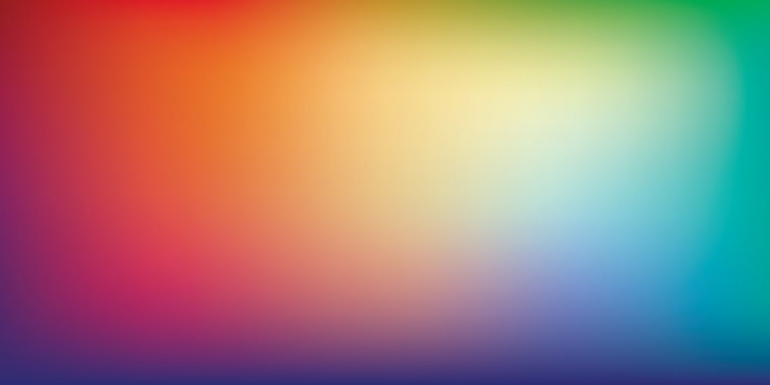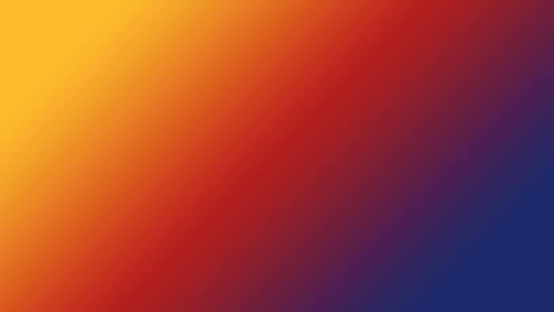
Colour Palette Mood Board


Playing around with darker colours since the fabrics of the shirts may be in darker colours too. These are still soothing and calming because of the gradient effect. I think it’s important to not have a rainbow of colours but rather choose three colours and additional light blue in the mixture. Example could be Purple, dark yellow (Nanoleq-like colour), dark pink, and an added blue.

