WILD Outdoor Apparel Shark Design Specs:
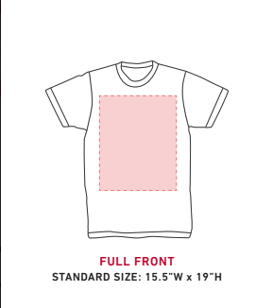
The space available to print on when made

Design will go here
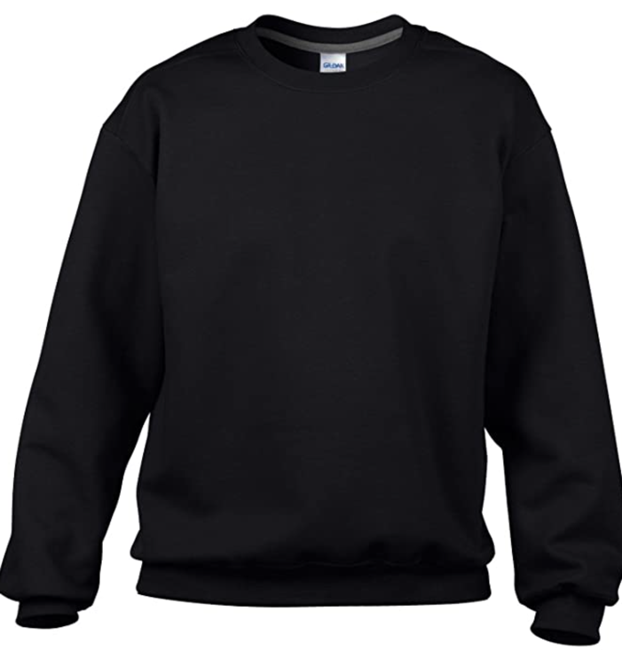

The Design – very similar to drawing:
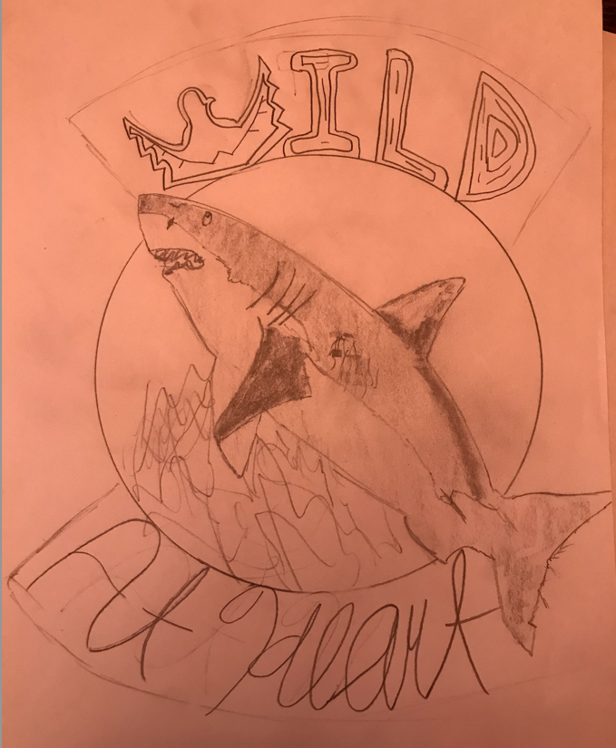
Will be wood texture, see image right below, same style and colours for all other letters.

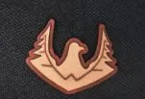
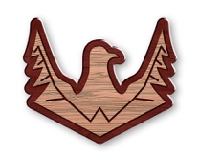

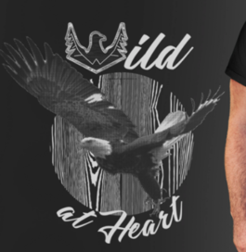
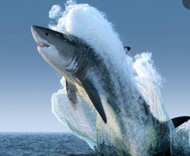
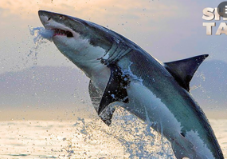
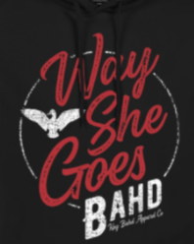
1 Shark jumping out of water or waves, find some images online, below are some examples for inspiration. Use real shark colours. *VERY IMPORTANT*: Make sure whatever image you use is legal to use please. I’m 100% sure you could find some nice ones.
For the background, perhaps make it a wood grain like the image below but make it look better. If it doesn’t look good, use your creativity to make it look good or choose another background – maybe waves or water splashing would look nice!
Like in the image, the shark does NOT have to stay in the bounds of the circle, I think it might look better that the tail and head crossover more than they do if the drawing. Use your best judgement here.
‘At Heart’ Text in some form of cursive that looks good on black. For colour, white will probably be best unless you have any recommendations. Make it a little thick like the writing in the design below: ‘Way She Goes’

