WILD Outdoor Apparel Tiger Design Specs:
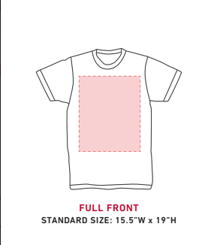
The space available to print on when made
Design will go here

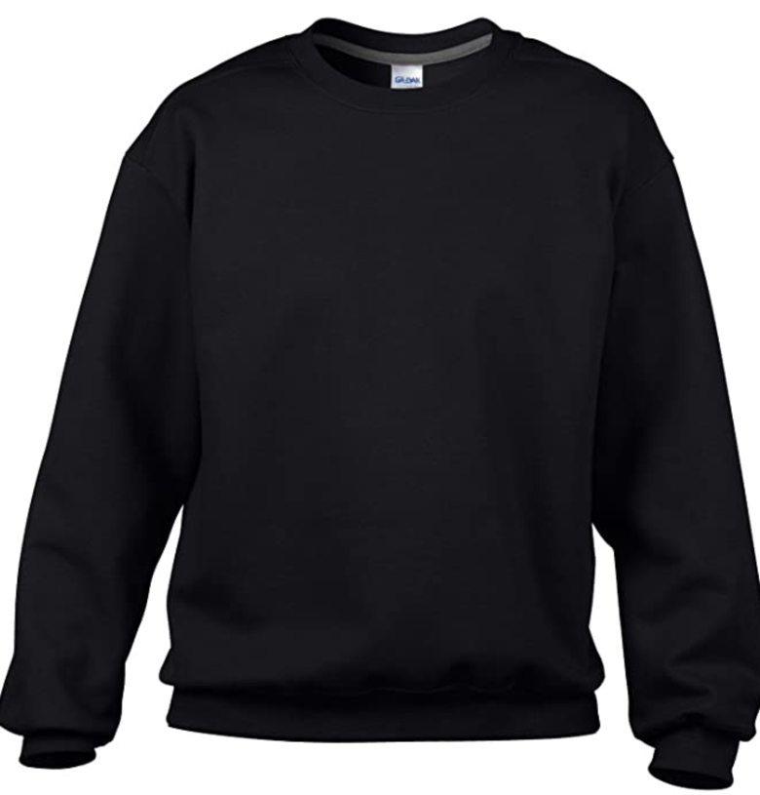

Will be wood texture, see image right below, same for all other letters

The design – very similar to the drawing below:
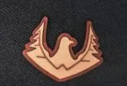
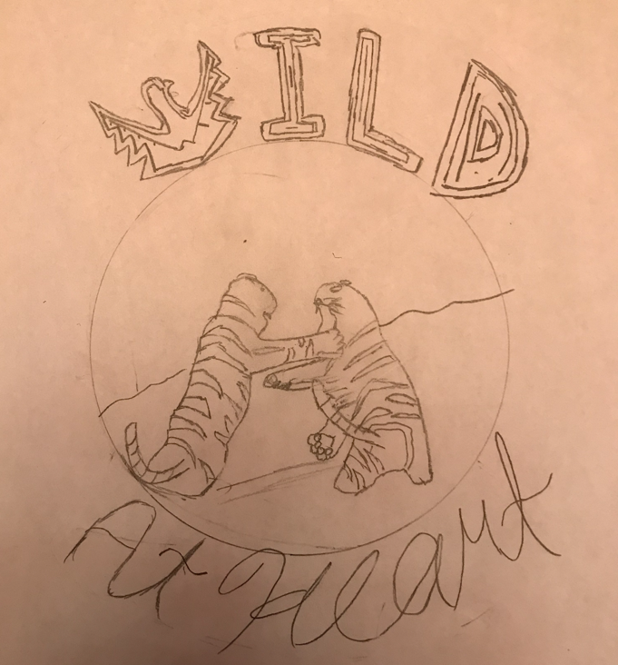

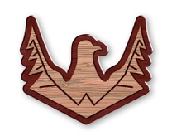

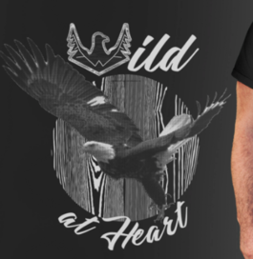
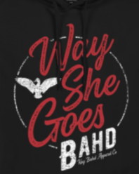
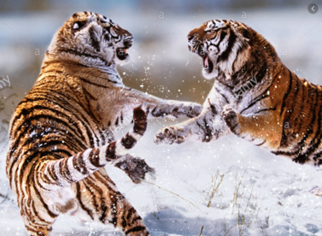
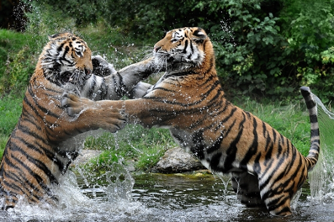
2 real tigers fighting, find some images online, below are some examples for inspiration. Use real tiger colours. Make sure whatever image you use is legal to use please.
The tiger tails and the tigers do not specifically have to stay in the circle lines. If it looks cool that they cross over, please do it. Use your creativity! To the right is an example of a crossover, see how the ‘G’ and ‘W’ go outside the circle?
‘At Heart’ Text in some form of cursive that looks good on black. For colour, white will probably be best unless you have any recommendations. Make it a little thick like the writing in the design below: ‘Way She Goes’
For the background, make it perhaps a lake and some jungle trees. I leave this part up to you, whatever looks good. Maybe the wood grain would look good like the image below
There’s a lot of space here, in the final product make sure the tigers take up most of the space, I just drew the tigers first then made the circle which is why there is a lot of blank space. Make the tigers take up the vast majority of the space.

