WILD Outdoor Apparel Eagle Design Specs:
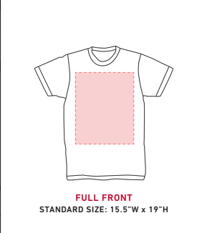
The space available to print on when made

Design will go here

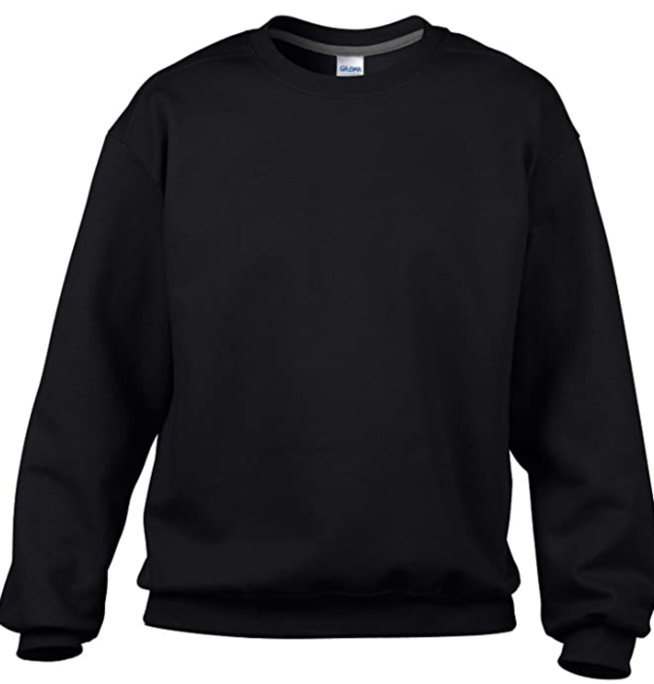

Will be wood texture, see image right below, same style and colours for all other letters.
The design – very similar to the drawing below:
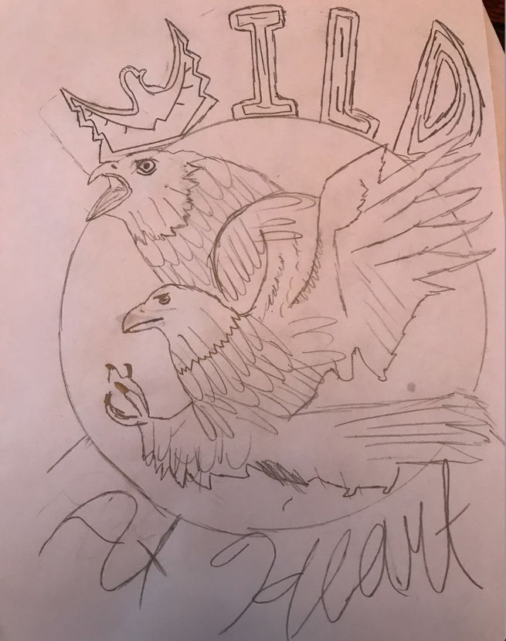

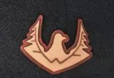
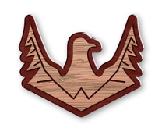

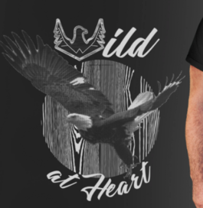
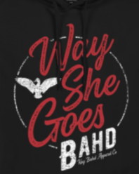
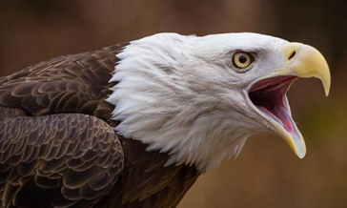
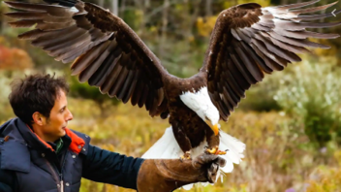
Like in the image, the eagles do NOT have to stay in the bounds of the circle, I think it might look better that the wings and feet crossover more than they do if the drawing. Use your best judgement here.
For the background, perhaps make it a wood grain like the image below but make it look better. If it doesn’t look good, use your creativity to make it look good or choose another background
2 real bald eagles edited together, find some images online, below are some examples for inspiration. Use real eagle colours. *VERY IMPORTANT*: Make sure whatever image you use is legal to use please. I’m 100% sure you could find some nice ones.
‘At Heart’ Text in some form of cursive that looks good on black. For colour, white will probably be best unless you have any recommendations. Make it a little thick like the writing in the design below: ‘Way She Goes’

