We are looking for a logo for our new mobile barbeque business. The name is Kickin Ash BBQ

A picture of the smoker is below, just so you get an idea of what we are doing. My partner was a paratrooper in the Army so we want to incorporate that some in to the logo as well. American Flag/Patriotic, etc…..I am also sending pictures of his badges, beret, etc., so you can draw those. He wants the pig to look more serious and not so “funny”, not holding a gun, maybe holding a flag in one hand and a rack of ribs in the other. We want him to be smoking a cigar and wearing the beret with the flash and patch on it. He wants him wearing multi-camos, with sleeves rolled up high, and a heart with the banner tattoo with “Jenny D” in the banner. He wants him wearing polished jump boots. He wants the Jump Wings and the Deuce Badge (Red, white and blue) somewhere incorporated in it, doesn’t matter…use your awesome creativity. I think I have attached pictures of everything so that you have reference.

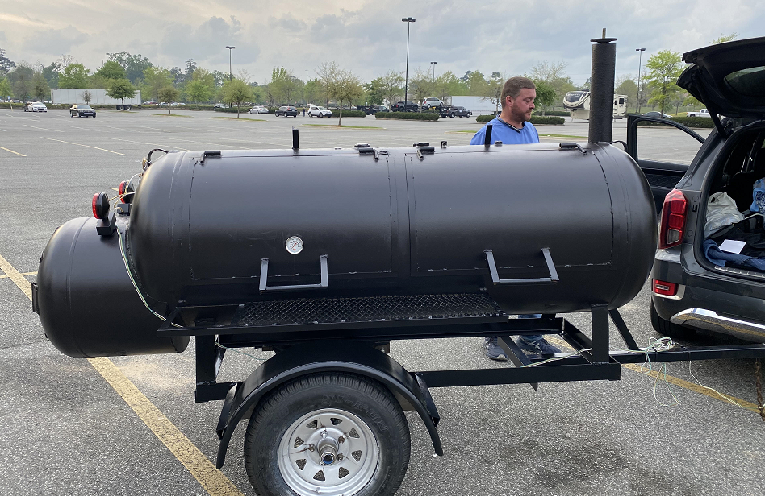

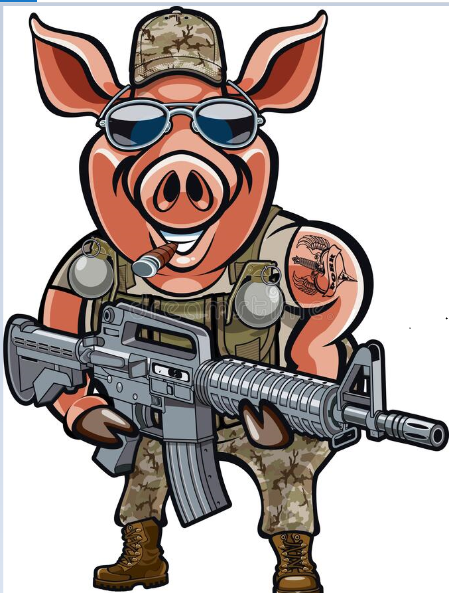

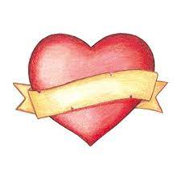

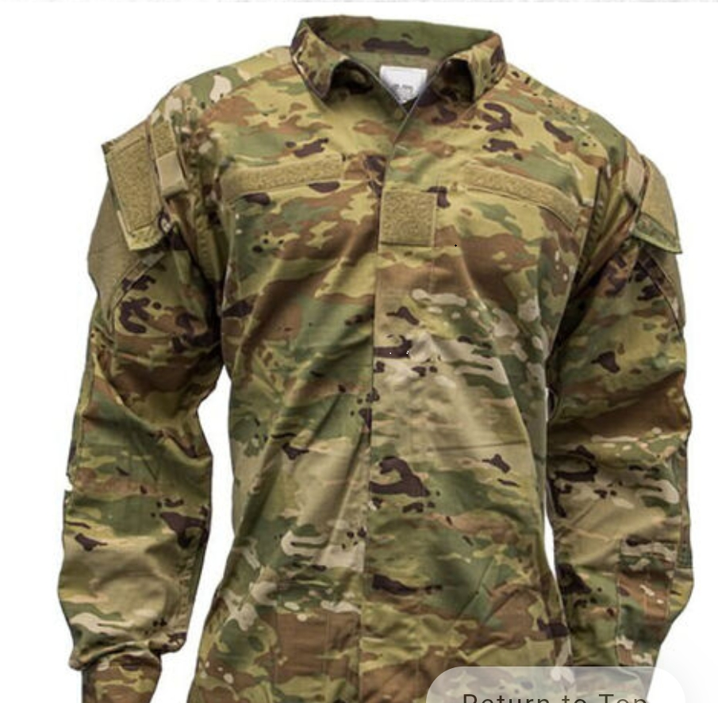Multi-cammo

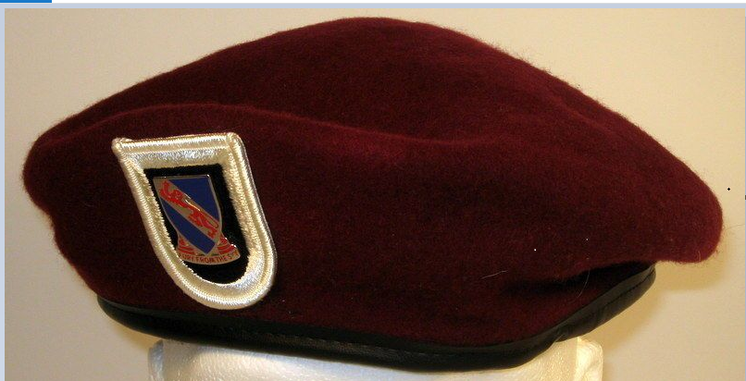
This is the actual beret color. The next picture is clearer picture of what it should look like but not the correct color.

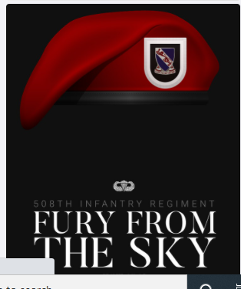

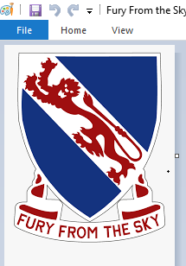
Badge for the beret
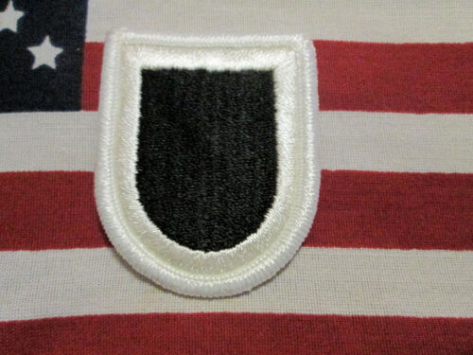

Beret Flash – the badge goes on this flash on the beret

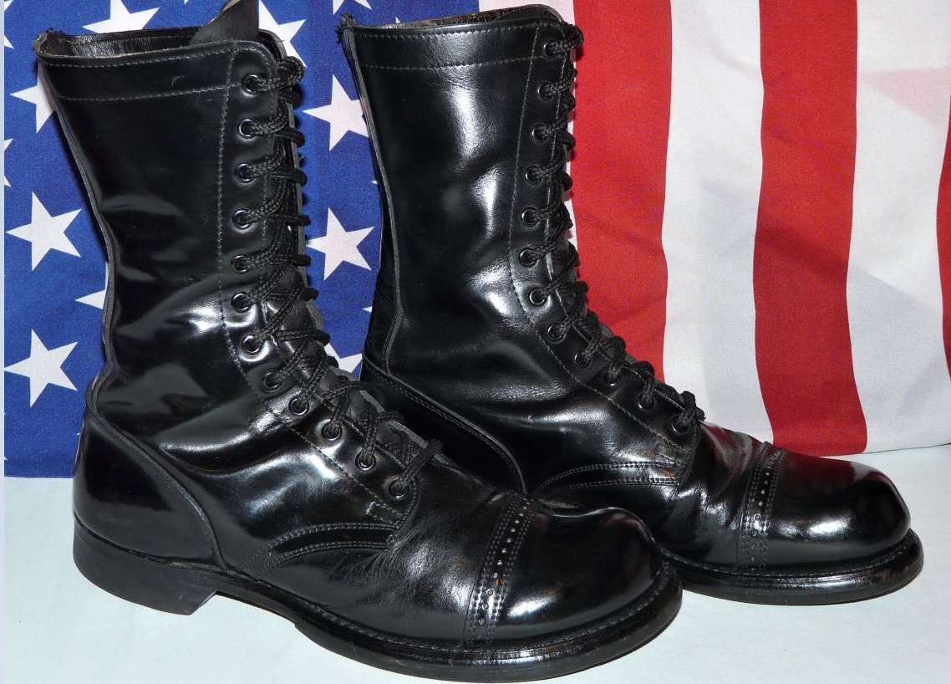

Jump Boots

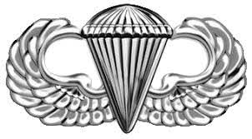
Jump Wings

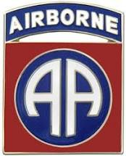
Deuce Badge

