TV TABLET BROCHURE HOLDER 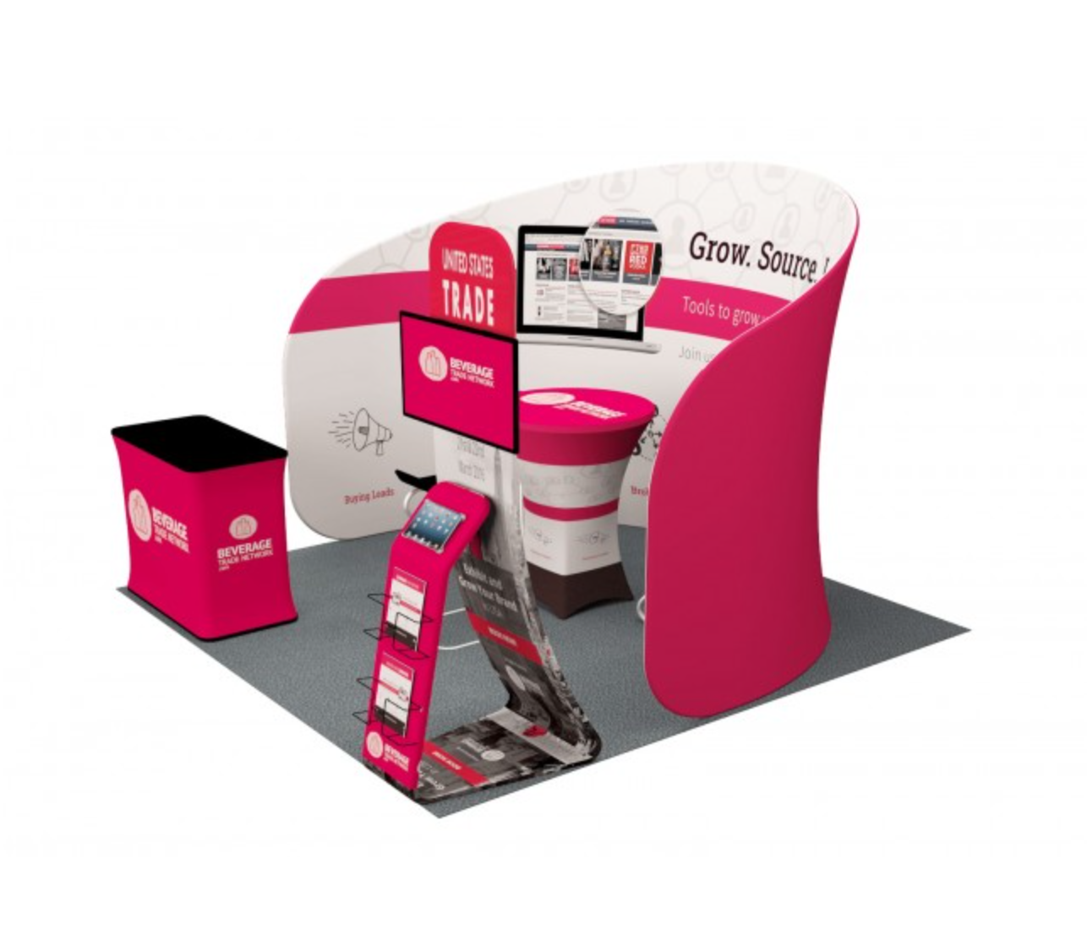

LED BACK WALL (3mtr) + LED COUNTER
https://www.displaysdirectaustralia.com.au/the-infinity

