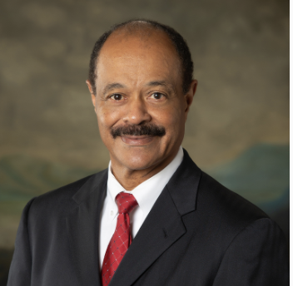

Harold J. Marioneaux, Jr., D.D.S.
As a result of working with Dr. Marioneaux, his clients received outstanding results and benefits.
- 100% student pass rate on the Dental Hygiene National Boards
- 100% student pass rate on Licensing Exams
- 94% of students accepted into medical and dental schools

I am looking for individuals interested in drastically changing their lives by obtaining academic success, improved teaching skills, and student motivation speeches.
Whom do you know that is interested in student success, improved teaching skills, and inspirational speeches.

Dr. Marioneaux earned his undergraduate degree in Chemistry from Hampton University. He received his Doctor of Dental Surgery Degree from Meharry Medical College, School of Dentistry. He served as a Dental Officer in the United States Navy and later in the reserves as an LCDR during Desert Storm/Desert Shield and the liberation of Kuwait.

Academic Experience
- Dean, School of Science Hampton University
- Founding Director, Dental Hygiene Program at Thomas Nelson Community College

Traveling from: Chesapeake, VA

Fee Schedule: $7,500.00-$10,000.00 (Speak)
$15,000-$25,000(Conference /workshops)
Speech Topics
- Program Development
- Accomplishing your Goal
- Impact of Beliefs
- Academic Success
- Starting over, building a new career
- Getting accepted into Medical/Dental School
- Six Sigma and metacognition

