Ambrosia Distillery:
Ambrosia Distillery is a boutique start-up spirit distillery located in Canberra, Australia.

Background of Ambrosia.
Meaning: “Nectar of the Gods”
Gods would drink/eat Ambrosia to sustain them and mortals consuming Ambrosia would become immortal. The goddess Hebe was the server of Ambrosia.

Label styling:
Ancient Greek Mythology focussing on the Olympian Gods.

Label description:
Very open to creative interpretation, but I like the look of the concept my friend pieced together (at the bottom of this document and in the attached PDF).

Front of bottle:
Large “A” symbolising “Ambrosia” using negative space to allow the liquid to be visible through the label.
Behind the “A” depiction of an Ancient Greek battle or orgy in Greek sculpture or Greek vase styling and colouring (example below).
Text: Ambrosia, flavour of product, 40%ABV, 700ml
Metallic bronze and/or gold colouring could make the labels stand out more.

Back of bottle to include the following information:
“Product of Australia”, barcode, 40%ABV, non preganancy friendly, recycle logo, text for address of production. Eg:
Bottles will most likely be something similar to this:
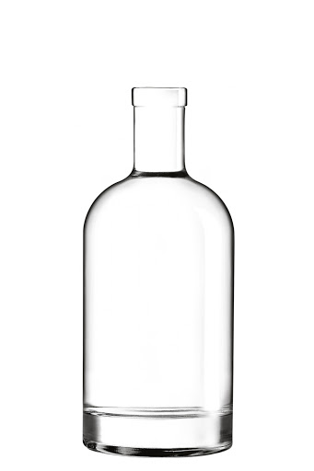

Scope:
I require labels for four types of spirits. Gin, Coffee vodka, lemon myrtle vodka, and apple and cinnamon vodka. It would be great to have a different Greek God matching each of the flavours to make them distinctive and recognisable from a distance.
**Open to suggestion about which Gods/Goddesses to pair with each flavour**
EG: Coffee vodka: Zeus with a thunderbolt in hand (gives energy, packs a punch)
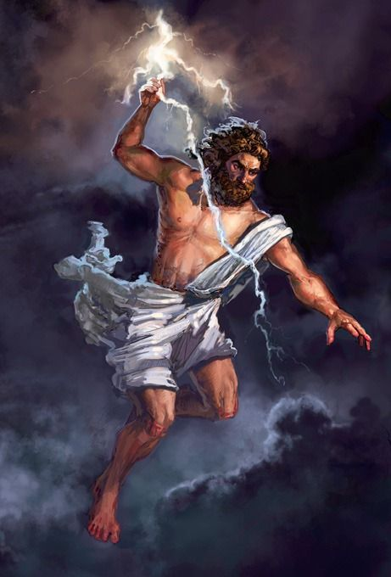

Gin: Athena (strength, weaving of the crafts/botanicals)
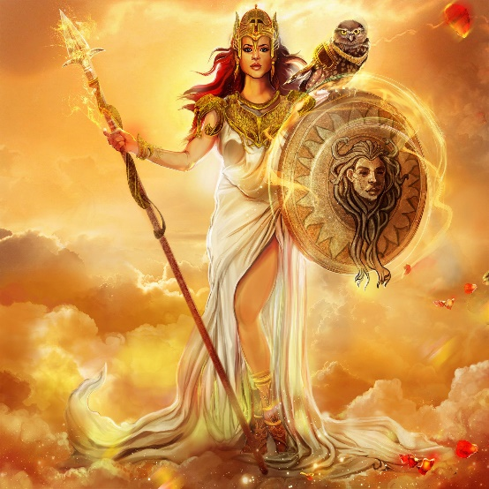

Lemon Myrtle: Aphrodite (elegant, feminine)
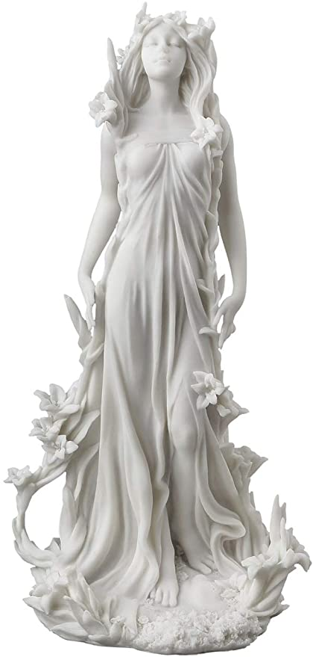

Apple/cinnamon: Gaia (Nature. Fruits of the Earth)
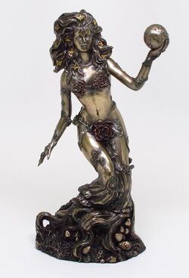

Each flavour will be 40% ABV
22 standard drinks

Greek Vase Styling:
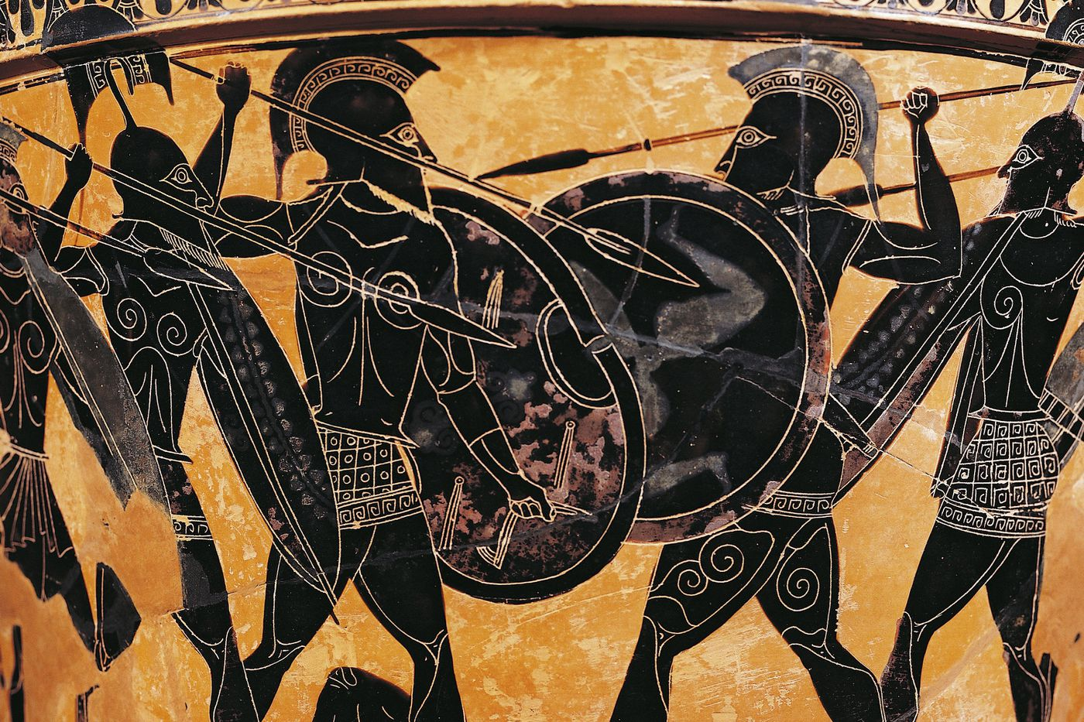
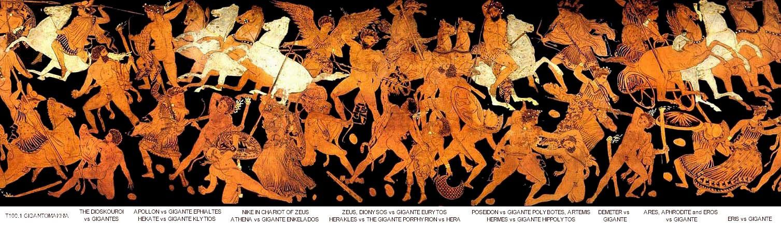

Concept to be improved/altered:
