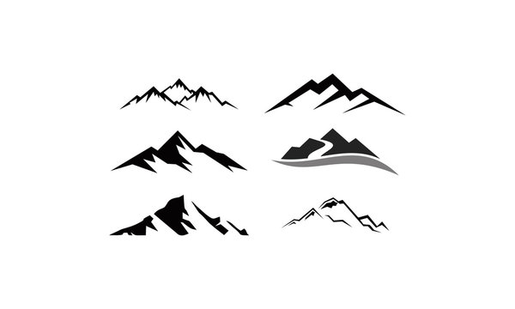

Symbol ideas


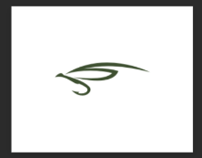


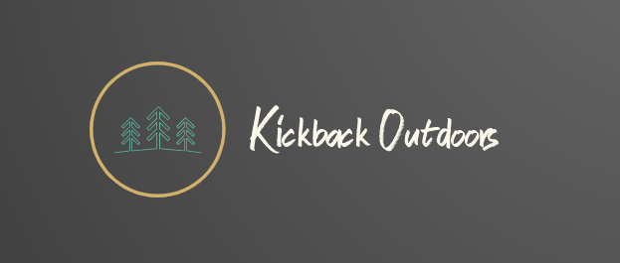





Preliminary design

Brief
- I would like a unique logo that will be on the face of an Outdoor brand. The brand will be focused on providing quality outdoor clothing while contributing to environmental conservation efforts
  - The symbol (see above ideas) should be where the circle is, in place of the tree symbol currently there. It can be within a circle or the circle can be eliminated.
  - If the symbol included mountains and fish it would be ideal (see example)
  - Alternative symbols could include a “K”
- I enjoy the “Kickback Outdoors” font currently in white
- I really enjoy the overall color scheme in the preliminary design, but am open to other color combinations
- Design should be slick and clean

