- I like the cool logo design and colors in this one. I like the the words below are two different colors as well.

- I like the A logo design in the center and that could work well for Alturance since is also starts with an A.
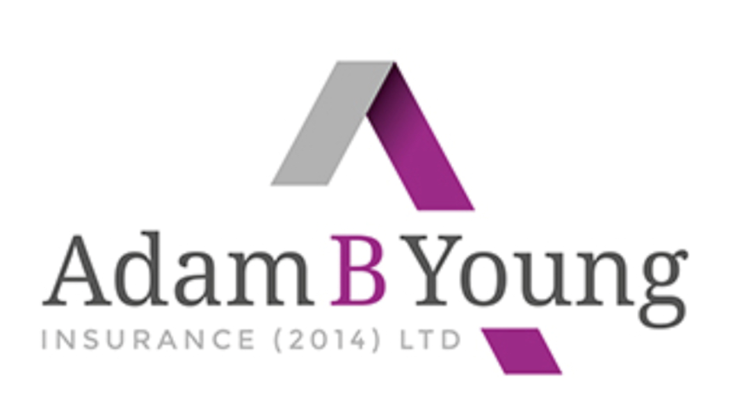
- I like the cool logo design and colors. I like that this one says insurance agency so you know right off what they do.
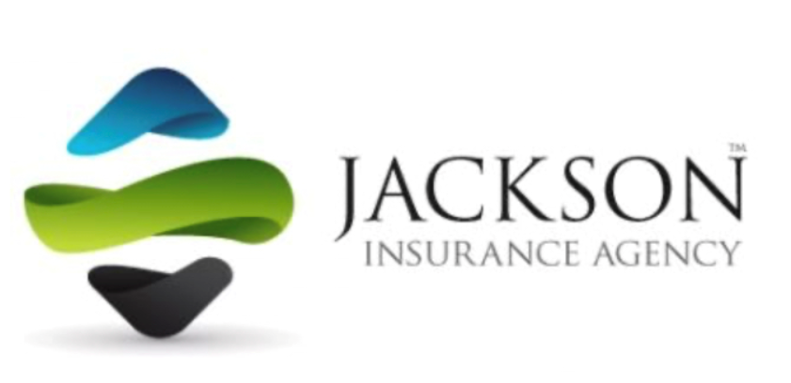

- Cool logo design and colors
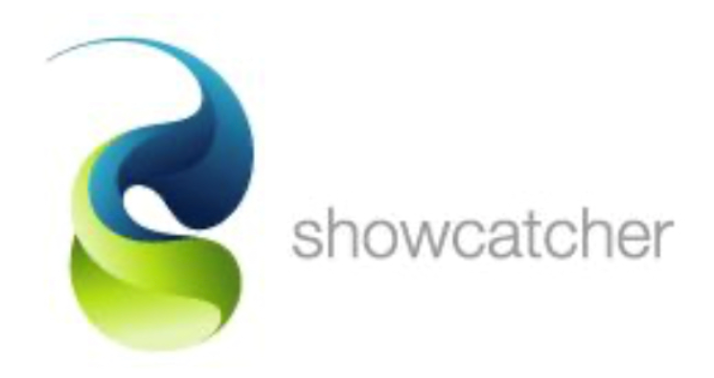
- All the remaining logos involve “links.” I kind of like the idea of a link, especially in the ones I highlighted in #7. I think it would be easy to come up with verbiage for it. Something like, “Linking the right products to your business” or “Linking the best products with the best prices for the best benefits for your employees.”
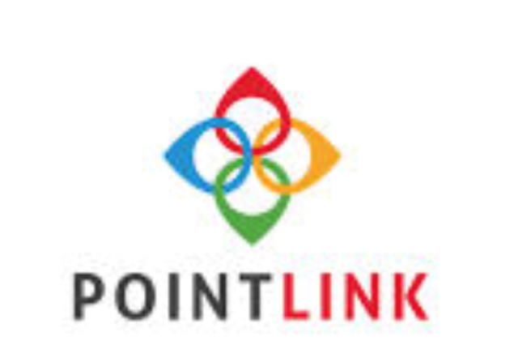
6.
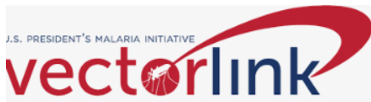

7.
