COMPANY PROFILE

Payoff Srl was founded in 2005 with the aim of producing specialized software developed using the latest technologies and methodologies (see also www.payoff.it).
Payoff has a proven experience and aptitude to work with complex organizations and large-scale supplies: Fiera Milano SpA, EXPO 2015, CAME Group, Fiera Verona have chosen Payoff as the software provider for their core business.
Payoff has become the provider of the core information system for Fiera Milano SpA, beating the world's leading IT players (Sales Force, ORACLE, Microsoft, Sales, IBM… supplier selection lasted more than a year and was carried out at the European level).
EXPO 2015, before using Payoff as a supplier (a paid provider, not a sponsor), requested and the Polytechnic University of Milan certified the quality of Payoff software.
Google's CTO for Europe, Middle East and Africa region (Google headquarters in Zurich), who evaluated Payoff software on behalf of EXPO 2015, sent an email to Payoff saying, “... congratulations on your software ... I saw Italian exccelency."
In 2018 Payoff implemented a ticket, card and coupon management system for Verona Fiere S.p.A and in particular for Vinitaly.
Payoff offers and uses only application software, the code of which is wholly owned by the company.
From its inception to the present, there have been no cases of litigation against Payoff by customers, suppliers or banks.

PRODUCTS
The nature of Payoff products is Enterprise strongly oriented to the cloud with proven robustness, performance and scalability.
All products can be used via the web, even on the move via smartphones and tablets.
Numerous software development orders completed have allowed Payoff to create application packages that can be defined "for immediate use." Below are some of our achievements.

CRM.BLOX
CRM.BLOX is a software that offers advanced customer relationship management and sales automation (hereinafter CRM and SFA), which allows 360-degree control of the Contact-Offer-Order-Invoice cycle and full web sales automation functions and mobile sales.

EXPO.BLOX
CRM.BLOX has undergone significant changes for the exhibition area, which gave life to the EXPO.BLOX package.
EXPO.BLOX is a 360° event management solution. EXPO.BLOX is a unique software for the panorama of Europe, adopted, in particular, at the Fiera Milano, Expo 2015 and Fiera Verona exhibitions.
EXPO.BLOX manages exhibitions and events without restrictions on the number of Districts/Pavilions/Stands and participants.
The system processes several million orders annually, and millions of users use it for both back office and front office.
The system integrates a portal for visitors and exhibitors, capable of managing hundreds of thousands of concurrent accesses.

CLOUD.BLOX
It is the application platform on which all Payoff enterprise solutions are developed. It is based on a set of microservices that communicate with each other through a distributed enterprise service bus to help share resources and scale services. The platform was created by defining a series of Open Source servers capable of managing large amounts of data that enable major portals such as Facebook, Twitter, LinkedIn to deliver their services and content on a daily basis.

THING.BLOX
Thing.Blox is Payoff's full-fledged cloud platform built on microservices for IOT (Internet of Things). It is able to provide concrete answers, operating with full support for emerging IOT technology in all sectors.
It is a development platform for centralized remote management of a wide variety of smart device types in the fields of home automation, mobility and access control in shared spaces.
European leader in security management and access control, CAME S.p.A has chosen Thing.Blox as the platform for the development and management of CAME-Connect.

health.blox
Health.Blox is the result of a dedicated research and development project, based on the Thing.Blox platform. The product, created as a result of engineering developments, allows individual control of the physiological state and physical activity of the patient. Manages the location of the patient and instruments with automatic identification of "critical" conditions. The platform is the result of a 1.9M MISE project.

CARE.blox

Care.Blox is a vital signs monitoring and control application specially designed for residents of nursing homes and patients who need constant supervision. Simple and reliable tool with high performance cloud server. A bio-surveillance IoT solution that monitors body temperature, oxygen saturation, heart rate directly from wearable devices, and provides real-time alarms in case of failures. Analyses and reacts to movements or immobility. Care.Blox is also an important tool for the control and monitoring of the new Covid-19 epidemic that is affecting the entire world, as it monitors key parameters and therefore allows programmed distancing of patients affected by a new acute infectious epidemic, subject to due care.

BIZ.BLOX
Biz.Blox is a full-featured e-commerce product for multiple stores, with diverse price list management and customizable even complex products. It allows you to make payments through various types of bank gateways, both by credit card and bank transfer and manages the collection and credit check. It operates the product check-in feature and is guaranteed by millions of transactions completed with tens of millions of managed sales. The system is used both at the exhibition and in the ticketing industry, but it can also be activated as a stand-alone store.
It managed the sale of millions of tickets sold at Expo 2015.
BIZ.Blox is integrated with all the other modules of the Suite.Blox
The system was integrated with AI (artificial intelligence) algorithms for the proposition of goods and mechanisms of related products.

DOC.BLOX
The Payoff document management system, powered by the Cloud.BLOX platform is a product designed for document management and decision making, even very complex ones. It allows you to manage distributed content using the following microservices:
- drive: a microservice to manage files, images and videos with permissions and shares
- WF: a distributed event workflow capable of driving decision-making processes. It can be configured over the Internet in drag and drop mode even for very complex processes
- Forms: it is a fully dynamic system capable of designing, displaying and saving screens and related data to be presented to users
- Report: it is a fully dynamic system capable of designing, displaying and saving screens and related data to be presented to users.
Thus, the system allows you to insert, manage, update and create documents, including interactions with third parties, such as sending unstructured or based on established processes.
The system was used among others for the management of all the practices of the participating countries of Expo 2015, managing over 2Terabytes of documents. In the public sector, it has also been used in the Veneto Region for the "MANAGEMENT, MAINTENANCE AND DEVELOPMENT OF THE REGIONAL INFORMATION SYSTEM VENETO - SIRV"

MAPS.BLOX
MAPS.Blox is a data card management and visualization system, whether it comes from third-party systems or specialized services. The system allows you to view maps directly from Google or other providers, as well as from other sources such as Autocad, images or Gis (shape files).
The system also allows you to display, view and interact with information received from the IOT system, CRM or Expo.blox.
Some of the examples of use:
- Management of exhibition factories at fairs
- Visitor route management, integration with artificial intelligence algorithms for shorter routes, filling by area, ...
- Management of the Maps of the EXPO 2015 pavilions
- Positioning and movement of devices in the IOT

TECHNOLOGY - KNOWLEDGE MANAGEMENT
Payoff possesses distinctive Know-How, which constitutes one of the main assets of the company.
The acquired skills are based on modern technological tools that are used by large companies in the IT world to manage their portals such as Facebook, Twitter, Google.
Below is a panel of various technologies that Payoff uses on a daily basis. The choice is confirmed by the use of major players and technology monitoring such as “Technology Radar (https://www.thoughtworks.com/radar)” or the Cloud Computing Foundation (CNCF), which confirm their status as Adopt and Graduated.
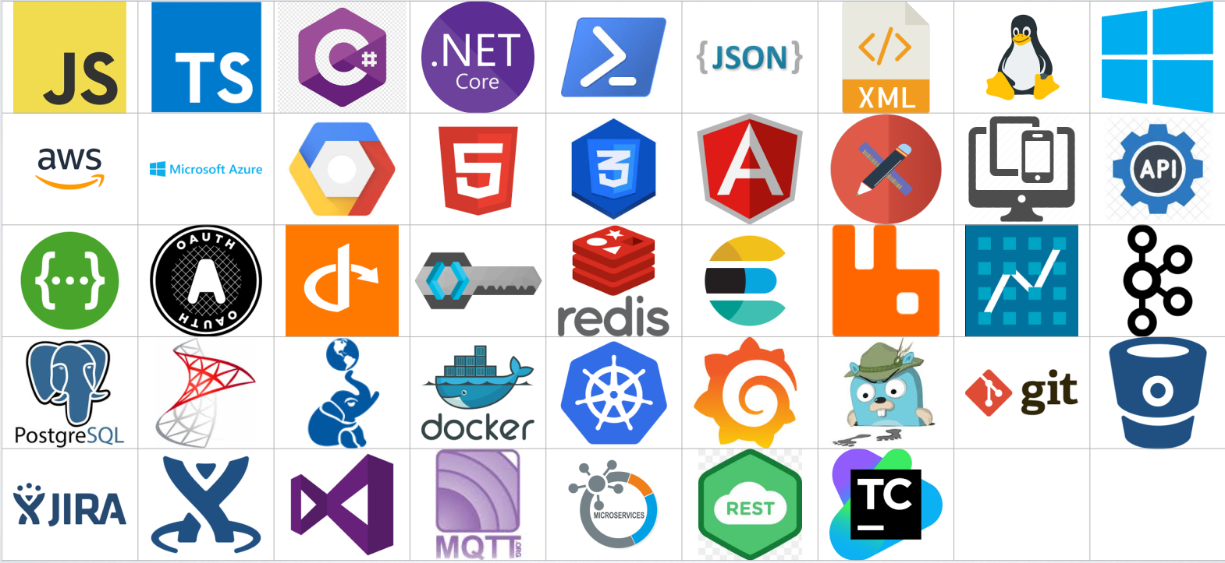
Payoff consistently provides its "knowledge worker" with specialized training by supporting them with international gurus (talented people) with high or very high level know-how. The goal is that everyone can have a good command of the technologies adopted by the company.
Therefore, Payoff took advantage of these tools, focusing its efforts on creating a series of solutions based on these technologies, almost always open source. The result is a patented platform that develops the functions of these tools to quickly deliver new services, but always with consistency and quality.
Some ideas on the above technologies:
- The Native Cloud Platform (PAAS-Platform as a service) is independent of vendor clouds (AWS, Google Cloud, Azure, ..) and can also be migrated in house on request
- There is a functional and technological separation between the different tiers of applications (web, app, store);
- External applications manage REST calls to specific endpoints, designed with mobile logic with full HTML 5, responsive design, JSON, WebSocket, and Ajax
- For the front-end, I chose to write applications in Angular app, as well as on a proprietary platform.
- Application Servers are RESTful, JSON & XML, using Swagger, Oauth and Oidc;
- Storage Event Store architecture with CQRS Pattern (Command Query Responsibility Segregation);
- The database can be both NoSQL and Relational;
- All systems operate with Cache System in memory and distributed Redis (technology adopted by Facebook, Wikipedia, YouTube, Twitter, ...);
- The data can be searched through the dedicated ElasticSearch search engine (technology adopted by FourSquare, Sony, Path, SoundCloud, ..);
- All the dialogue stack via ESB-Enterprise Service Bus RabbitMQ (technology adopted by Nokia, HuffingtonPost,…) or Kafka.

COMPANY ASSETS AND MANAGEMENT
Assets
Payoff software consists of its own source code, which is then presented to the operator as a single SUITE through the integration of microservices.BLOX.
Software assets have a competitiveness that can be considered sustainable because the market analysis does not reveal significant threats to replacement products or new entrants.
The said software has a cost (development cost) which, calculated using a classic “audit” tool such as COCOMO II, is 4.5 million euros: it should be emphasized that this software cost is NOT indicated in the financial statements (for an accurate selection business). The cost of (wholly) proprietary software is the “de facto”(not “de jure”) main business asset.
TURNOVER
The turnover of the last two years was + 1 million

Human Resources
Payoff has a workforce made up of:
- 4 developer technicians
- 2 senior application consultants
- 2 project managers and business consultants, technical developers
- 1 program manager (who is also the CEO)
- 1 administrative, (an accountant firm completes the administration)
- 1 marketing and commercial consultant.
For an accurate business selection, Payoff has only high-level technical resources that have been continually selected over the years; the last 2 resources involved were group leaders in previous companies: they chose Payoff not because of salary, but because of the value that is acquired both in terms of know-how and in terms of development methodology and quality of work.
In the event that sales are higher than expected, or in the face of a peak in activity, Payoff already has the ability to double, risk-free, its direct workforce because it:
- has a proven freelance network
- can use their 2 project managers as team leaders, coordinators of 2 groups of 2-4 technical specialists-developers, involved in the "Time and Materials" mode from third-party companies
In both cases, setup time was reduced, overall costs remained unchanged, and direct control over all developments confirmed the quality of the final product.
It should be noted that two business consultants can, in complete autonomy (each of them) manage the maintenance of all current deliveries and be the program manager himself, or each of the two can completely replace the program manager.
In the production, support or organizational structure of the company, there are no key employees, conceived as employees, whose flight can create imbalances.
The quality of personnel should be viewed as an asset of the company, as well as the possibility of significant expansion of production capacity with minimal risk of providing services and in a short time.

research & development

Payoff received government funding for its research and development activities in 2018 and 2019, which was fully invested in improving its products. Over the years, the company has always financed itself, with internal R&D costs estimated at about 35% of turnover, ensuring continuous growth at the technological level.

team work

Payoff prefers “Agile” Methodologies which favour face-to-face communication over written documentation.
Typically, a flexible team works in one office and consists of a maximum of five people to facilitate communication and collaboration, thus creating much less supporting documentation. When the team is split between different offices, they maintain daily contact through video conferencing, calls, email, etc.
Agile methodologies are practical, flexible and “light” methods for the effective modelling of software systems, created in contrast to the rigidity of traditional models. Essi sono caratterizzati dall’aderire con un occhio estremamente pratico ai quattro principi fondanti del manifesto (http://agilemanifesto.org/):
1) Individuals and interactions outperform processes and tools
2) Working software outperforms all-encompassing documentation
3) The collaboration with the client outperforms the negotiation of the contract
4) Responding to change outperforms sticking to a plan
Agile methodologies typically foster project management that encourages frequent review and adaptability, team leadership, a person's ability to plan and be available, a set of best practices that enable high-quality software to be delivered quickly, and a business approach that aligns development with customer needs and goals.
PRINCIPLES OF BEST PRACTICE
The Agile Manifest does not provide walkthroughs or prescriptions on how to create a project management model. Instead, it is a collection of best practices based on principles and values that should be discarded as appropriate:
▬ The highest priority is to satisfy the customer with frequent and continuous delivery of valuable software, ensuring continuous feedback
▬ Commercials and developers need to work closely and frequently
▬ Projects grow thanks to motivated individuals. Give them the environment and support they need, and trust them to complete their tasks
▬ The most efficient and effective way to convey information in the team is through face-to-face communication
▬ Running software is the primary measure for business progress
▬ lender, developers and users must always proceed in a common step
▬ Agility is enhanced with a continuous focus on technical excellence and elegant design
▬ Simplicity is the most advanced sophistication
▬ The best architectures, prerogatives and designs emerge only from self-organizing teams
▬ At regular intervals the team reflects on how to become more effective; then he adjusts and adjusts his
behaviour accordingly

