Company Brief: BackDroppz Selfie Spot
NAP:
BackDroppz Selfie Spot
559 Freedom Way
Midway Park, NC 28544
Phone: (910) 353-4434
Email: backdroppznc@gmail.com
Website: backdroppznc.com
Social Media:
Instagram: Instagram.com/backdroppznc
Facebook: Facebook.com/backdroppznc
Twitter: twitter.com/backdroppznc
Youtube: TBD
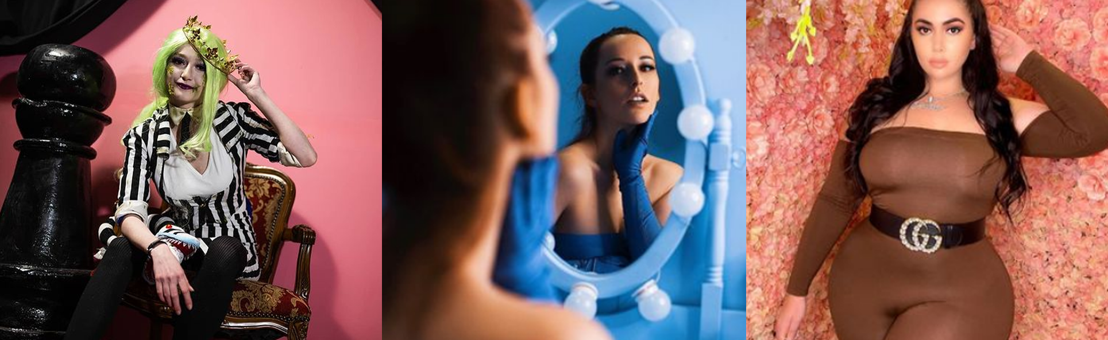
TikTok: TBD

What it is: BackDroppz Selfie Spot is an interactive Instagram museum, AKA selfie museum. Customers take personal photography photos for posting to social media in front of a variety of scenic photographic back drops. Backdrops are fun, inspirational, interactive, trendy, and creative.

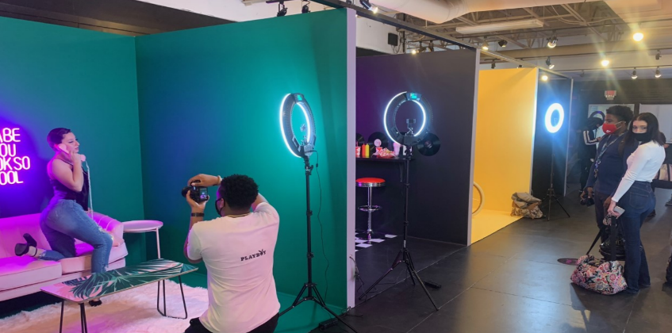
Customer Profile:
Gender/Age: Female 13-25 year old
Ideal customer types:
Military Wives
Teen Girls 13-21
Pregnant Women
Likes/Dislikes
Social media: TikTok, Intagram, Twitter
Brands:
Coach, Michael Kors, Luis Vuitton, Sephora, Ulta Beauty, Apple, Starbucks,
Attitude:
Strong, Authentic, Inspired, Creative, Beautiful, Boss-Babe, Independent, Caring, Loving, Nurturing, Trendy, Nostalgic
Why would she visit?
Promote the idea that life is grand and that she’s living her best life.
Self promotion: Social Media, professional headshots, vanity/narcissism
Life Events: Date Night, Engagement, Maternity Photos/ Gender Reveal photos, Bachelorette party, birthday party, Girls Night Out
School Events/Commemoration: Prom, Graduation/Rising, Senior in High School
Company Vision/Mission:
We are a fun, open, non-judgemental place for young women to express their self-image and promote body positivity.

How do we intend to market the brand?
Online Marketing. Primary marketing will be via social media including Facebook, Instagram, Pinterest, and YouTube videos. Graphics should be scalable to common display sizes 19:6, 1:1, 1280X1920
Collateral Material:
We use a variety of collateral material including Business cards, 4X6 post cards, 4.5X9 inch Rack cards, Posters 24X36, X-Frame displays 24X72 inch. Tri-fold Brochures and A5 One-Sheets. 1.5 inch buttons
Merchandising:
We plan to create a variety of merchandise items graphic logo and logotype should be able to stand on their own and still convey the idea of what BackDroppz is.

Branding Strategy
Keywords: TikTok, Instagram, Influencer, Boss-Babe, Salt Life, Easy Money, Fun,

Logo Examples of others in the industry.
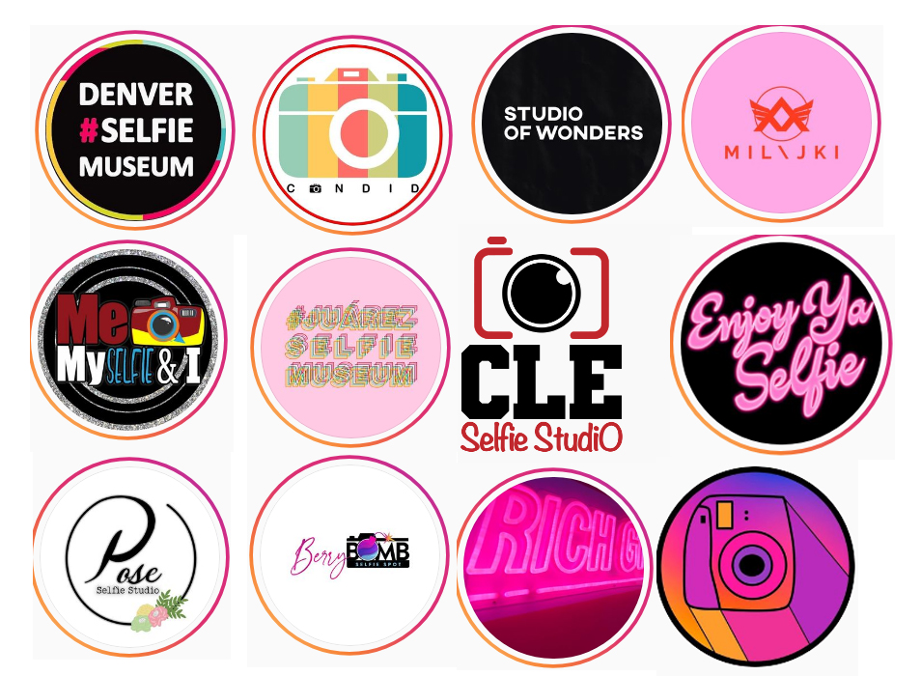
Our logos should convey a sense of fun and excitement, they should be modern but timeless. They should appeal to a younger demographic. Though our ideal customer trends female our branding should have universal appeal.
Iconic:
Logo designs should give a head nod towards photography such as Candid and CLE Selfie Studio above. Color palette should be limited to 1-2 colors with the idea of creating a brand that can be printed on t-shirts, hoodies, and other merchandising. We would eventually like to have a custom Neon Sign made so the ability to have a strong outline that could be translated into neon would be desirable.
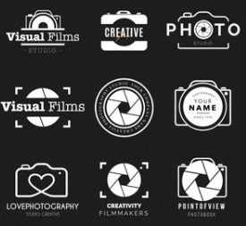
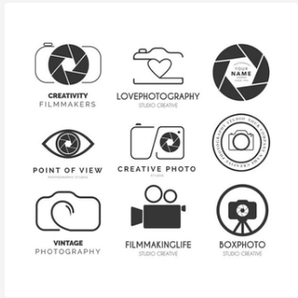

Colors: Color Profile Below is CMYK-8
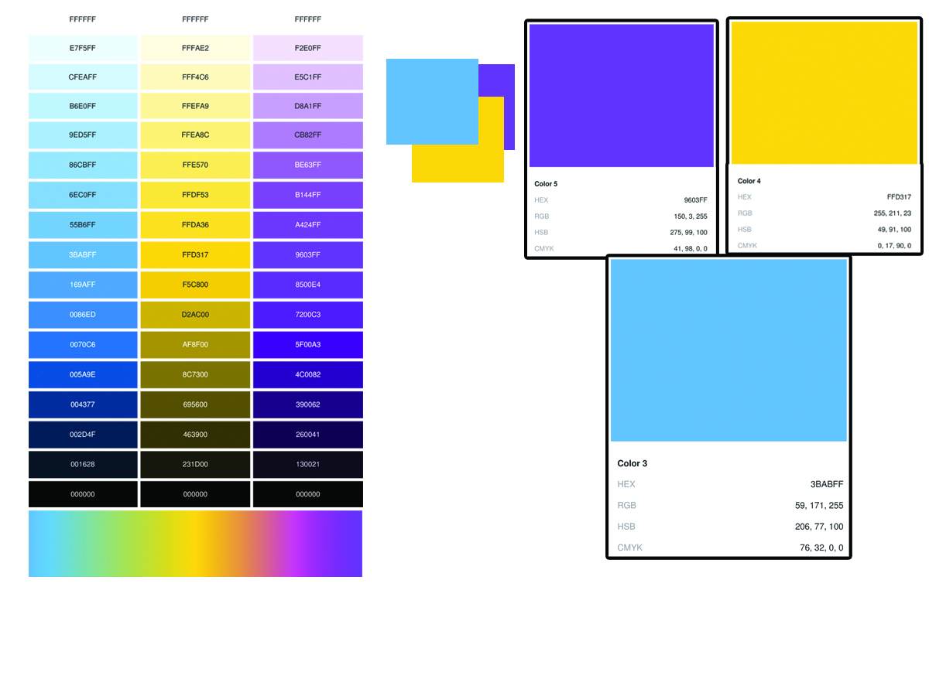
Fonts:

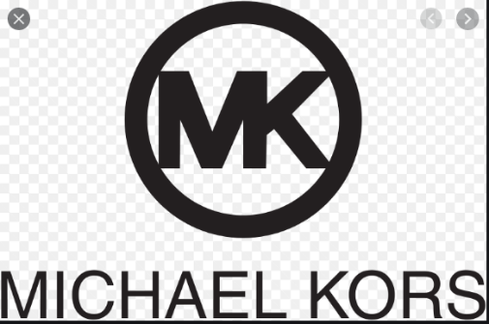
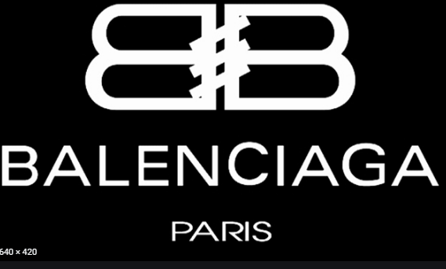
Ideal fonts would be Modern Looking with Classic Elements that appeal to trendy women. Examples include Balenciaga, Michael Kors,

